

College of Business,

Technology and   
Engineering

MSc Dissertation Report

**AI-Powered Urban Traffic Optimization in the UK using Reinforcement Learning and Edge Computing.**

|  |  |
| --- | --- |
| Student Name | **Mandar Dnyaneshwar Satpute.** |
| Student ID | **34064994** |
| Supervisor | **Domdouzis Konstantinos.** |
| Date of Submission |  |

A dissertation submitted in partial fulfilment of the requirements of Sheffield Hallam University for the degree of Master of Science in Big Data Analytics.

This dissertation does NOT contain confidential material and thus   
can be made available to staff and students via the library.

# Abstract

Urban traffic congestion is still a major problem in UK cities, and fixed time signals often cannot adapt when traffic demand changes. This dissertation tests whether an AI-based traffic signal controller, supported by a results dashboard, can improve junction performance in simulation and make fixed time vs AI comparisons easier to understand.

A full SUMO-based pipeline was built using a Sheffield city centre subnetwork from OpenStreetMap and AADF calibrated traffic demand. A GNN based A2C controller was trained to make adaptive signal decisions and evaluated against a fixed-time baseline under identical conditions using waiting time, queue length, and throughput metrics, with results presented through a dashboard at network and junction level.

A small user study also assessed dashboard clarity and usefulness. Most participants found the layout and graphs understandable and helpful for comparing controllers, while feedback highlighted the value of adaptivity and suggested improvements for real-world robustness and simpler summaries for non technical users.

Overall, the work provides an end-to-end workflow from scenario creation and RL training to evaluation and user facing reporting, and sets a foundation for future improvements in sensing, safety, and deployment realism.

# Acknowledgement

I would like to thank my supervisor, Dr Konstantinos Domdouzis, for his guidance, support, and feedback throughout this dissertation. His suggestions helped me improve the research direction, improve the implementation, and make the writing stronger.

I am also thankful to all the participants who took part in my dashboard evaluation and shared their feedback. Their responses helped me check the clarity and usefulness of the dashboard and supported my final evaluation.

I would like to acknowledge Sheffield Hallam University and the School of Computing and Digital Technologies for providing the learning environment, resources, and support during my MSc programme.

Finally, I would like to thank my family and friends for their encouragement, patience, and support during the full dissertation journey.

Mandar Dnyaneshwar Satpute

Table of Contents

Abstract ii

Acknowledgement iii

List of abbreviation: xiv

CHAPTER 1: INTRODUCTION 1

1.1 Background and Context 1

1.2 Problem Statement 2

1.3 Research Aim 3

1.4 Research Objectives 3

1.5 Research Questions 3

1.6 Scope of the Study 4

1.7 Significance of the Study 4

1.8 Dissertation Structure 5

CHAPTER 2: Literature Review 6

2.1 Literature Review: Advanced Traffic Management Using Deep Reinforcement Learning and Simulation 6

2.2 Introduction: The Imperative for Intelligent Traffic Management 6

2.3 Background Studies: Limitations of fixed based timing Traffic Signal Control 6

2.4 Deep Reinforcement Learning for Adaptive Traffic Signal Control 8

2.5 DRL Algorithms and Enhancements 9

2.7 Multi-Agent Reinforcement Learning (MARL) 13

2.8 Graph Neural Networks (GNNs) 13

2.9 Multi-Objective Optimization for Sustainability and Safety 14

2.10 The Essential Role of Simulation and SUMO 15

2.11 Conclusion: 16

CHAPTER 3: Methodology 18

3.1 Research design and methodological framework 18

3.1.1 Research Philosophy: 19

3.1.2 Research Approach: 19

3.1.3 Research Strategy: 19

3.1.4 Methodological Choice: 19

3.1.5 Time Horizon: 20

3.1.6 Summary Table 20

3.1.7 Research Plan Workflow Diagram 21

3.2 System Architecture Overview 22

3.3 Dataset 24

3.3.1 Network Preparation 28

3.3.2 Network statistics (SUMO network used in this study): 30

3.3.3 Graph adjacency matrix construction (node + edge definition): 31

3.4 Traffic Demand Generation 31

3.4.1 Deriving Peak-Hour Demand 31

3.4.2 Generating AADF Calibrated Synthetic Routes 32

3.5 Baseline Fixed Time Controller 33

3.6 Reinforcement Learning Controller (ADDRL + GNN + A2C) 34

3.6.2 State Representation 35

3.6.3 Action Space and Control Logic 36

3.6.4 Reward Function 36

3.6.5 GNN Based Actor Critic Architecture 37

3.6.6 Learning Algorithm and Training Strategy 38

3.6.7 Hyperparameter and training configuration: 41

3.6.8 Training Settings (GNN–A2C Controller): 42

3.6.9 Software and compute environment: 44

3.8 Ethical Considerations 44

3.9 Validity, Reliability, and Limitations 45

CHAPTER 4: Simulation Evaluation and Experimental Results 46

4.1 Experimental Setup 46

4.2 Model Training and Learning Behaviour 50

4.2.1 State Representation and Graph Configuration 51

4.2.2 Actor - Critic Output Validation 52

4.2.3 Training Reward Progress and Check point 53

4.3 Evaluation Data Generation and Dashboard Outputs 53

4.3.1 Dashboard based performance monitoring 54

4.3.2 Exported evaluation datasets 56

4.4 Network Level Quantitative Results 57

4.4.1 Average Waiting Time 58

4.4.2 Queue Length Analysis 60

4.4.3 Vehicle Movement Analysis 61

4.4.4 Reward Trend During Evaluation 62

4.5 Intersection Level (TLS) Performance Analysis 64

4.5.1 Overview of Analysed Traffic Light Systems 65

4.5.2 Individual TLS Performance Analysis 65

4.5.2.1 TLS 1234828897 66

4.5.2.2 TLS 1757353212 67

4.5.2.3 TLS 1757353214 68

4.5.2.4 TLS 1783045940 69

4.5.2.5 TLS 1783045985 70

4.5.2.6 TLS 1843356909 71

4.5.2.7 TLS 7671039164 72

4.5.3 Network Wide Comparison of TLS Behaviour 72

4.6 Overall Performance Improvement Summary 73

CHAPTER 5: Discussion and User Evaluation 74

5.1 Discussion of Network Level Results 74

5.1.1 Average waiting time: 74

5.1.2 Queue length: 75

5.1.3 Vehicles processed: 75

5.1.4 Reward trends: 75

5.1.5 Why the AI controller improved performance overall: 75

5.2 Discussion of Junction Level Performance 76

5.2.1 Overall junction level pattern: 76

5.2.2 TLS where AI keeps performance consistently near zero: 76

5.2.3 TLS where fixed time produces extreme delay events: 76

5.2.4 Why improvements vary across junctions 77

5.3 User Evaluation 77

5.3.1 Purpose and scope: 77

5.3.2 Participants and recruitment: 77

5.3.3 Ethics, consent, and anonymity: 78

5.3.4 Evaluation setup: 78

5.3.5 Evaluation procedure: 78

5.3.7 Data analysis method 79

4.3.8 Qualitative Feedback 82

Chapter 6: summary of this dissertation report 84

6.1 Conclusion summary 84

6.2 Key contributions 84

6.3 Limitations 85

6.4 Future work 85

6.5 Closing statement 86

References: 87

Appendices 101

Appendices A: Ethics approval 101

Appendices B: Participant documents 118

Appendices C: User evaluation instrument 126

Appendices D: User evaluation responses 133

Appendices E: Project code 143

**List of figures and tables:**

|  |  |  |
| --- | --- | --- |
| **Figure no. / table no.** | **Title** | **Page no.** |
| Figure 2.1 | shows a general learning agent. | 7 |
| Figure 2.2 | Basic Agent-Environment Interaction in RL | 8 |
| Figure 2.3 | Operational cycle of the reinforcement learning agent | 11 |
| Figure 2.4 | design diagram for the overall DRL framework | 12 |
| Figure 2.5 | shows the overall DRL-DG framework for adaptive traffic signal control | 14 |
| Figure 2.6 | The Reinforcement Learning training loop | 16 |
| Figure 3.1 | Research onion diagram illustrating the methodological framework | 18 |
| Table 3.1 | Summary of Research Design Choices and Alignment with Study Objectives. | 21 |
| Figure 3.2 | Research Plan Workflow Diagram | 21 |
| Figure 3.3 | System Architecture Flow Chart | 23 |
| Figure 3.4(A) | Raw AADF dataset sample (UK-wide, before filtering). | 24 |
| Figure 3.4(B) | Raw AADF dataset sample (UK-wide, before filtering). | 25 |
| Figure 3.5 | Cleaned Sheffield datasets. | 26 |
| Figure 3.6 | Distribution of AADF values for Sheffield Road segments (vehicles/day). | 26 |
| Figure 3.7 | shows the trend of mean AADF for all motor vehicles in Sheffield across the available years | 27 |
| Figure 3.8 | Vehicle Class Distribution in Sheffield Based on AADF | 28 |
| Figure 3.9 | Network preparation workflow from OpenStreetMap extraction to SUMO network generation and graph construction for the GNN-based controller. | 29 |
| Figure 3.10 | graph representation of the traffic network used by the GNN, where signalised junctions are modelled as nodes and connectivity between neighbouring junctions is modelled as edges. | 29 |
| Table 3.2 | network statistics table | 30 |
| Figure 3.11 | Data lineage showing how UK AADF traffic counts are calibrated and transformed into fixed synthetic route demand, ensuring consistent and reproducible traffic conditions across all simulation experiments. | 33 |
| Figure 3.12 | Fixed Time Phase Logic Diagram | 34 |
| Figure 3.13 | The reinforcement learning training loop | 35 |
| Figure 3.14 | High level reinforcement learning control loop illustrating the interaction between the RL agent, the SUMO simulation environment, and the TraCI interface during state observation, action execution, and reward feedback. | 37 |
| Figure 3.15 | High level GNN based actor critic architecture showing shared graph representations and separate actor and critic heads used for traffic signal control. | 38 |
| Table 3.3 | Hyperparameter and training configuration (implementation values). | 41 |
| TABLE 3.4 | Training Settings Summary (GNN-A2C Controller) | 44 |
| Figure 4.1 | OpenStreetMap view of the Sheffield city-centre junction used as the basis for the SUMO evaluation network (St Mary Rd, shoreham st). | 47 |
| Figure 4.2 | SUMO network generated from the OpenStreetMap data, showing lane-level geometry and signalised junction structure. | 48 |
| Figure 4.3 | Signalised intersections within the SUMO network, representing the traffic light systems. | 49 |
| Figure 4.4 | SUMO simulation during execution, showing vehicle movements and active signal phases under evaluation conditions. | 49 |
| Figure 4.5 | SUMO simulation snapshot captured during a 3600-step evaluation run, showing vehicle movements and active signal phases. | 50 |
| Figure 4.6(a) | Controlled traffic light signals and their associated incoming lane mappings used to construct per-junction state representations. | 51 |
| Figure 4.6(b) | state lengths per traffic light signal and padding to a fixed feature size for graph based neural network processing. | 51 |
| Figure 4.6(c) | adjacency structure of the traffic signal network, showing connectivity between adjacent junctions and isolated nodes. | 52 |
| Figure 4.7 | Actor - critic network outputs showing intersection policy shapes. | 52 |
| Figure 4.8 | Training episode returns of the GNN A2C agent across 50 episodes, illustrating variability in reward behaviour and checkpointing of the best-performing policy. | 53 |
| Figure 4.9 | Evaluation dashboard interface showing controller selection, simulation step navigation. | 54 |
| Figure 4.10 | Global time series performance metrics displayed in the dashboard over the full 3600 step simulation | 55 |
| Figure 4.11 | Intersection level performance visualisation using the traffic light system (TLS) selector. | 55 |
| Figure 4.12 | Global_metrics_all_controllers evaluation metrics downloaded from the dashboard in CSV format. | 56 |
| Figure 4.13 | tls_metrics_all_controllers evaluation metrics downloaded from the dashboard in CSV format. | 57 |
| Figure 4.14 | Average waiting time over simulation steps under fixed time control | 58 |
| Figure 4.15 | Average waiting time over simulation steps under GNN - A2C control | 59 |
| Figure 4.16 | total accumulated waiting time (whole episode) | 59 |
| Figure 4.17 | Total queue length over simulation steps (vehicles in queue) for fixed time and AI (GNN - A2C) traffic signal controllers. | 60 |
| Figure 4.18 | Cumulative vehicles processed over simulation steps for fixed-time and AI (GNN - A2C) traffic signal controllers. | 62 |
| Figure 4.19 | Total number of vehicles processed over the full 3600-step simulation episode under fixed-time and AI (GNN - A2C) control (higher is better). | 62 |
| Figure 4.20 | Reward signal over simulation steps for fixed time and AI (GNN - A2C) controllers during the 3600 steps evaluation episode. | 63 |
| Figure 4.21 | Reward trend over simulation steps for the fixed time traffic signal controller during the 3600 steps evaluation episode. | 64 |
| Figure 4.22 | Reward trend over simulation steps for the AI(GNN - A2C) traffic signal controller during the 3600 steps evaluation episode. | 64 |
| Figure 4.23 | Intersection level queue length and waiting time over simulation steps for TLS 1234828897 under fixed time and AI (GNN - A2C) control. | 66 |
| Figure 4.24 | Intersection level queue length and waiting time over simulation steps for TLS 1757353212 under fixed time and AI(GNN - A2C) control. | 67 |
| Figure 4.25 | Intersection level queue length and waiting time over simulation steps for TLS 1757353214 under fixed time and AI (GNN - A2C) control. | 68 |
| Figure 4.26 | Intersection level queue length and waiting time over simulation steps for TLS 1783045940 under fixed time and AI(GNN - A2C) control. | 69 |
| figure 4.27 | Intersection level queue length and waiting time over simulation steps for TLS 1783045985 under fixed time and AI(GNN - A2C) control. | 70 |
| Figure 4.28 | Intersection level queue length and waiting time over simulation steps for TLS 1843356909 under fixed time and AI(GNN - A2C) control. | 71 |
| Figure 4.29 | Intersection level queue length and waiting time over simulation steps for TLS 7671039164 under fixed time and AI (GNN - A2C) control. | 72 |
| Figure 4.30 | reduction in average waiting time achieved by the AI controller relative to fixed time control. | 73 |
| Figure 5.1 | Summary of descriptive statistics for Likert scale questions (Q1 to Q6, Q8, Q11 to Q15, Q21 to Q22) showing N, mean, median, and mode, including overall average. | 79 |
| Figure 5.2 | Categorical results summary showing counts and percentages for Q7 (information amount), Q9 and Q10 (controller preference), and Q23 (metric improved most). | 80 |
| Table 5.1 | Descriptive Statistics of User Evaluation Responses | 80 |
|  |  |  |

# List of abbreviation:

**A2C** - Advantage Actor-Critic,

**A3C** - Asynchronous Advantage Actor-Critic

**AADF** - Average Annual Daily Flow,

**AC** - Actuated Control

**ACM** - Association for Computing Machinery

**ADDRL** - Adaptive Deep Reinforcement Learning

**AI** - Artificial Intelligence,

**API** - Application Programming Interface

**ATSC** - Adaptive Traffic Signal Control

**CMD** - Command Prompt

**CNN** - Convolutional Neural Network

**CSV** - Comma-Separated Values

**D3QN** - Dueling Double Deep Q-Network,

**DDPG** - Deep Deterministic Policy Gradient

**DDQN** - Double Deep Q-Network

**DE** - Differential Evolution

**DfT** - Department for Transport,

**DLR** - German Aerospace Center

**DNNs** - Deep Neural Networks

**DPO** - Data Protection Officer

**DQN** - Deep Q-Network

**DRL** - Deep Reinforcement Learning,

**DRL-DG** - Dual-Objective Deep Reinforcement Learning,

**DTSE** - Discrete Traffic State Encoding

**FL** - Federated Learning

**FLDQN** - Federated Learning Deep Q-Network

**FTSC** - Fixed-Time Control

**GB** - Gigabyte

**GCNs** - Graph Convolutional Networks

**GNN** - Graph Neural Network,

**HGVs** - Heavy Goods Vehicles

**ID** - Identifier

**ITS** - Intelligent Transportation Systems,

**KS-DDPG** - Knowledge Sharing Deep Deterministic Policy Gradient,

**LGVs** - Light Goods Vehicles

**LSTM** - Long Short-Term Memory

**MARL** - Multi-Agent Reinforcement Learning,

**MDP** - Markov Decision Process,

**OD** - Origin Destination

**OGL** - Open Government Licence

**OSM** - OpenStreetMap,

**ReLU** - Rectified Linear Unit

**RL** - Reinforcement Learning,

**SSD** - Solid State Drive

**SSRN** - Social Science Research Network

**SUMO** - Simulation of Urban MObility,

**TD** - Temporal Difference

**TLS** - Traffic Light System,

**TraCI** - Traffic Control Interface,

**TSC** - Traffic Signal Control

# CHAPTER 1: INTRODUCTION

## 1.1 Background and Context

Urban traffic congestion is still a major, long-lasting challenge in modern cities, creating long queues, longer waiting times on roads , wasting fuel, and high levels of dangerous air quality problems(Chen & Wu, 2025; Garg et al., 2023; Xu, 2025; Zhang et al., 2024).Looking to the cities people needs travel more and that causes to jam in roads as well as these things makes fixed time signals less effective(Garg et al., 2023; Xu, 2025).That conditions tells the weaknesses of traffic signal systems, which struggle to manage with changing and undefined traffic patterns (Chen & Wu, 2025; Shen et al., 2023). The fixed time signals are based on a certain period of time and it cannot do any unpredictable changes in traffic due to peak hours, accidents, any kind of special events, and seasonal variations (Shen et al., 2023; Kumar et al., 2024). These limitations contribute to repeated congestion points that reduce travel stability, slow network performance, and make every day travel harder for millions of people (Chen & Wu, 2025; Baeva et al., 2025).

Nowdays rapidly developing urban city environments,and there is a growing demand for intelligent traffic management approaches that can operate in real time and are used to continuously changing road conditions (Alshardan et al., 2024; Hazarika et al., 2024). The Intelligent Transportation Systems has a major aim of innovation, combining artificial intelligence, sensor networks, and advanced analytics to move behind fixed timing plans and enable automated, adaptive traffic-control decisions (Sreejith et al., 2024; Baeva et al., 2025). Based on real time data instead of using fixed decisions, these systems aim to gain smoother traffic flow, safer junctions across urban areas (Garg et al., 2023; Kumar et al., 2024).

The expansion of smart city creativities, the rapid growth of connected devices, and the increasing availability of high resolution mobility data, AI-driven traffic management has become not only relevant but increasingly important for modern transport networks (Hazarika et al., 2024; Xu, 2025; Meng et al., 2022). This evolving condition gives strong motivation to investigate adaptive, intelligent traffic control solutions capable of supporting vaild and strong urban mobility in practice (Paul & Mitra, 2022; Mamond et al., 2025; Skoropad et al., 2025).

## 1.2 Problem Statement

Modern traffic networks are becoming harder to manage as increasing populations, expanding travel demands as well as unpredictable patterns put heavy stress on existing road structure (Chen & Wu, 2025; Xu, 2025). Traditional traffic signal systems, especially fixed time and rule based methods, are unable to manage with these conditions because they depend on preset timing plans and cannot adapt to sudden changes in traffic flow (Shen et al., 2023; Kumar et al., 2024). In the result, intersections experience recurring congestion, long queues, and long waiting lanes that significantly decrease network efficiency and make it more difficult to travel for road users (Garg et al., 2023; Baeva et al., 2025).

The traffic control system had some limitations which were highlighted and that can be learned continuously as well as they can adapt instantly and operate in real time to match change in time situations (Sreejith et al., 2024; Paul & Mitra, 2022). Overall, machine learning solutions have been explored, and many current solutions still operate at a single intersection, based on centralized processing that cannot react quickly for real time control (Li et al., 2021; Mamond et al., 2025). Furthermore, very few studies focus on how these intelligent traffic systems can be applied within UK urban networks, where left-hand driving, unique junction layouts (Flötteröd & Wagner, 2025; Meng et al., 2022).

Doing real world experimentation for traffic control systems is expensive and risky, so simulation plays an important role in creating and evaluating AI driven solutions. (Cao et al., 2024; Zhang et al., 2024). Hence, there is a strong need for a flexible, decentralized, and network aware traffic signal control model that can operate effectively within a Sheffield city centre based simulation environment, used as a prototype for wider UK urban traffic optimisation strength (Bouktif et al., 2023; Yang, 2024; Zhang et al., 2025).

## 1.3 Research Aim

The goal of this study is to show how an AI controller can manage traffic flow more smoothly by reducing waiting time and supporting real time decision making within a simulated Sheffield city centre road network using UK traffic data filtered for the Sheffield area. This AI controller uses Adaptive Decentralised Deep Reinforcement Learning combined with a Graph Neural Network. The aim is to demonstrate how the AI can keep traffic flowing smoothly instead of depending on a standard fixed time controller.

## 1.4 Research Objectives

The objectives of this study are:

**1.**To build an AI traffic signal controller using Adaptive Decentralised Deep Reinforcement Learning combined with a Graph Neural Network.

**2.**To create a SUMO based on a UK traffic dataset filtered to the Sheffield area and use a suitable UK traffic dataset, cleaning and filtering the data to keep realistic traffic values for the simulation.

**3.**To set up a standard fixed time traffic signal controller on the same network to use as a baseline for comparison.

**4.**To train and run the AI controller in the simulated Sheffield city centre road network and find how it acts under changing traffic situations.

**5.**To measure simple traffic behaviour like how long vehicles wait, how long queues get, and how many vehicles get through the junction for both the fixed time and AI controllers.

**6.**To compare how the AI controller and the fixed-time controller perform, and see if the AI can keep traffic flowing more smoothly and give better overall results.

**7.**To build a working simulation and an interactive dashboard that clearly shows how both controllers behave and how their traffic performance differs.

## 1.5 Research Questions

1. Can a GNN supported A2C (adaptive decentralised deep reinforcement learning) traffic signal controller reduce congestion related delay and improve traffic flow compared to a fixed time controller in a simulated Sheffield city centre network?
2. Under identical network and demand settings, what differences are observed between fixed-time and GNN, A2C control in key efficiency indicators (vehicle waiting time, queue length, and throughput/vehicles processed)?
3. How does the GNN, A2C controller adapt its signal decisions over time during varying traffic conditions (e.g., demand spikes within an episode), compared with the fixed-time cycle behaviour?

## 1.6 Scope of the Study

This study focuses on an urban Traffic road network based on the real Sheffield city centre map which is used in a sumo base simulation environment. The work will be limited to a single city centre road network behaving as a proof of concept model rather than a complete nationwide solution. The traffic signals in this system will be managed using two methods: 1. fix time control system, 2. AI control system that uses adaptive decentralised deep reinforcement learning integrated with graph neural networks. All testing will be done in a simulation environment only there is no real time implementation. The study will also include basic user evaluation of the dashboard to see how well the A can manage smooth traffic flow compared to the fixed time controller and users clearly see the difference between fixed time based signals and AI control signals. border issues like hardware setup and legal rules, rolling the system out across the whole you cable be outside the scope of this project. The UK wide DfT traffic dataset will be filtered so that only records related to the Sheffield area are used in the simulations.

## 1.7 Significance of the Study

This study is very important because it tests how artificial intelligence can control and improve traffic efficiency and flow of the traffic in a realistic environment. But it is also a manageable Sheffield city centre network. By using a real city map in the sumo environment and comparing it with fixed time based signals and artificial intelligence Controller, this project shows clearly what artificial intelligence can do practically, not just in theory. The work clearly shows how an adaptive decentralized deep reinforcement learning and graph neural network can work together in a real traffic setup.

This study is also useful from a user point of view because the dashboard is designed to make the result easy to see and learn the patterns and for the understanding, even those who are not machine learning experts. This can help student task planners or the future researchers to quickly compare fixed time based signals and artificial intelligence base control signals and whether this kind of system is worth using in the future. message Lee The project is limited to one city centre Network, the ideas and the methods as well as results can be used as a starting point of the bigger picture and more complex UK traffic networks in the future work.

## 1.8 Dissertation Structure

This dissertation is organised into six chapters.

Chapter 1 introduces the background, problem, aim, objectives, research questions, scope, and overall importance of the study.

Chapter 2 reviews the existing research on traffic control, reinforcement learning, graph neural networks, edge style control, and simulation tools.

Chapter 3 explains the methodology, including the Sheffield city centre network, SUMO setup, dataset use, AI model design, training process, and user evaluation plan

Chapter 4 presents the simulation results for both the fixed-time controller and the AI controller.

Chapter 5 discusses these results in more depth and includes feedback from the user evaluation.

Chapter 6 concludes the study and suggests ideas for future work.

# CHAPTER 2: Literature Review

## 2.1 Literature Review: Advanced Traffic Management Using Deep Reinforcement Learning and Simulation

## 2.2 Introduction: The Imperative for Intelligent Traffic Management

Urban traffic congestion continues to be a widespread and persistent issue in modern cities, causing long delays, extended waiting times at signals, higher fuel consumption, and serious air pollution (Chen & Wu, 2025; Garg, Kaur, & Rana, 2023; Xu, 2025; Zhang et al., 2025). The continuous growth of urbanization worsen these issues, making it necessary to develop advanced solutions for optimizing road network utilization and improving people’s daily quality of life (Chen & Wu, 2025; Zhang et al., 2025; Xu, 2025). To meet this increasing demand, Intelligent Transportation Systems and Intelligent Traffic Management frameworks based on machine learning and artificial intelligence (AI) have become very important for achieving greater efficiency, sustainability in traffic management (Garg et al., 2023; Mall et al., 2023).

## 2.3 Background Studies: Limitations of fixed based timing Traffic Signal Control

Cities are going to develop intelligent traffic management because AI has advanced quickly in recent years and the limitations of traditional, fixed-timing control systems (Agrawal et al., 2020; Sreejith et al., 2024). Artificial intelligence is fundamentally defined as the study of agents that interpret their environment and take actions based on those perceptions to achieve a function that maps those percept sequences to appropriate behaviours, to produce rational, goal oriented behaviour (Chen & Wu, 2025; Poole et al., 1998, as cited in Russell & 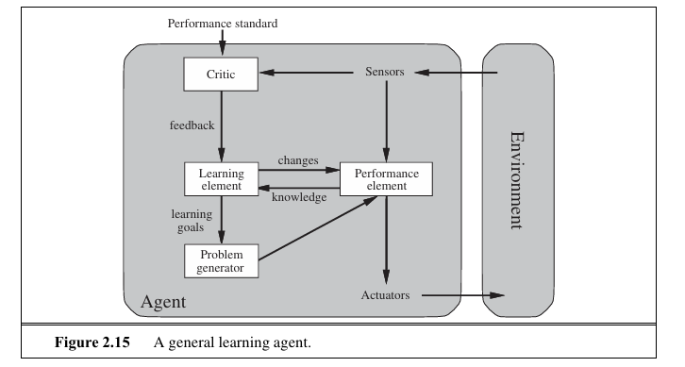Norvig,2016; Russell&Norvig,2016).

**Figure 2.1** shows a general learning agent. The agent senses the environment and takes actions, while a learning part updates its behaviour using feedback so that it performs better over time (Russell & Norvig, 2016).

In this field, reinforcement learning (RL) is remembered as a powerful model focused on goal directed adaptation, in this approach, an agent gradually learns the best possible policy by interacting with its environment and maximizing a numerical reward over time (Paul, 2022; Sutton & Barto, 2018, as cited in Zhang et al., 2025). This learning framework is formally represented as a Markov Decision Process (MDP), which acts by states, actions, and rewards (Bouktif et al., 2023; Cao et al., 2024; Kővári et al., 2022).Deep reinforcement learning (DRL) builds on this idea by using deep neural networks (DNNs) to interpret complex and high-dimensional state-action spaces inherent in large-scale control problems, overcoming the common limitations found in reinforcement learning (Cao et al., 2024; Kővári et al., 2022).

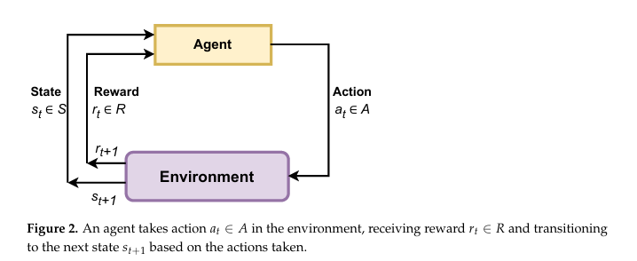

**Figure 2.2:** (Basic Agent-Environment Interaction in RL). The basic agent-environment interaction in reinforcement learning, showing the agent taking an action (A t) in the environment and receiving a reward (R t+1) and next state (S t+1 ) (Mamond et al., 2025).

In history, traffic control was based on static Fixed-Time Control (FTSC) or rule-based Actuated Control (AC) systems (Shen et al., 2023; Yang, 2024). It is used widely, these systems are inherently rigid and lack the predictive capability needed to handle the fast-changing and unpredictable nature of urban traffic flows (Baeva et al., 2025; Chen & Wu, 2025; Xu, 2025). Because of these limitations, there is a clear need for more advanced Adaptive Traffic Signal Control (ATSC) systems that can learn continuously and self-learning and real time effectiveness to reduce congestion and delays (Paul, 2022; Sreejith et al., 2024).

## 2.4 Deep Reinforcement Learning for Adaptive Traffic Signal Control

Deep reinforcement learning (DRL) has introduced how traffic signal control (TSC) and vehicle routing problems are approached (Garg et al., 2023; Kővári et al., 2022; Paul et al., 2022; Zhang et al., 2025). DRL gives a flexible framework for handling complex, sequential decisions by allowing it to learn from continuous interaction with real or simulated traffic environments and by earning more rewards as it learns (Kővári et al., 2022; Paul et al., 2022; Yang, 2024). Unlike supervised learning, RL agents generate their own training data through online interaction (Kővári et al., 2022; Sutton & Barto, 2018).

In the DRL framework formalizes the interaction as a Markov Decision Process (MDP) which known by the components of states, actions, and rewards, and aim for the learning agent it represents an intersection or a vehicle, and it is best effective policy for decision-making (Kővári et al., 2022; Sutton & Barto, 2018; Paul et al., 2022). DRL complexing deep neural networks (DNNs) as a approximate complex functions to enabling the system to handle high-dimensional state and action spaces, this will help to overcome the combinatorial challenges that traditional reinforcement learning faces when applied to Adaptive Traffic Signal Control (ATSC) (Paul et al., 2022; Arulkumaran et al., 2017, as cited in Yang, 2024).

## 2.5 DRL Algorithms and Enhancements

#### Many wide ranges of DRL algorithms are used in traffic control and each suited two different types of decision making challenges:

* **Value-Based Methods:** Value based methods are typically applied when the action space is discrete. In traffic signal control, this often involves selecting from a limited set of choices at each step, such as maintaining the current phase or switching to the next one (Kővári et al., 2022; Yang, 2024). In Deep Q-Network (DQN)-based traffic signal control, each junction is treated as an agent that observes a state made up of features like queue length, waiting time, and current signal phase, and then selects one action from this fixed action set (Bouktif et al., 2023; Jamil et al., 2025; Zhang et al., 2025). The DQN uses a deep neural network to approximate the Q-value of each action, and this network is trained through repeated interaction with a traffic simulator so that actions leading to lower delay, shorter queues, or higher throughput receive higher long-term value (Bouktif et al., 2023; Jamil et al., 2025; Kővári et al., 2022). In this way, the DQN gradually learns signal timing strategies that reduce congestion compared to hand-designed rules or fixed-time plans (Jamil et al., 2025; Zhang et al., 2025).

DQN remains one of the most widely used value-based approaches in this area (Yang, 2024; Mnih et al., 2015, as cited in Zhang et al., 2025), but it can suffer from overestimating Q-values (Yang, 2024; Arel et al., 2010, as cited in Yang, 2024). To address this, improved versions such as the Double Deep Q-Network (DDQN) separate action selection from value estimation, improving stability (Bouktif et al., 2023; Hasselt et al., 2016, as cited in Yang, 2024; Zhang et al., 2025). Further refinements include the Dueling DQN, which separately models state value and action advantage, and D3QN, which combines dueling and double mechanisms to strengthen both stability and performance (Wang et al., 2016, as cited in Yang, 2024; Yang, 2024).

* **Policy-Gradient Methods:** The Policy gradient methods form another important category, especially when managing more complex traffic-control scenarios. Methods such as Advantage Actor-Critic (A2C), Asynchronous Advantage Actor-Critic (A3C), and Deep Deterministic Policy Gradient (DDPG) (Li et al., 2021; Yang, 2024). These methods, along with DDPG variants like Knowledge Sharing Deep Deterministic Policy Gradient (KS-DDPG), are particularly helpful for managing large, network-wide traffic systems (Li et al., 2021; Paul et al., 2022). Policy gradient methods such as A2C, A3C and DDPG are useful when many junctions need to be controlled at the same, for example green times or phase durations (Li et al., 2021; Yang, 2024). In these methods, each junction is treated as an agent, where the actor selects the signal action and the critic finds how good that action is, so the policy can be improved step by step through interaction with the simulator (Li et al., 2021; Yang, 2024). Variants such as KS-DDPG allow different agents to share what they have learned, so junctions do not learn on their own and the whole network can be improved together instead of one junction at a time (Li et al., 2021; Paul et al., 2022).

To make training more stable and efficient, many DRL models use additional mechanisms such as experience replay and target networks (Gao et al., 2017, as cited in Bouktif et al., 2023; Xu, 2025). Specifically, Prioritized Experience Replay (PER) assigns higher priority to important transitions, allowing the agent to learn faster and more effectively (Bouktif et al., 2023; Schaul et al., 2015, as cited in Yang, 2024; Sun et al., 2025).

#### **2.6 Challenges in Defining RL Components**

Organizing the core elements of reinforcement learning (RL), especially the state representation and the reward system is one of the most important and discussing parts of applying DRL to traffic control. These two design choices widely decide how smoothly the algorithm performs in real-world situations (Kővári et al., 2022; Genders & Razavi, 2018, as cited in Bouktif et al., 2023).

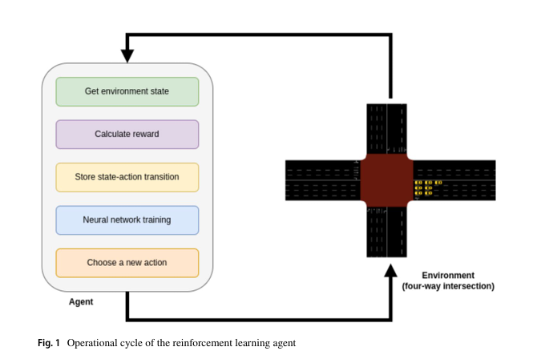

**Figure 2.3:** Operational cycle of the reinforcement learning agent, showing the steps of state acquisition, reward computation, memory storage, network training, and action selection (Jamil et al., 2025).

* **State Space Representation:**State Space Representation have different studies have used a number of state formats, such as pixel-based images, complex traffic State Encoding which is known as discrete Traffic State Encoding (DTSE) for lane by lane descriptions, and vector-based states that include features like queue length, vehicle position, density, and speed (Liu et al., 2022; Genders & Razavi, 2018, as cited in Bouktif et al., 2023 However, representing the traffic state space with the lane as the unit can lead to unnecessary information and the challenging “curse of dimensionality” when training DRL models, because it creates a lot of repeated or low-value information and a high-dimensional input space that requires more data, more memory, and more training time (Liu et al., 2022).
* **Reward Function Design:** In reward function design earlier DRL studies usually concentrated on a single objective, such as reducing delay, waiting time, or queue length (Liu et al., 2022; Genders & Razavi, 2018, as cited in Bouktif et al., 2023). But modern traffic management frequently requires multiple aims like safety, efficiency, fairness, and order, which makes reward design more complicated. Setting accurate weights for these objectives can be personal and difficult because they are repeatedly based on expert judgment rather than measurable criteria (Liu et al., 2022). Another issue is that delay based rewards may react too slowly, because of lag between the action and the feedback. This has motivated researchers to prefer quicker indicators, such as the number of vehicles passing through an intersection (Liu et al., 2022). To overcome these challenges, many studies recommend using simpler, well-structured state definitions and reward functions to improve learning stability and help DRL models converge more reliably (Bouktif et al., 2023).

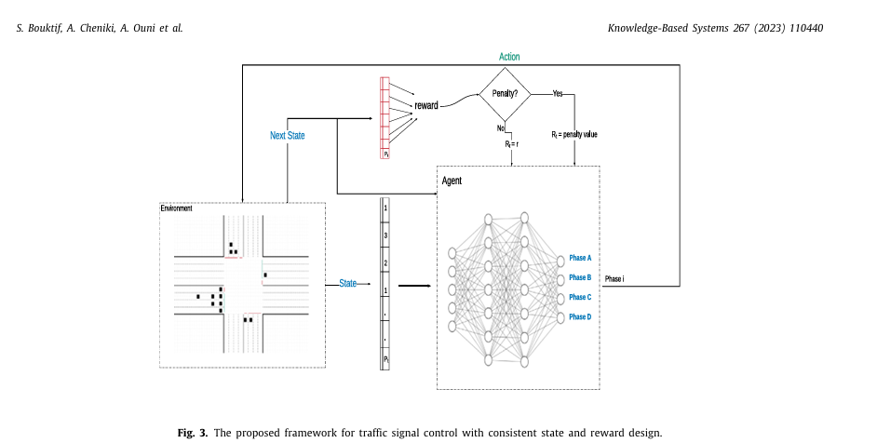

**Figure 2.4:** provides a design diagram for the overall DRL framework and explicitly incorporates a unique reward modification element (the Penalty Process) central to the paper's novel reward scheme (Bouktif et al., 2023).  
 **Advanced Architectures and Collaborative Control**

To manage and optimize traffic flow across large urban networks, multi-agent systems and advanced neural network architectures are necessary (Baeva et al., 2025).

## 2.7 Multi-Agent Reinforcement Learning (MARL)

In a large network, a multi-agent reinforcement learning (MARL) approach is used where each intersection functions as a separate agent (Baeva et al., 2025; Song et al., 2011, as cited in Baeva et al., 2025). The goal of MARL is to coordinate these distributed agents across multiple agents (intersections) to achieve better network-wide traffic flow optimization compared to single-agent approaches (Li et al., 2021; Zhang et al., 2019, as cited in Baeva et al., 2025).

One of the main difficulties with MARL is ensuring that agents can effectively cooperate and share useful information (Kim et al., 2025). Methods like the Knowledge Sharing Deep Deterministic Policy Gradient (KS-DDPG) introduce explicit communication mechanisms to allow each agent access to a collective representation of the environment, significantly improving efficiency of controlling large-scale networks (Li et al., 2021). Another cooperative framework, FLDQN, uses federated learning (FL) to enable knowledge sharing among agents (intelligent vehicles equipped with DQN models) to reduce overall travel time (Kim et al., 2025).

## 2.8 Graph Neural Networks (GNNs)

To handle the complex topology of road networks, Graph Neural Networks (GNNs), such as Graph Convolutional Networks (GCNs), are used (Sun et al., 2025; Yang, 2024; Zhang et al., 2025). GCNs are particularly effective at capturing the spatial and temporal dependencies and complex inter-relations between traffic flow and road conditions, that traditional neural networks often fail to represent well (Sun et al., 2025; Yang, 2024; Chen et al., 2021; Ling et al., 2020, as cited in Yang, 2024). When combined with deep reinforcement learning (DRL), these GNN-based models, often referred to as a hybrid approach (e.g., Bidirectional Adaptive Gated Graph Convolutional Network + DRL), enhance the intelligence and adaptability of traffic signal control systems by enabling more informed decision making based on complex traffic features (Sun et al., 2025).

## 2.9 Multi-Objective Optimization for Sustainability and Safety

Although improving traffic performance, such as reducing delays and waiting times has traditionally been the primary objective in ATSC research (Li et al., 2020; Xu, 2025; Yang, 2024), there is a significant research trend which focuses on integrating broader goals that are important for long term urban development (Yang, 2024; Lin et al., 2024, as cited in Yang, 2024).

* **Decarbonization and Emissions:** Considering the severe air pollution and energy waste caused by idling times and frequent stop-and-go movements, DRL-based ATSC systems are increasingly considering vehicle emissions, particularly carbon emissions, into their optimization goals (Yang, 2024; Chen et al., 2021; Xu, 2025). Dual objective DRL systems (DRL-DG) designed to minimize both travel delay (efficiency) and carbon emissions have shown notable improvements in reducing fuel consumption and toxic air pollution compared to single-objective approaches that prioritize efficiency alone (Yang, 2024). Additionally, modeling public transport operations in simulations has brought more detailed energy consumption metrics offering valuable guidance for policies aimed at fossil fuel dependence and overall emissions (García-Cerrud et al., 2023).

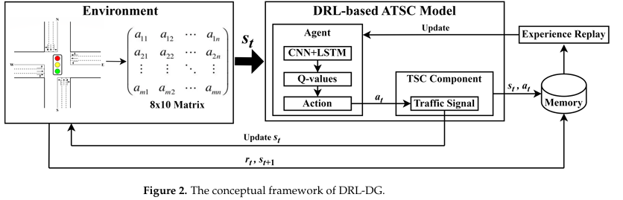

**Figure 2.5:** shows the overall DRL-DG framework for adaptive traffic signal control. The environment (the junction and its lanes) is converted into an $8×10$ matrix state $s_{t}$, which is fed into the DRL-based ATSC model where a CNN–LSTM network estimates Q-values and selects an action for the traffic signal (Zhang et al., 2024). The chosen action updates the signal, the environment returns a new state and reward, and these transitions $\left(s_{t},a_{t}\right)$ are stored in memory for experience replay so that the agent can keep improving its policy over time (Zhang et al., 2024).

* **Safety:** Improving traffic safety by reducing conflicts has become a key element in multi-objective DRL ATSC systems (Yang, 2024; Gong et al., 2020, as cited in Yang, 2024). Research shows that multi-objective DRL approaches, such as those utilizing D3QN to balance safety, efficiency, and emission reduction simultaneously, can achieve meaningful reductions in traffic conflicts while also enhancing waiting times and lowering emissions (Yang, 2024). This is done by adding safety terms straight into the reward function, for example by giving penalties when vehicles get too close or behave in a risky way, while still giving rewards for low delay and low emissions (Yang, 2024; Gong et al., 2020, as cited in Yang, 2024). Over time, the D3QN agent learns signal policies that avoid these safety penalties but still keep traffic efficient and emissions under control (Yang, 2024).

## 2.10 The Essential Role of Simulation and SUMO

Microscopic traffic simulation plays a major role in developing and evaluating intelligent traffic control systems before they are applied in real world settings (Garg et al., 2023; Yang, 2024). The Simulation of Urban MObility (SUMO) is one of the most widely used, open source, microscopic, multi modal simulation tool frequently used in this area (Cao et al., 2024; Garg et al., 2023; Lopez et al., 2018, as cited in Garg et al., 2023; Zhang et al., 2025).

SUMO’s capabilities allow researchers accurate modeling of complex traffic scenarios, including individual vehicle movements, various road network structures, and diverse traffic demands (Cao et al., 2024; Garg et al., 2023; Behrisch & Weber, 2019; Lopez et al., 2018, as cited in Krajzewicz et al., 2012). For DRL-based studies, SUMO is particularly valuable because it provides the large volume of realistic data needed to train models effectively, helping mitigate common concerns around DRL’s sample inefficiency (Zhang et al., 2025; Kővári et al., 2022; Muresan et al., 2021, as cited in Cao et al., 2024).

A major advantage of SUMO is its Traffic Control Interface (TraCI), a Python-based API (Cao et al., 2024; Xu, 2025). TraCI enables external optimization algorithms, such as DRL agents or Differential Evolution (DE) algorithms, to communicate with the simulation which allows dynamic adjustments of signal timings and testing of adaptive control strategies dynamically (Cao et al., 2024; Xu, 2025; Garg et al., 2023). Furthermore, the complex process of building large scale road networks for simulation often relies on public data sources like OpenStreetMap (OSM), which may require innovative preprocessing techniques to convert and simplify the data into a usable SUMO network format (Meng et al., 2022; Xu, 2025).

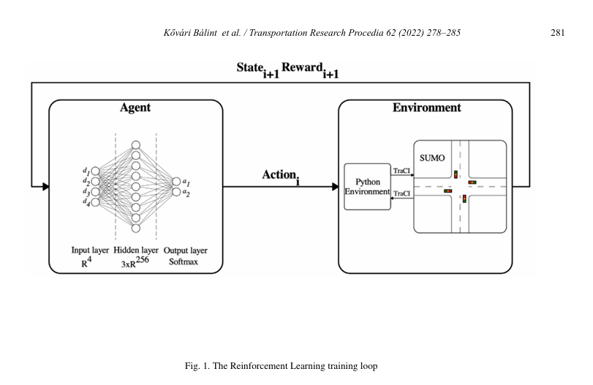

**Figure 2.6:** The Reinforcement Learning training loop, illustrating the essential feedback pathway between the Python training environment, TraCI, and the SUMO simulator (Kővári et al., 2022).

## 2.11 Conclusion:

The literature review clearly shows that deep reinforcement learning (DRL) and AI driven models provide more effective solutions for managing modern urban traffic than traditional fixed or rule based systems. These newer approaches are more suitable to handle the dynamic and unpredictable nature of real traffic flow (Baeva et al., 2025; Chen & Wu, 2025). Current research points to the further multi objective optimization to balance efficiency, where traffic systems are designed not only for efficiency but also for environmental benefits such as decarbonization and for improving overall safety. This involves frequent use of advanced frameworks like multi agent reinforcement learning (MARL), where agents communicate and cooperate between the network (Li et al., 2021; Yang, 2024). The microscopic simulation environment, SUMO, remains necessary. It offers a highly flexible and reliable platform for designing, testing, and validating complex AI algorithms, and its integration with tools like TraCI (Cao et al., 2024; Garg et al., 2023; Zhang et al., 2025). Looking to the future, research is expected to focus on scaling these models to larger networks, improving the stability of DRL architecture, and exploring real world deployment especially in mixed traffic scenarios where different types of vehicles and behaviors are seen (Cao et al., 2024; Li et al., 2021).

# CHAPTER 3: Methodology

## 3.1 Research design and methodological framework

This study used structured methodological framework, evaluate the performance of AI based traffic signal Control system fix time Traffic Signal Control system and Controlled simulation setting using the SUMO Traffic simulation environment which used TraCI. Overall research design is guided by layered logic of the research Onion framework which gives support and clarity by aligning philosophy, approach, strategy, methodological choice, and time horizon to defining procedures (Saunders et al., 2016; Melnikovas, 2018). The methodological choices were driven by the objective of the conducting and evidence best comparison using measurable performance metrics produced from the repetitive simulation (Saunders et al., 2016).

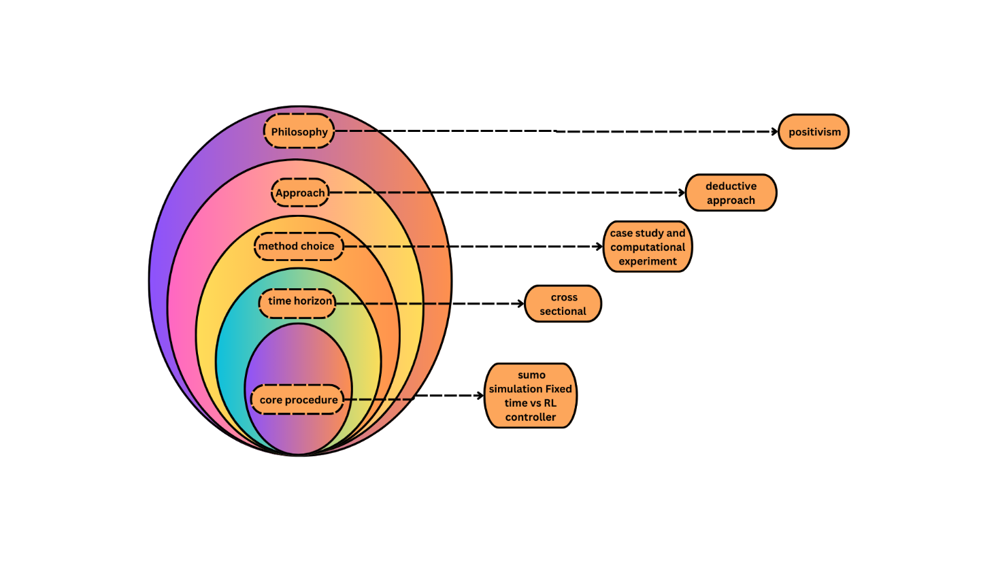

**Figure 3.1:** Research onion diagram illustrating the methodological framework of the study (Inspired by Saunders et al., 2016; Melnikovas, 2018).

### 3.1.1 Research Philosophy:

This research comes under the positivist philosophical position, where valid knowledge is derived from observable and measurable outputs and evaluates objectives using observed data (Saunders et al., 2016; Melnikovas, 2018). This approach suited the study because traffic performance can be calculated using numerical results from the experiments.

### 3.1.2 Research Approach:

In this study deductive research approach was used, consistent with the selected philosophy. A deductive approach supports the testing of expectation through structured observation and analysis instead of theory generation (Saunders et al., 2016). In this, expectations regarding performance between fixed time traffic control system and adaptive learning-based traffic control system were examined and tested through comparable simulation experiments using predefined quantitative metrics.

### 3.1.3 Research Strategy:

The research strategy combines a case study with computational experiments. The case study only focused on Sheffield city centre subnetwork, which is selected for its local relevance and the availability of suitable network and traffic inputs, and limited area for controlled simulation testing. In the research onion, both case study and experiment are recognized strategies where the aim is doing systematic comparison under defined conditions (Saunders et al., 2016). The computational experiment involved running simulations while keeping the network structure and traffic demand fixed and only changed the controller to compare results.

### 3.1.4 Methodological Choice:

A mono method quantitative approach was used because the evaluation depends on numerical metrics and structure comparison across experimental conditions (Saunders et al., 2016). Sumo simulation supported experimental control and consistent data collection as well as repeatable execution of the scenarios under the identical settings.

### 3.1.5 Time Horizon:

The study used a cross sectional time horizon. Cross sectional research is categorized by analysis time frame rather than repeated observations (Saunders et al., 2016). In this study Cross sectional refers to fixed simulation episodes that used to compare under the Consistent Conditions rather than real world longitudinal traffic data.

### 3.1.6 Summary Table

|  |  |  |  |
| --- | --- | --- | --- |
| **Research onion layer** | **Choice in this study** | **What it means in this project** | **How it supports the study objectives** |
| **Philosophy** | **Positivism** | Knowledge is based on measurable, observable results from simulation outputs (e.g., waiting time, queue length, throughput). | Supports Objective 5-6 by enabling an evidence-based evaluation using quantitative metrics and a fair comparison between controllers. |
| **Approach** | **Deductive** | Tests an expected outcome: AI control should outperform fixed-time control under the same conditions. | Supports Objective 4-6 by testing performance differences through structured experiments and measurable outcomes. |
| **Strategy** | **Case study + computational testing** | Sheffield city-centre subnetwork is the case, while simulation runs are the experiments (controller is the only variable changed). | Supports Objective 2-4 by focusing the evaluation on a realistic Sheffield network and enabling controlled baseline vs AI testing. |
| **Methodological choice** | **Mono-method quantitative (simulation based)** | Uses SUMO/TraCI to produce numeric outputs; results are analysed using quantitative metrics and plots/dashboard. | Supports Objective 5-7 by generating consistent metrics and enabling clear performance reporting and dashboard visualisation. |
| **Time horizon** | **Cross-sectional** | Evaluation is based on fixed simulation episodes (same network and demand), not long term real world monitoring. | Supports Objective 6 by ensuring both controllers are tested under identical conditions for a direct comparison within the project scope. |

**Table 3.1:** Summary of Research Design Choices and Alignment with Study Objectives.

### 3.1.7 Research Plan Workflow Diagram

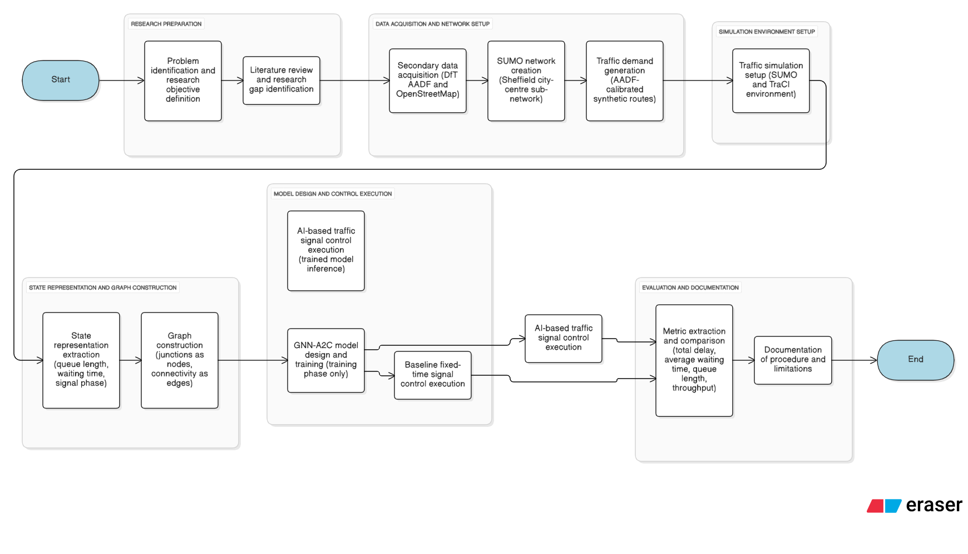

**Figure 3.2:** Research Plan Workflow Diagram.

## 3.2 System Architecture Overview

The system architecture is organized as a modular pipeline consisting data preparation simulation control learning and evaluation components all components operate on the same Sheffield City network implemented with the SUMO simulation environment to ensure the consistency across baseline and reinforcement learning experiments. (Krajzewicz et al., 2012). The traffic demand hand and network data are prepared using the UK Department for Transport which is annual average daily flow records and OpenStreetMap for road network extraction process. These data sources are filtered and processed to generate SUMO simulation compatible network and route configuration files which can be reused across all simulation runs and ensure experimental reproducibility. The Sumo Simulation environment is controlled through TraCI interface (German Aerospace Center [DLR], n.d.). to signal control Saturdays arrival which is a fixed time baseline controller and adaptive reinforcement learning controller but controller operates under the network and demand conditions allowing direct and fair performance comparison. simulation outputs are recorded and processed to extract quantitative performance metrics such as average delay queue length and vehicle throughout vehicle Processed By fix time controller and AI controller. These metrics visualize through plots and interact with the dashboard to support comparative analysis of controller performance under the same safe fields traffic conditions (Garg et al., 2023). The following diagram shows the actual system architect.

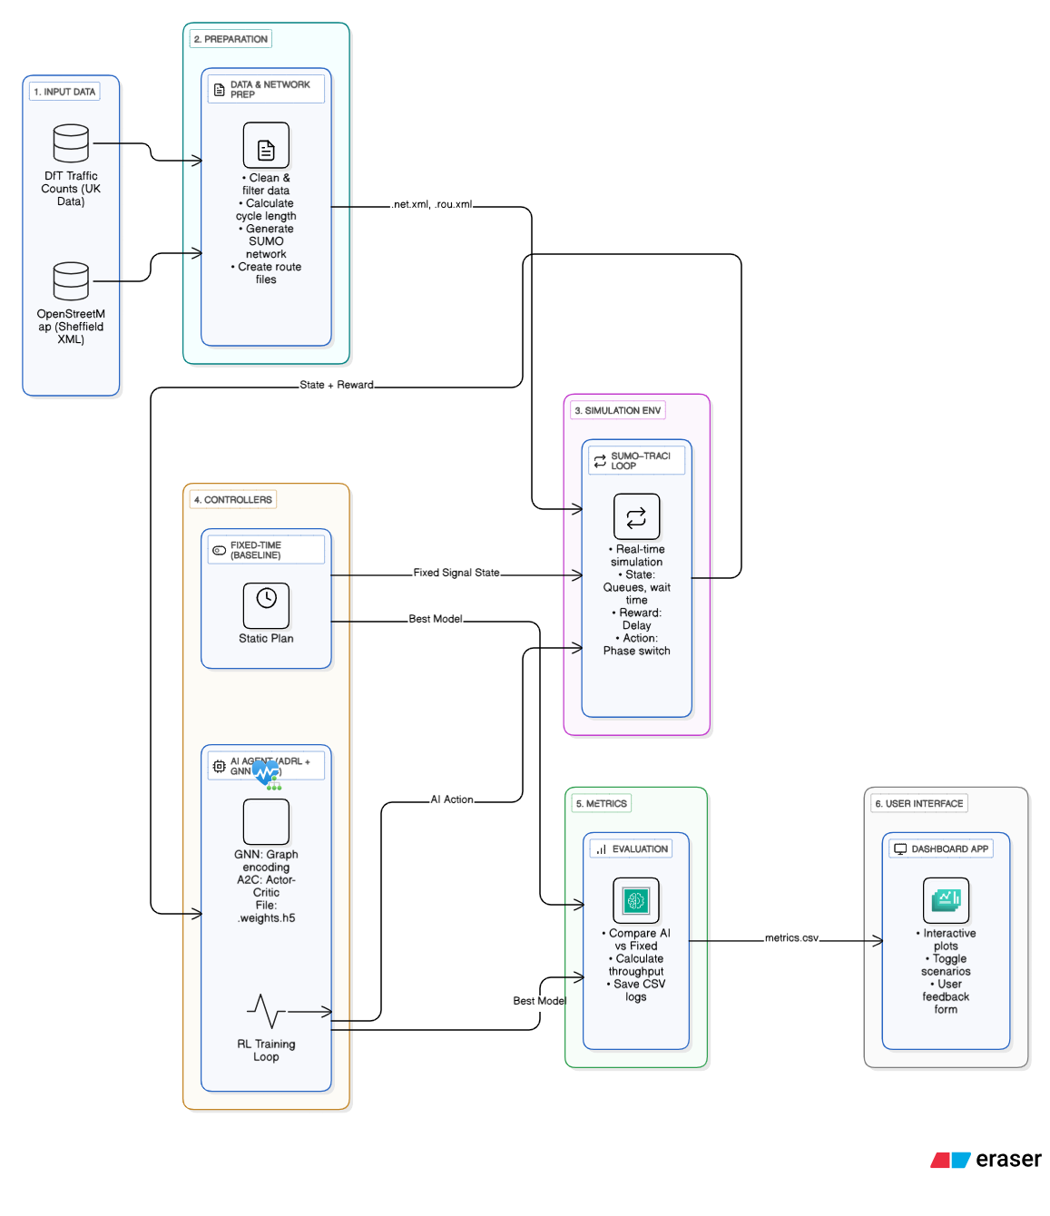

**Figure 3.3:** System Architecture Flow Chart.

## 3.3 Dataset

In this project, the **Average Annual Daily Flow (AADF)** dataset from the UK Department for Transport is used to derive traffic demand. This dataset provides stable annual traffic counts at national scale and is widely used for modelling realistic road network flows (Garg et al., 2023; Wang et al., 2025). The AADF dataset covering **years 2000-2024** and includes **578,217** records covering class-level vehicle counts, geographic information, and road attributes. The dataset was obtained from the official DfT Data Portal: *(DfT) Average Annual Daily Flow (AADF) dataset*.:[(DfT) Average Annual Daily Flow (AADF) dataset](https://storage.googleapis.com/dft-statistics/road-traffic/downloads/data-gov-uk/dft_traffic_counts_aadf.zip) *(Department for Transport [DfT], n.d.).*

The data set is licensed under the Open Government license (OGL v3.0), which permits copying, publishing and distributing Adapting the data for both commercial and no commercial purpose. This makes the data set fully useful for academic simulation, reinforcement learning experiments and reproducible workflows. The complete content is available at: Open

Furthermore, several Department for Transport Data Sets were listed in the ethics materials and only the primary average annual daily flow data set was used because it already provides stable counts suitable for degenerating the traffic demand in the Sheffield City centre area.

A preview of the raw AADF dataset is shown in **Figure 3.4(A)** and **Figure 3.4(B)**, which illustrate its structure prior to processing, including columns for *count_point_id*, *local_authority_name*, road type, vehicle class counts, and coordinates.

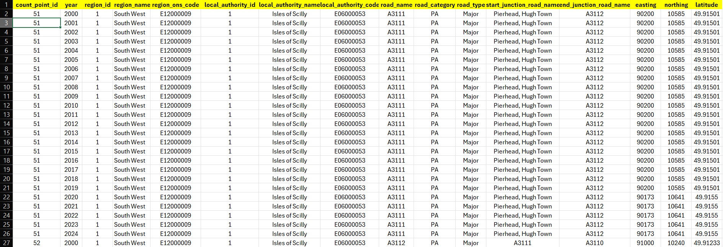

**Fig 3.4(A):** Raw AADF dataset sample (UK-wide, before filtering).

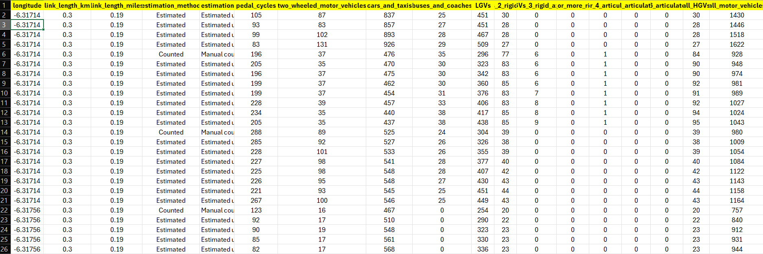

**Figure 3.4(B)**: Raw AADF dataset sample (UK wide, before filtering).

The data set was then filtered Two counts belong specifically Sheffield, using the local authority code which is “E08000019” to avoid accidentally losing valid records. Standard daily includes removing gross with the missing or invalid numerical values and narrowing the subset to major roads relevant to the traffic condition around the city center (Meng et al., 2022; Xu, 2025). A view of the process of cleaning Sheffield data It's shown in Figure 3.3(C) that clean Sheffield data is used for SUMO simulation.

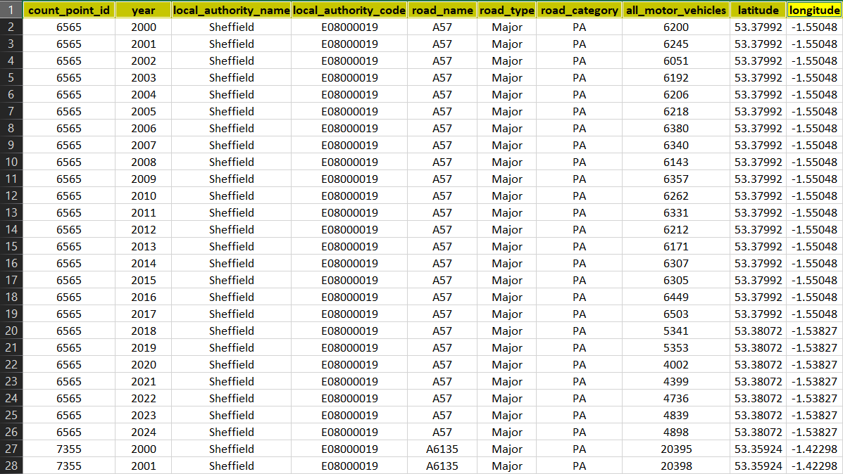

**Figure 3.5**: Cleaned Sheffield datasets.

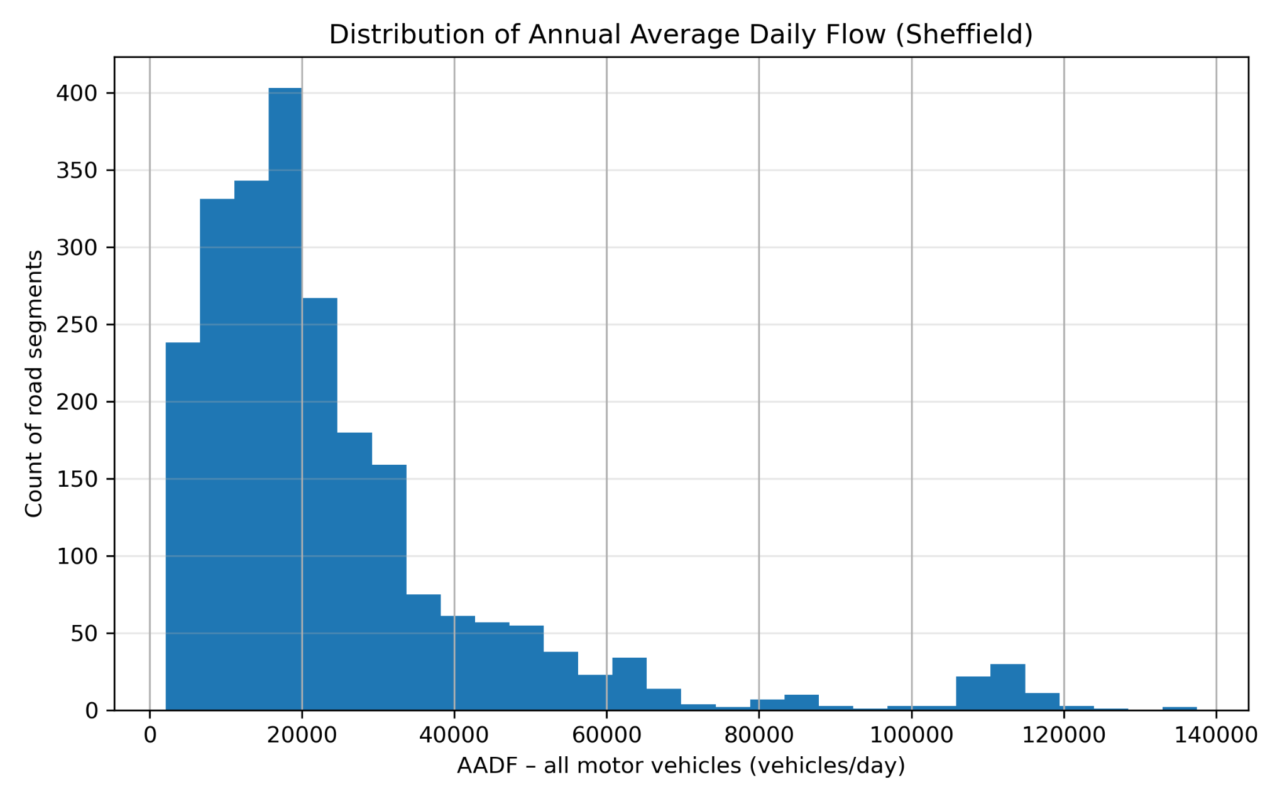The DFT AADF data set is fully quantitative, and the exploratory analysis also follows a quantitative approach. A Histogram of average annual daily flow values in Figure 3.6 was generated to understand distribution of daily flows. Most values cluster within urban ranges that indicate the data set is suitable for producing realistic demand for a sumo simulation (Garg et al., 2023).

**Figure 3.6:** Distribution of AADF values for Sheffield Road segments (vehicles/day).

It is shows that most Sheffield roads carry about 5,000 - 30,000 vehicles per day, and only a few roads carry more than 60,000 vehicles per day. This fits what we expect in a city: many roads with moderate traffic and only a small number of very busy main roads.

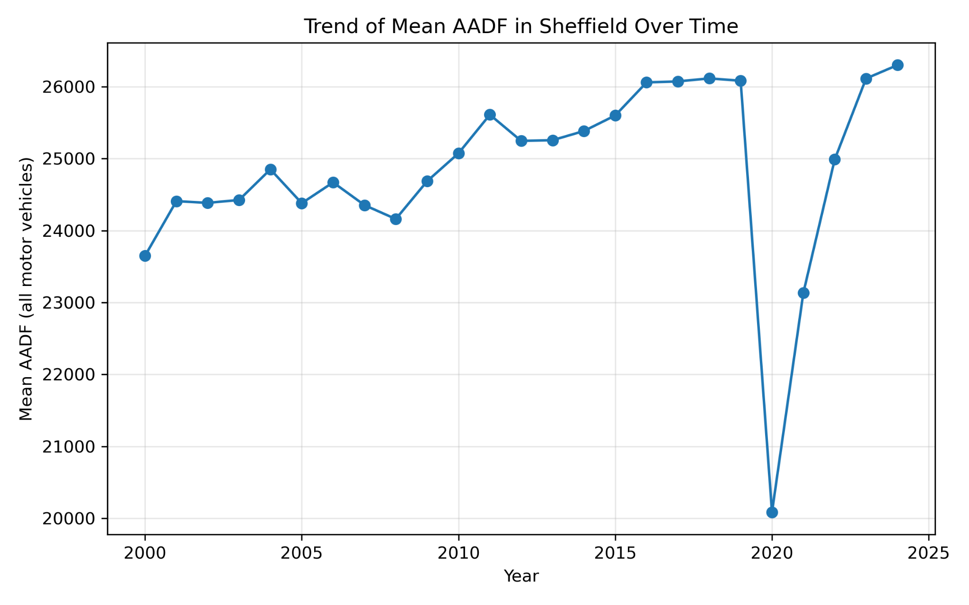

**Figure 3.7:**  shows the trend of mean AADF for all motor vehicles in Sheffield across the available years. The overall pattern is relatively stable with a gradual increase over time.

The AADF dataset also provides vehicle class counts, allowing construction of a realistic multi model traffic mix sumo simulation. average flows for cars LGVs, HGVs, buses, motorcycles and cycles were calculated for Sheffield and visualized in **Figure 3.8** (Meng et al., 2022; Angelina et al., 2024). However, for simplicity in the study the all_motor_vehicles column was used to generate a single aggregated traffic realistic 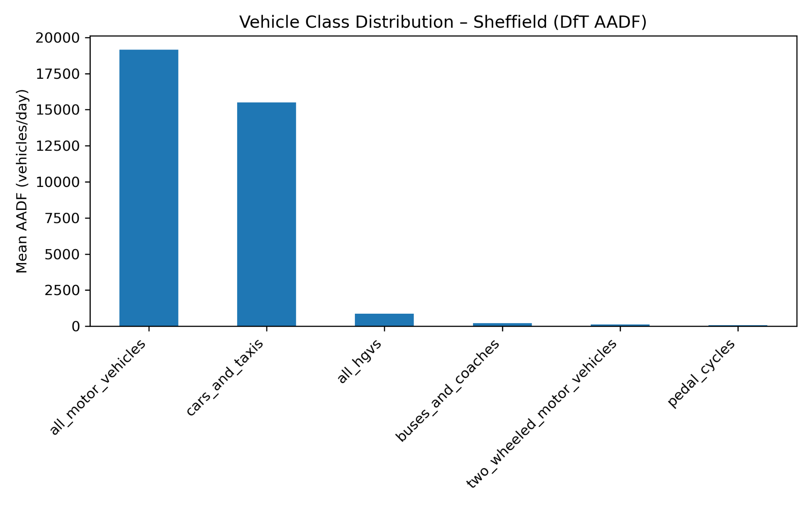demand for sumo routes.

**Figure 3.8:** Vehicle Class Distribution in Sheffield Based on AADF (Including All Motor Vehicles)

This study used the DFT AADF dataset, which is properly licensed, accurately filtered, and quantitatively analysed, and it provides a suitable input for generating traffic demand for both baseline and reinforcement learning experiments.

### 3.3.1 Network Preparation

The traffic network used in this project was constructed with an open Street map, which contents the “.osm” file (German Aerospace Center [DLR], n.d.), to create a realistic but computationally manageable Sheffield city centre sub network. The selected area captures several key junctions including all signal lights intersections controlled by the baseline and AI agents.

OSM geometry was converted into a sumo simulation, which is a compatible network using net convert tool, because so much simulation cannot read the “. OSM” file. following official SUMO documentation to ensure the correct ratio, turning Connexion and UK left hand driving (Behrisch & Weber, 2019). in the result were my_network_file.net.xml file it is displayed in figure 3.9 The workflow is shown below.

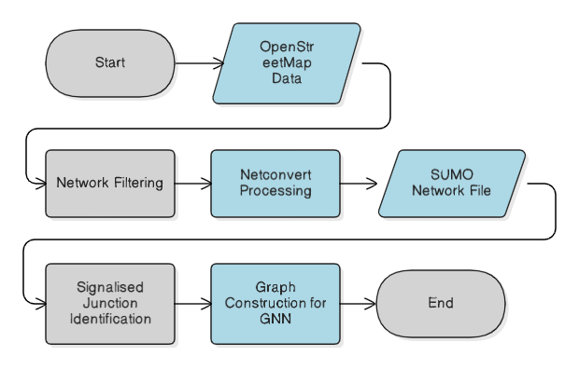**Figure 3.9:** Network preparation workflow from OpenStreetMap extraction to SUMO network generation and graph construction for the GNN-based controller.

To support the decentralised ADDRL + GNN controller, all signalised intersections were represented as graph nodes, with road connectivity between neighbouring intersections modelled as edges. This graph abstraction enables each junction to incorporate information from its neighbouring intersections during decision making (Chen et al., 2021; Sun & Liu, 2025).

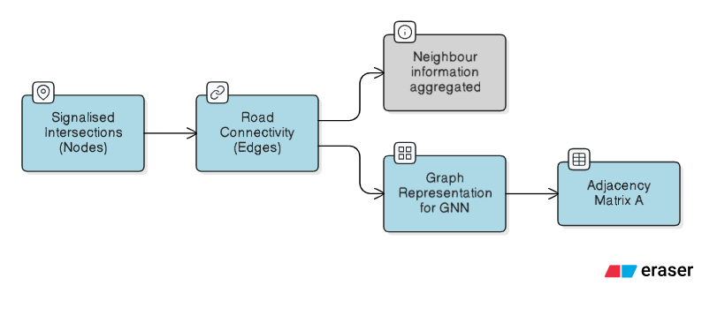

**Figure 3.10**: graph representation of the traffic network used by the GNN, where signalised junctions are modelled as nodes and connectivity between neighbouring junctions is modelled as edges.

### 3.3.2 Network statistics (SUMO network used in this study):

|  |  |
| --- | --- |
| **Network items** | **Value** |
| Total junctions | 94 |
| Real junctions | 89 |
| Signalised junctions (traffic lights / TLS) | **7** |
| Total edges | 285 |
| Real edges | **133** |
| Real lanes | **162** |

**Table 3.2:**  network statistics table.

### 3.3.3 Graph adjacency matrix construction (node + edge definition):

The adjacency matrix 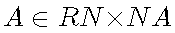was constructed where N is the number of signalised junctions (TLS nodes).

**Node definition:** each node corresponds to one SUMO traffic light ID.

**Edge definition:** In implementation, this was obtained using TraCI controlled links: for each TLS, outgoing lanes were checked against the lane sets controlled by other TLS. If a match exists, the TLS pair is treated as neighbours and the adjacency matrix is updated as

and .

This produces a binary adjacency matrix that captures inter intersection road connectivity, enabling the GNN to propagate information across neighbouring junctions during policy inference.

## 3.4 Traffic Demand Generation

To ensure that the sumo simulation reflects realistic traffic demand for the Sheffield Study area, the demand level was calibrated using data from the UK Department for Transport is known as DFT annual average daily flow AADF data set. After filtering the data set includes only records belonging to Sheffield and the highest recorded value of *all_motor_vehicles* was found. This value presents the busiest counted road segment in the region and provides an upper bound Indicator of traffic weight.

### 3.4.1 Deriving Peak-Hour Demand

Average Annual Daily flow data provides the average number of vehicles passing through location over a full 24 hours period. To estimate peak hour, flow The Study adopts a mostly used assumption in transport modelling that approximately 10% of the traffic occurs during busiest hours of the day (Garg et al., 2023; Zhang et al., 2024). Thus, if **AADFmax**​ is the maximum daily flow:

$Period = 3600 / Q_peak$

$Q_peak = 0.10 × AADF_max$

This peak hour flow is converted into equivalent arrival rate expressed as the vehicle generation period

Period **= $\frac{3600}{(0.10 × AADF_max)}$**

where 3600 is the number of seconds in an hour and $Q_peak$ is the estimated peak hour volume. For the Sheffield data set used in this project, this calculation produces a period approximately 0.26 seconds per vehicle. This provides a simple but transparent way to link average annual daily flow values to demand parameters and that required by sumo route generation process (Behrisch & Weber, 2019).

### 3.4.2 Generating AADF Calibrated Synthetic Routes

This derived peak flow is huge once to calibrate the traffic demand for the simulation’s simulation route generation procedure which is in “randomTrips.py” clarify the period as a mean inter arrival time when creating randomized origin Destination (OD) trips across the network (Behrisch & Weber, 2019; Flötteröd & Wagner, 2025). The OD patterns produced by “randomTrips.py” are synthetic rather than reconstructed from OPS of origin destination, overall traffic volume is grounded in average annual daily flow observations, ensuring that the simulated flow level goes under realistic range for the Sheffield network (Garg et al., 2023; Meng et al., 2022).

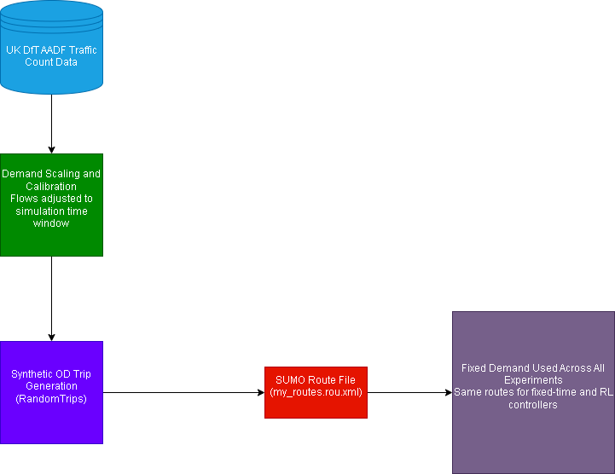

**Figure 3.11:** Data lineage showing how UK AADF traffic counts are calibrated and transformed into fixed synthetic route demand, ensuring consistent and reproducible traffic conditions across all simulation experiments.

In the result route file my_routes.rou.xml therefore satisfies the requirement first one it provides average annual daily flow scale demand ensuring that the total flow intensity is consistent with the expected for a busy urban area in Sheffield. Second it offers experimental reproducibility as the same generated roads are reused across all experiments so both the fixed time baseline and RL best controller experience identical demand conditions (Li et al., 2021; Bouktif et al., 2023).

This design choice supports fair comparison between fix time base controller and AI controller while keeping the simulation trackable and reproducible which is appropriate for evaluating adaptive signal control strategies in sumo environment (Garg et al., 2023; Li et al., 2021; Zhang et al., 2024).

## 3.5 Baseline Fixed Time Controller

A fixed time traffic signal was implemented as the baseline condition for this project. In this approach each signal at a junction operates using a predefined sequence of signal phases with static grain durations that remains unchanged regardless of real traffic time conditions. This control logic reflects conventional non adaptive traffic signal operation was implemented directly using TSUMO simulation built in traffic light programmed Across the shifted city Centre subnetwork (Krajzewicz et al., 2012).

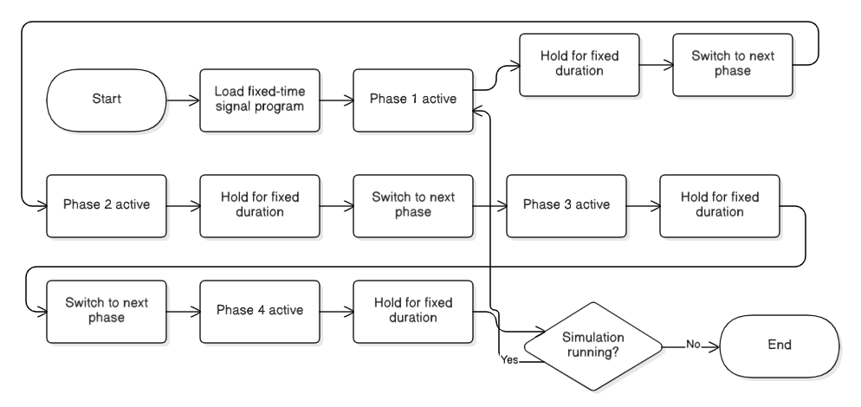The baseline signal controller provides a reference benchmark against reinforcement learning to keep comparison fair. Both fixed time and artificial intelligence controllers run on the same SUMO network, same traffic demand and the same route file so any performance difference comes from control method only (Xiao et al., 2025).

**Figure 3.12:** Fixed Time Phase Logic Diagram.

## 3.6 Reinforcement Learning Controller (ADDRL + GNN + A2C)

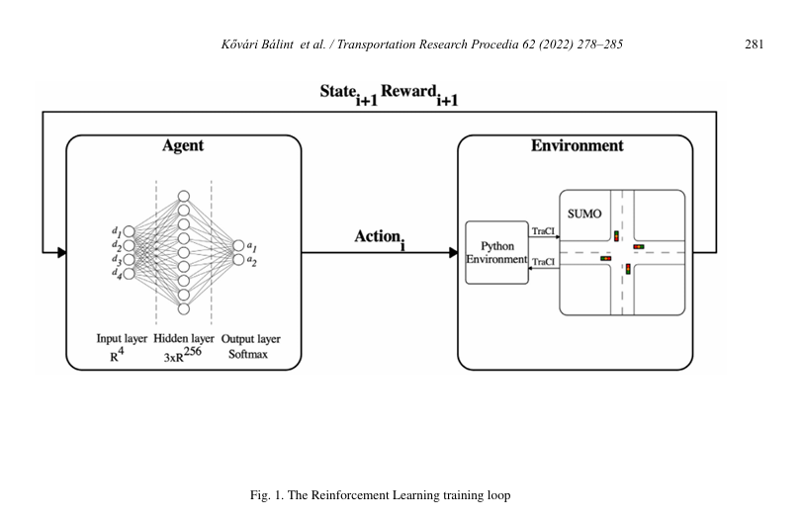The Reinforcement learning traffic signal implemented in this study was designed as an adaptive deep reinforcement learning system (ADDRL) that integrates graph neural networks (GNN) with the Actor critic algorithm (A2C). The controller operates through the Sumo simulation traffic environment and connected simulation through Traci interface, using real time observations traffic States and application of the signal control access during simulation runtime (Behrisch et al., 2011; Krajzewicz et al., 2012). The learning framework followed centralized training with a shared policy, while signal control decisions were applied at the level of individual intersections during execution.

**Figure 3.13:** The reinforcement learning training loop (Kővári et al., 2022, *Deep reinforcement learning based approach for traffic signal control*)

Figure 3.6 shows the standard agent environment interaction loop used in this study, where the RL agent selects signal actions, these actions are applied to SUMO via TraCI, and the simulator returns the next state and reward for learning (Kővári et al., 2022).

### 3.6.2 State Representation

The state representation was constructed using measurable traffic features extracted directly from the SUMO simulation. For each signal at a junction the state vector includes queue length, waiting time and current signal phase. The features are commonly used in reinforcement learning based traffic signal control systems because they provide direct representation of traffic level and control status at intersections (Wei et al., 2019; Kővári et al., 2022). Because different intersections have different numbers of lanes the state vectors were padded to the same size before Bing combined for the craft neural network.

The state representation is constructed from lane level traffic features extracted from SUMO at each simulation step. For each traffic light system (TLS), the raw state vector is:



### 3.6.3 Action Space and Control Logic

The action space was defined as a discrete set of signal control decisions. For each junction the agent selected either to maintain the current single phase to switch the current phase to the next predefined phase. The minimal Breakdown Action formulation is widely used in traffic signal control studies to balance learning stability (Wei et al., 2019). Actions were applied synchronously at each time step through the TraCI interface, while their effects were evaluated collectively at each network level true shared reward signal.

**Action 0:** keep current phase.

**Action 1:** switch to the next phase in the predefined program.

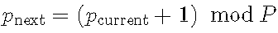Switching advances cyclically through the predefined phases (modulo the number of phases).

### 3.6.4 Reward Function

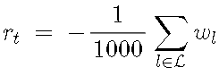A global reward formula was used to encourage cooperative behaviour across the traffic network. At each simulation timestamp the reward was defined as the negative of the total accumulated waiting time across all controller lanes:

Where $Wl$ known as the calculated waiting time on leane $l$. This formulation aligns the learning objective with a widely used traffic efficiency indicator and supports the network level optimization by punishing overall traffic instead of localized delay (Wei et al., 2019; Bouktif et al., 2023).

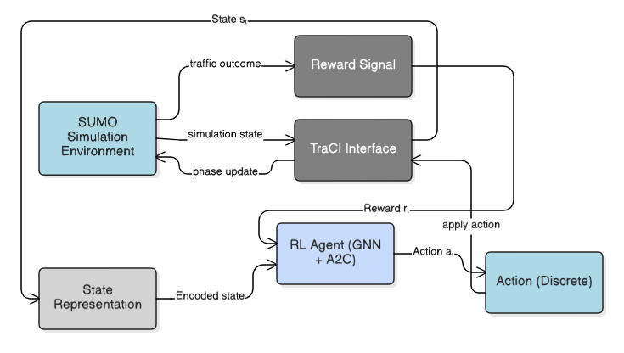**Figure 3.14**: High level reinforcement learning control loop illustrating the interaction between the RL agent, the SUMO simulation environment, and the TraCI interface during state observation, action execution, and reward feedback.

### 3.6.5 GNN Based Actor Critic Architecture

The policy and value functions were implemented using shared graph neural network-based actor critic architecture. junction state vectors were first transformed into nodes enabling through connected layers. neighbourhood Information Watch collected using an adjacency matrix derived from the network connectivity, allowing each junction to incorporate information from adjacent intersections. Using a graph that helps the model understand how nearby intersections affect each other, an actor gives an action for each junction and the critic estimates one overall value for the whole network (Li et al., 2021; Chen et al., 2021).

**Model configuration used in the code:**

* **Hidden dimension:** 64
* **GNN layers:** 1 message passing aggregation (adjacency MATRIX)
* **Node embedding:** Dense (ReLU)
* **Post GNN transform:** Dense (ReLU) on concatenated h, hneigh.

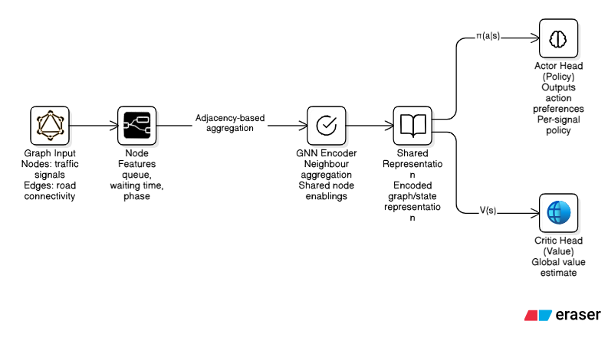**Figure 3.15:** High level GNN based actor critic architecture showing shared graph representations and separate actor and critic heads used for traffic signal control.

### 3.6.6 Learning Algorithm and Training Strategy

The Reinforcement learning controller was trained using the Actor critic (A2C) learning algorithm, in that policy and value function parameters were updated stepwise during interaction with the SUMO simulation environment instead of batch updates *(Mnih et al., 2016; Sutton & Barto, 2018)*.

At each simulation time step $t$, the actor produces an asemantic policy over the district action by applying a softmax function through the policy logits:

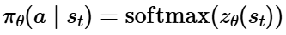

(Sutton & Barto, 2018).

the critic estimated the state value $V(st​)$, and OH-1 step temporal difference (TD)

target was completed as:

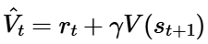

(Sutton, 1988; Sutton & Barto, 2018).

**The advantage function was then calculated as:**

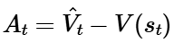

(Mnih et al., 2016; Sutton & Barto, 2018).

* **Actor loss:**

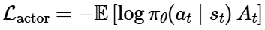

(Williams, 1992; Sutton & Barto, 2018).

* **The critic minimises square TD error (CRITIC LOSS):**

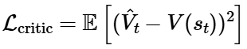

* **Entropy term:**

(Mnih et al., 2016).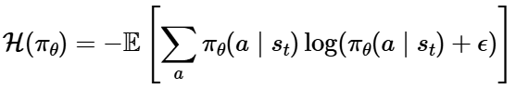

In implementation entropy watch competitor as a mean across the actions and intersections and its effect was controlled by the entropy coefficient $β$.

* **Total loss**:

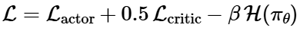

parameter updates use the Adam optimizer (Kingma & Ba, 2015), with gradient clipping applied to stabilise training (Pascanu et al., 2013).

The training was conducted over repeated and fixed network and average annual daily flow (AADF) computes traffic demand. After training the model parameters were kept unchanged during evaluation and reuse unchanged parameters during evaluation. During evaluation runs action were selected deterministically using greedy (argmax) selection to access interface time performance without exploring noise.

### 3.6.7 Hyperparameter and training configuration:

|  |  |
| --- | --- |
| **Item** | **Value used** |
| Algorithm | A2C (online updates, no replay buffer) |
| Optimizer | Adam |
| Learning rate | **5e-6** |
| Discount factor ((\gamma)) | **0.99** |
| Entropy coefficient | **1e-3** |
| Gradient clipping | Global norm **0.5** |
| Training episodes | **50** |
| Max steps per training episode | **900** |
| Evaluation episode length | **3600** steps |
| Hidden dimension | **64** |
| Actions per node | **2** (keep / switch) |
| Reward scaling | ({total waiting time}/1000) |
| Model selection rule | Save weights when episode return improves (**best return**) |
| Saved model file | gnn_a2c_best. weights.h5 |

**Table 3.3:** Hyperparameter and training configuration (implementation values).

### 3.6.8 Training Settings (GNN–A2C Controller):

| **Category** | **Setting** | **Value / Description** |
| --- | --- | --- |
| **Environment** | Simulator | SUMO (controlled via TraCI) |
|  | Network | Sheffield city centre subnetwork (SUMO .net.xml) |
|  | Demand | Fixed route file reused across runs (.rou.xml) |
|  | Episode length (training) | 900 simulation steps |
|  | Episode length (evaluation) | 3600 simulation steps |
| **Agent / Model** | RL algorithm | Advantage Actor-Critic (A2C) |
|  | Graph component | GNN message passing using adjacency matrix |
|  | Hidden size | 64 |
|  | Actions | 2 actions per TLS (keep phase / switch phase) |
|  | Policy output | Per-node action logits (softmax) |
|  | Critic output | Single global state value (network-level) |
| **State / Reward** | State features | Queue length + waiting time + current phase |
|  | Padding | Applied so all intersections share the same input size |
|  | Reward | Global reward based on total waiting time (scaled) |
| **Optimisation** | Optimizer | Adam |
|  | Learning rate | 5e-6 |
|  | Discount factor ((\gamma)) | 0.99 |
|  | Entropy coefficient | 1e-3 |
|  | Gradient clipping | Global norm = 0.5 |
| **Training Procedure** | Training episodes | 50 |
|  | Exploration (training) | Stochastic sampling from policy distribution |
|  | Action selection (evaluation) | Greedy argmax (deterministic) |
|  | Model checkpointing | Save best weights by highest episode return |
|  | Saved model | gnn_a2c_best. weights.h5 |

**TABLE 3.4:** Training Settings Summary (GNN-A2C Controller)

### 3.6.9 Software and compute environment:

* **Software:** Python + TensorFlow (Keras), SUMO accessed via TraCI(Python Software Foundation, n.d.).
* **Versions:** SUMO (1.25.0), TensorFlow: 2.20.0, Keras (tf.keras): 3.12.0, PYTHON (3.12) *(TensorFlow, n.d.) (Keras team, n.d.).*
* **System configuration:** 16 gigabyte ram,144 Hertz refresh rate, 516SSD, 4 GB RTX 3050.

## 3.8 Ethical Considerations

This study was conducted according to the Sheffield Hallam University research ethics guidelines and was reviewed under the UREC2 low risk process. The core research was simulation based and involved no human subject or personal data is used. In addition, a low risk user evaluation questionnaire was conducted to collect general participation of AI based traffic signal control. Participation is voluntary and responses are anonymous. All experiments were performed with the SUMO simulation environment using UK Department for Transport average annual daily flow data and Open Street Map Network is used to construct a network of Sheffield city centre sub network. The reinforcement learning controller was trained and evaluated only in simulation.

## 3.9 Validity, Reliability, and Limitations

Validity what's supported by maintaining network configuration and traffic demand across all experiments, ensuring that observations only apply to the control strategy. Reliability was filtered through repeatable simulation runs using fixed random seeds and consistent evaluation metrics. Use of a well structured simulation platform which is SUMO simulation. This study is limited by its reliance on simulation traffic conditions and synthetic demand, which may not fully capture real world driver behaviour. Findings are limited to simulation-based evaluation and do not represent real world deployment.

# CHAPTER 4: Simulation Evaluation and Experimental Results

In this study, chapter 4 shows the simulation based evaluation of the traffic signal control system is developed. The performance of the GNN - A2C reinforcement learning controller is evaluated and compared against fixed time traffic signals using the SUMO simulation environment. For doing fair comparison of the fixed time traffic signal system and AI based traffic signals and tested under the same network, same traffic demand conditions. Evaluation is carried out using quantitative traffic performance metrics that includes waiting time queue length throughput and the reward trends. The dashboard is used to visualise global and intersection level results that support transparent and structured analysis of system performance.

## 4.1 Experimental Setup

The experimental evaluation was conducted using a Completed and configured SUMO simulation environment that represents a Sheffield city centre road network known as **Saint Mary's Road.** This experimental setup section focuses on the final evaluation results. The experimental setup ensures both traffic signal control strategies are evaluated under identical and controlled conditions so that the observed performance differences are 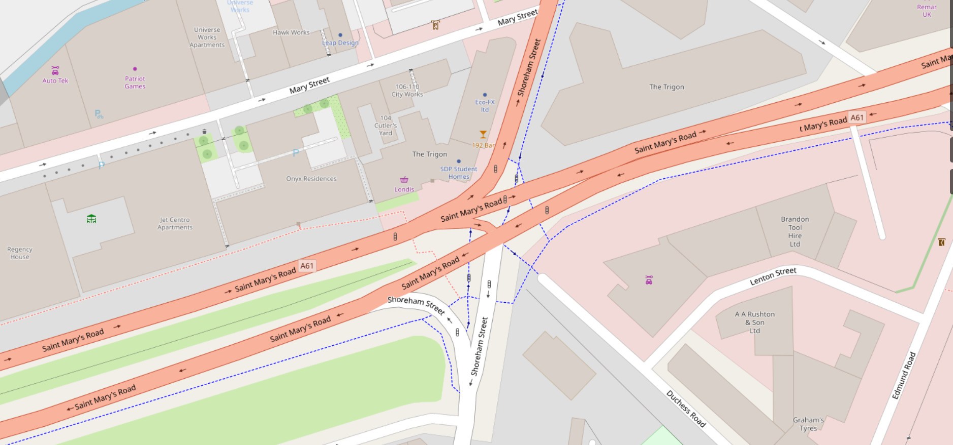simply allocated to the control approach.

**Figure 4.1:** OpenStreetMap view of the Sheffield city-centre junction used as the basis for the SUMO evaluation network (St Mary Rd, shoreham st).

The evaluation environment consists of a fixed city road network containing multiple signalised intersections, which act as decision points for the traffic control. All experiments were performed on the same network, same traffic demand, ensuring the consistent road geometry and junction layout as well as lane structure across the runs. The selected junctions represent a compact urban area where coordination between nearby intersections is important for managing traffic efficiently.

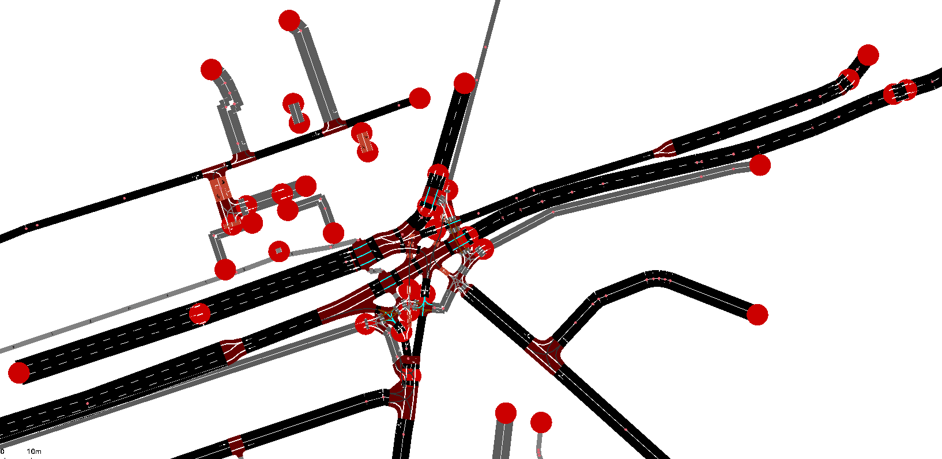

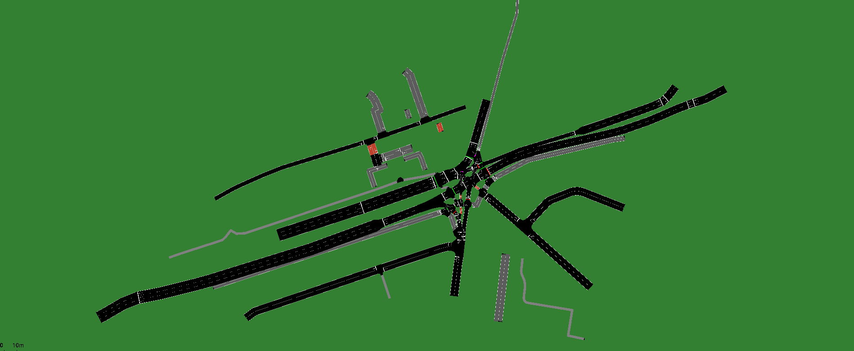

**Figure 4.2:** SUMO network generated from the OpenStreetMap data, showing lane-level geometry and signalised junction structure.

Traffic demand was constant across all experiments by reusing the same predefined routes file generated from an average annual daily flow calibrated demand process. This ensured that vehicle flow patterns, route choices, and overall traffic intensity were unchanged between the experiments. 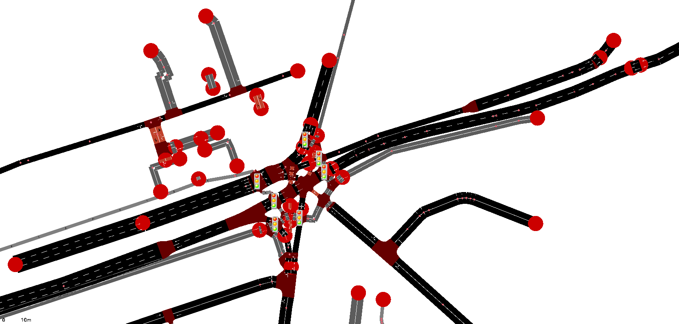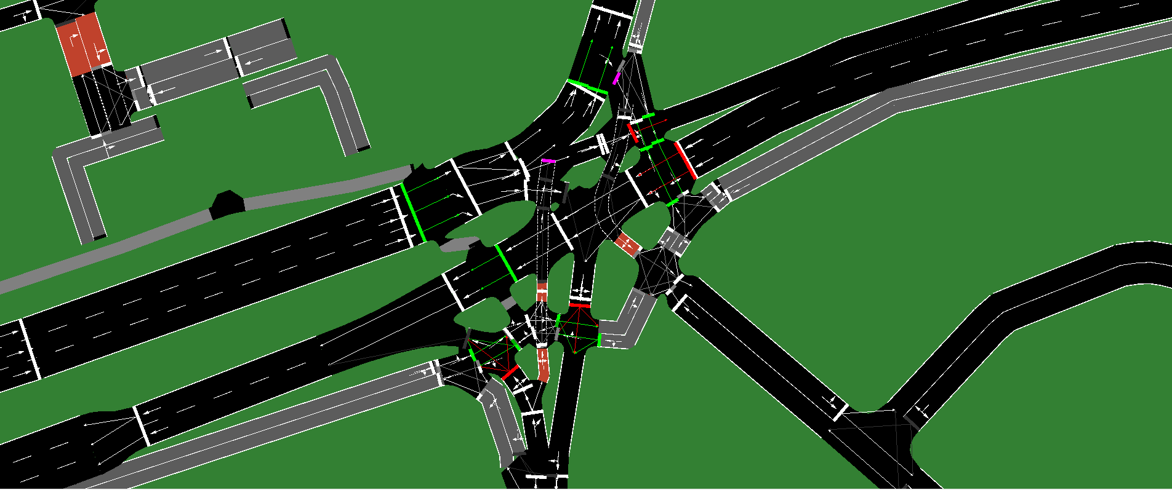

**Figure 4.3:** Signalised intersections within the SUMO network, representing the traffic light systems.

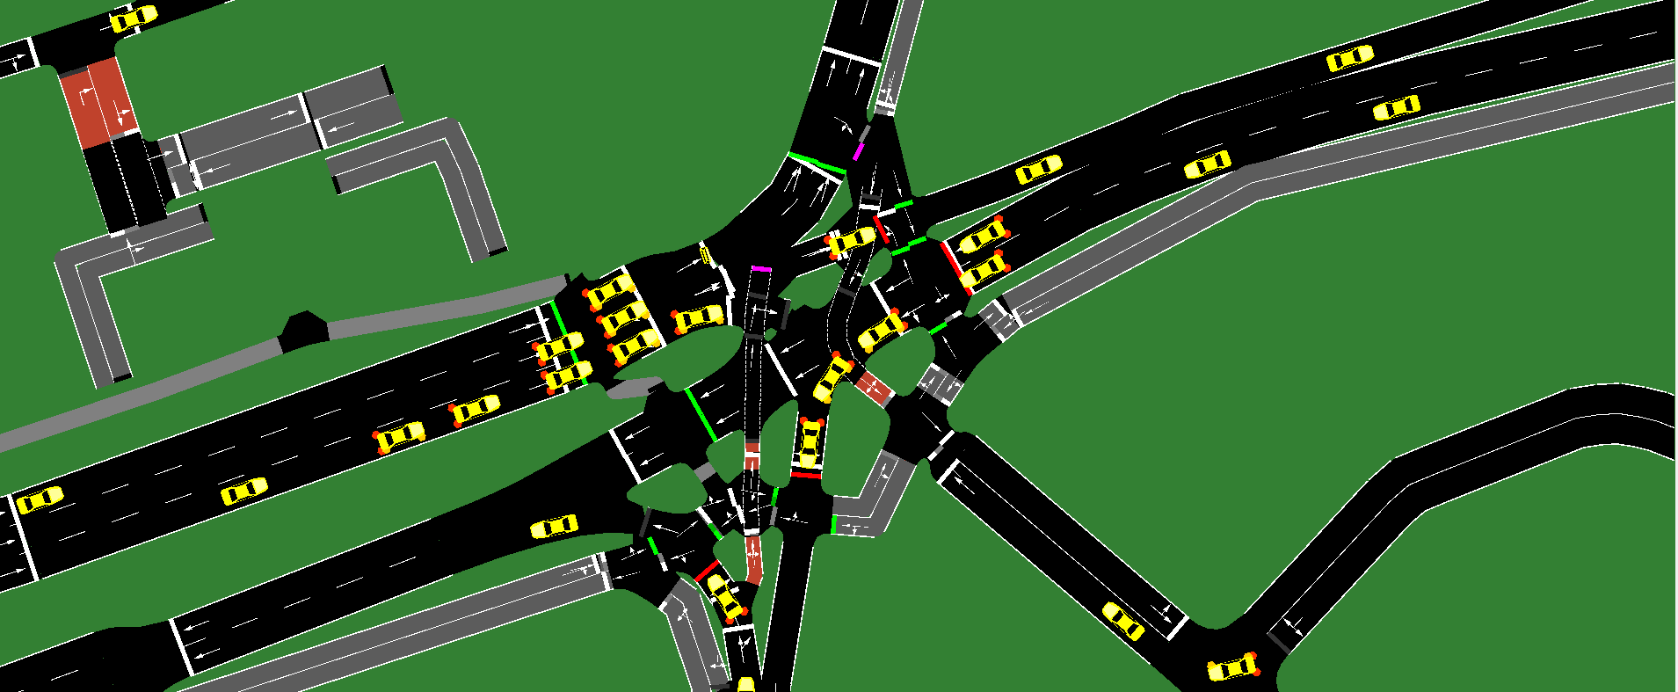Two traffic signal control strategies were evaluated. The first is a fixed time controller, which uses a static phase sequence and fixed phase durations, so it does not adapt to real time traffic conditions. The second one is a GNN - A2C Reinforcement Learning controller, which applies a trained policy to dynamically select signal actions during the runtime. In the evaluation process, the learned policy parameters are fixed and no further training occurs, allowing the assessment to reflect the controller's learned behaviour rather than ongoing flow.

**Figure 4.4:** SUMO simulation during execution, showing vehicle movements and active signal phases under evaluation conditions.

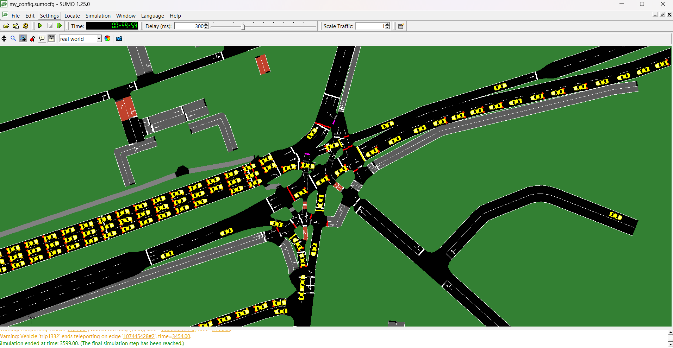Furthermore, each simulation run was executed for 3600 simulation steps, which is related to one hour of simulation traffic time. Simulation outputs were logged consistently to support quantitative analysis and visualisation. These outputs form the basis for the performance metrics and the dashboard visualisation presented in the next sections of this chapter.

**Figure 4.5:** SUMO simulation snapshot captured during a 3600-step evaluation run, showing vehicle movements and active signal phases.

## 4.2 Model Training and Learning Behaviour

This section presents the behaviour of the graph neural network and actor - critic algorithm for traffic system control during the training and for the policy execution. The aim is to check that the state representation graph structure and actor - critic model work is correctly within the simulation environment.

### 4.2.1 State Representation and Graph Configuration

The RL agent was trained using the graph view of the traffic network with 7 TLS and the traffic light system is treated as a node. The raw state sizes are not the same across the traffic light system with state length of [7, 7, 5, 9, 7, 5, 7].

For making inputs consistent for the neural network, all state vectors are added to a fixed size of 9, and each node feature includes traffic information such as the queue length, waiting time and the current signal phase

The final graph contains 7 nodes with a 7× 7 adjacency matrix. The adjacency is sparse, matching the real road layout: only one pair of junctions is connected as neighbours. This setup allows mostly local control.

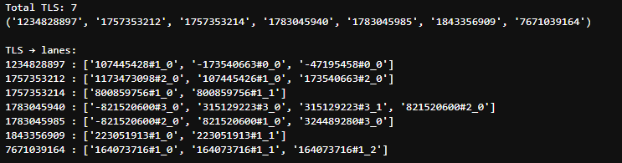

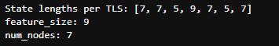**Figure 4.6(a):** Controlled traffic light signals and their associated incoming lane mappings used to construct per-junction state representations.

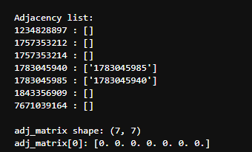**Figure 4.6(b):** state lengths per traffic light signal and padding to a fixed feature size for graph based neural network processing.

**Figure 4.6(c):** adjacency structure of the traffic signal network, showing connectivity between adjacent junctions and isolated nodes.

### 4.2.2 Actor - Critic Output Validation

In the training and early policy execution the graph neural network and actor - critic algorithm model produce output that match the expected A2C design. the actor policy network generated with shape (1, 7, 2), that means that outputs are two action scores for each of the 7 traffic light signals at every step. It shows that each traffic light system selects its action from the same action space while using the shared graph based state input.

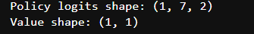At the same time the critic network generates a single scalar value which shapes(1, 1). This value represents a global estimate of the expected return from the current network state, overall traffic condition while still applying actions at the individual junction level. These output shapes remain consistent across all episodes and confirms that the actor and critic were correctly integrated with the graph neural network architecture.

**Figure 4.7:** *Actor - critic network outputs showing intersection policy shapes.*

### 4.2.3 Training Reward Progress and Check point

The training of the Graph Neural Network (GNN) and A2C agent was conducted for 50 Reinforcement Learning episodes, and the reward was defined as the negative of the total waiting time across the whole network. Therefore, a less negative reward implies lower waiting time, for a better return. The training length was kept at 50 episodes to allow the agent sufficient learning and exploration while remaining computationally manageable.

To find the best policy the training uses reward based checkpoints. That means the model weights were saved whenever a new episode achieved a higher return than previous episodes, this method ensured that the best performing policy during training was selected.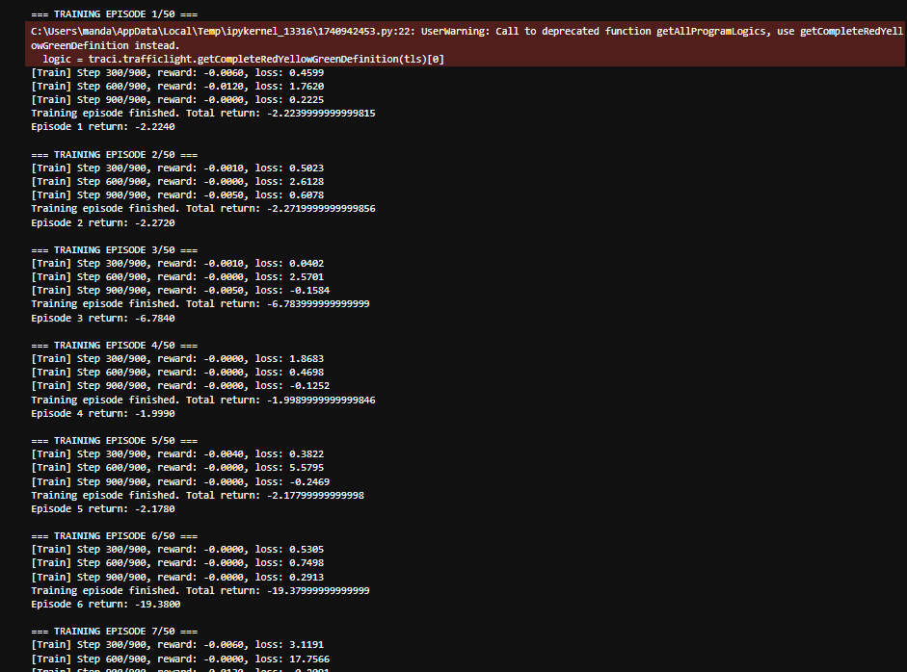

**Figure 4.8:** *Training episode returns of the GNN A2C agent across 50 episodes, illustrating variability in reward behaviour and checkpointing of the best-performing policy.*

## 4.3 Evaluation Data Generation and Dashboard Outputs

Following execution of the traffic simulation, performance data were generated and recorded to support the evaluation of the fixed time baseline controller and the AI based traffic signal controller. This section describes the data outputs produced by the simulation framework and the dashboard interface used to visualise this output to detail the result analysis.

All simulations were executed for a fixed duration of 3600 simulation steps, which is equal to one hour of simulation traffic time. In each simulation run, the same network, same traffic demand, and simulation configuration were used; only the traffic signal control strategy was changed. This ensured that the resulting datasets are directly comparable between both controllers.

### 4.3.1 Dashboard based performance monitoring

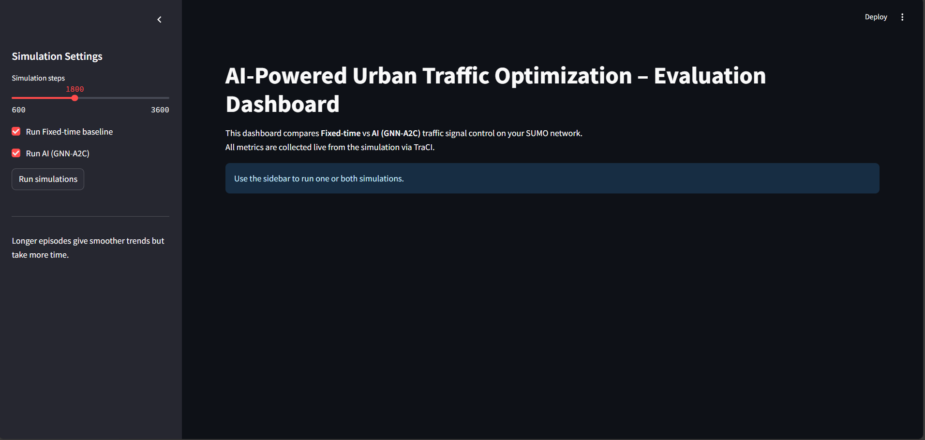

**Figure 4.9:** Evaluation dashboard interface showing controller selection, simulation step navigation.

An interactive dashboard was developed to visualise simulation outputs in real time and during post simulation analysis*(Streamlit, n.d.)*. The dashboard provides an interface for checking global and intersection level performance metrics generated through the TraCI connection to SUMO. Key dashboard components include a Controller Selection Toggle (which is fixed-time or AI), a simulation step slider for temporal navigation, and multiple metrics visualisation panels.

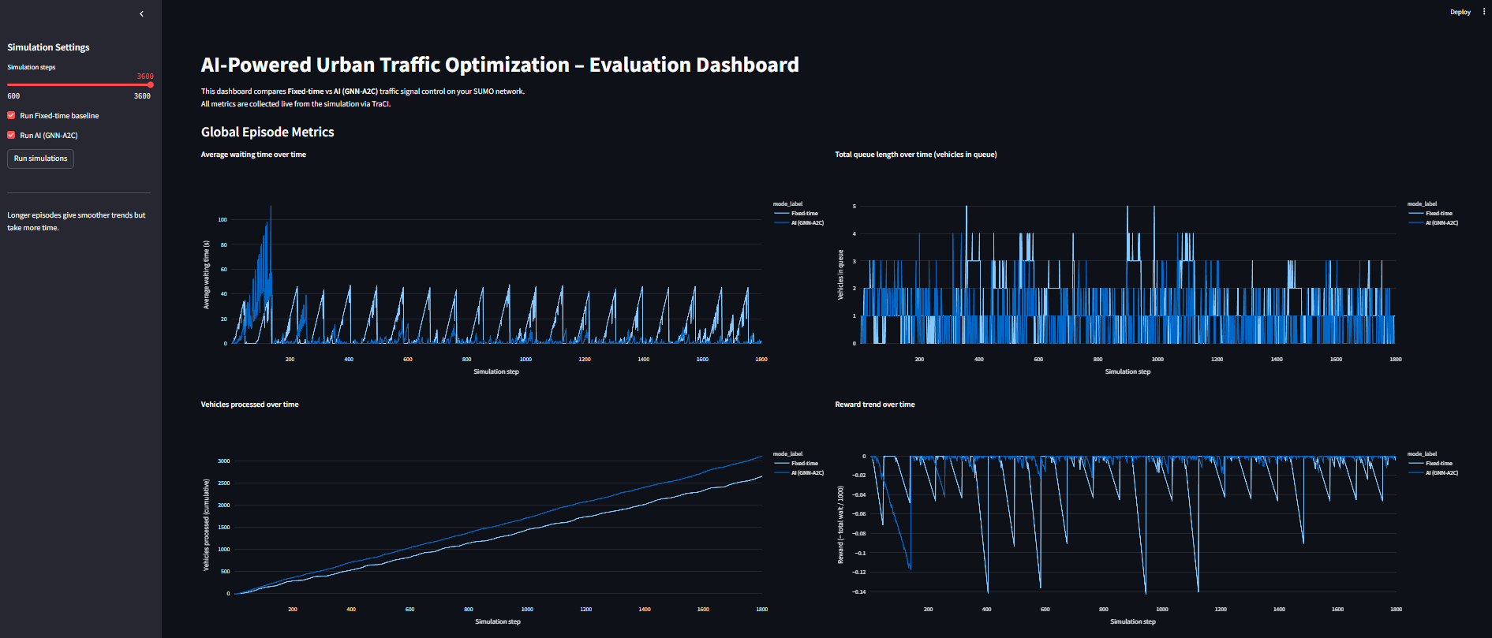**Figure 4.10:** Global time series performance metrics displayed in the dashboard over the full 3600 step simulation.

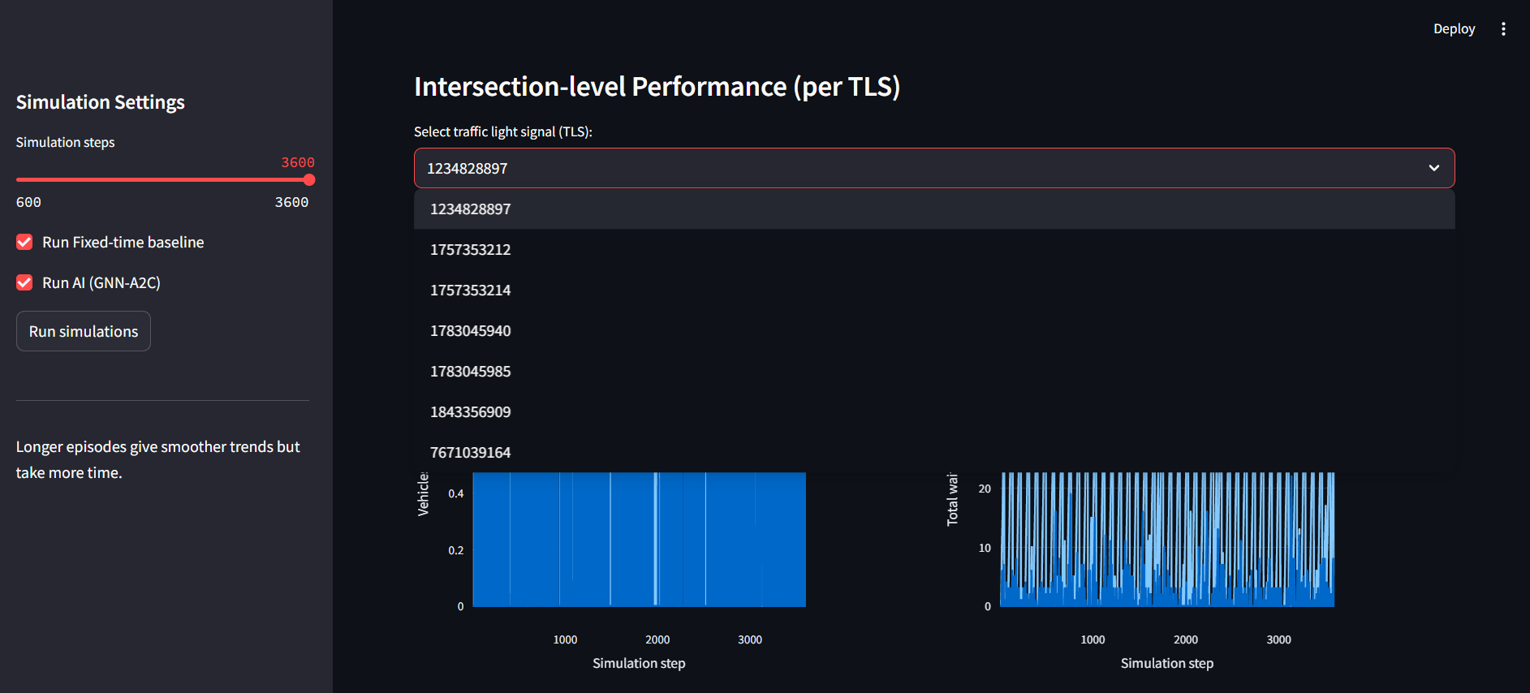The global metrics display time series plots for average waiting time, queue length, and vehicles processed, as well as the reward signal for the full simulation*(Plotly, n.d.)*. These plots allow the user to observe how traffic conditions grow and develop over time under each control strategy without applying any filter.

**Figure 4.11:** Intersection level performance visualisation using the traffic light system (TLS) selector.

The dashboard supports intersection level performance through a traffic light system selector that enables detailed analysis of individual signalised junctions using the same metrics.

4.3.2 Exported evaluation datasets  
After completing the simulation run and reviewing the results the dashboard provides an export function to download recorded simulation metrics in CSV format. the exported data set were used to support structured reporting and reproductivity of the evaluation result such as follows**:**

* **Global_metrics_all_controllers.csv** contains network level metrics recorded across simulation steps for each controller, including average waiting time, total queue length, cumulative vehicles processed, and the reward signal.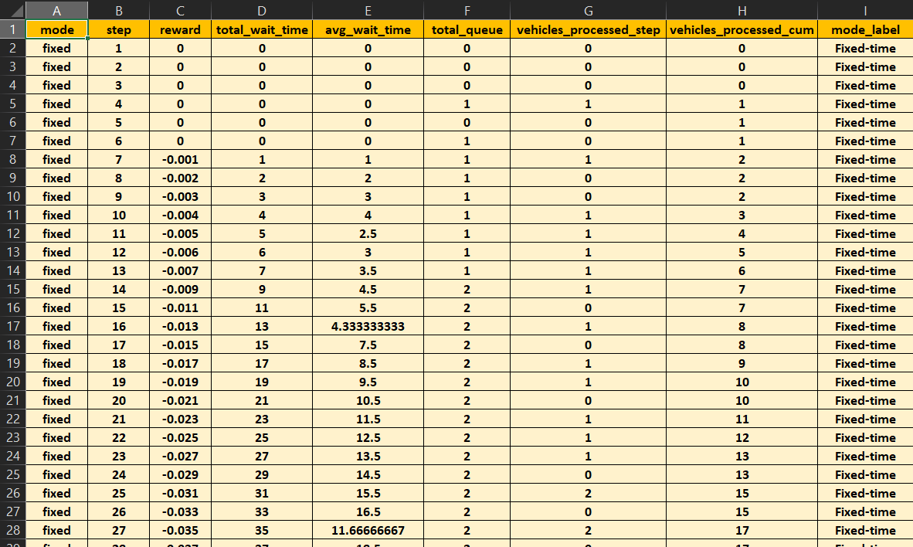

**Figure 4.12:** **Global_metrics_all_controllers** evaluation metrics downloaded from the dashboard in CSV format.

* **tls_metrics_all_controllers.csv** contains intersection level metrics recorded across simulation steps for each signalised junction (TLS), enabling detailed per-junction comparison of waiting time and queue behaviour.

**Figure 4.13:** **tls_metrics_all_controllers** evaluation metrics downloaded from the dashboard in CSV format.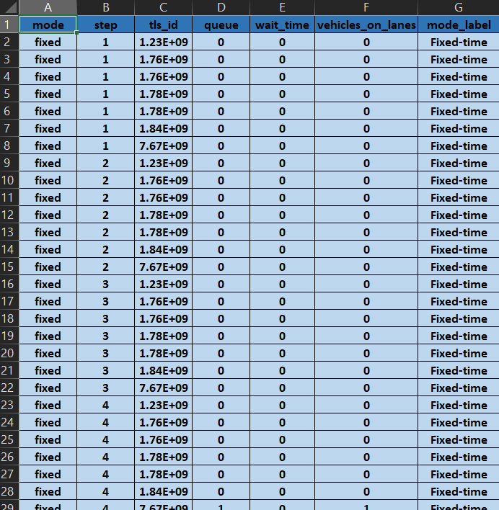

## 4.4 Network Level Quantitative Results

This section presents the network level quantitative results evaluation for the fixed-time baseline controller and the AI controller. The time series and summary plots were generated by the evaluation dashboard. All results relate to a single 3600 steps simulation episode with the same network configuration and traffic demands for both controllers.

### 4.4.1 Average Waiting Time

Figures 4.14 and 4.15 present the time-series trends in waiting time for the fixed-time and AI (GNN - A2C) controllers, respectively. Figure 4.16 summarises overall episode performance by comparing total accumulated waiting time over the full 3600 steps simulation.

**Figure 4.14:** *Average waiting time over simulation steps under fixed-time control.*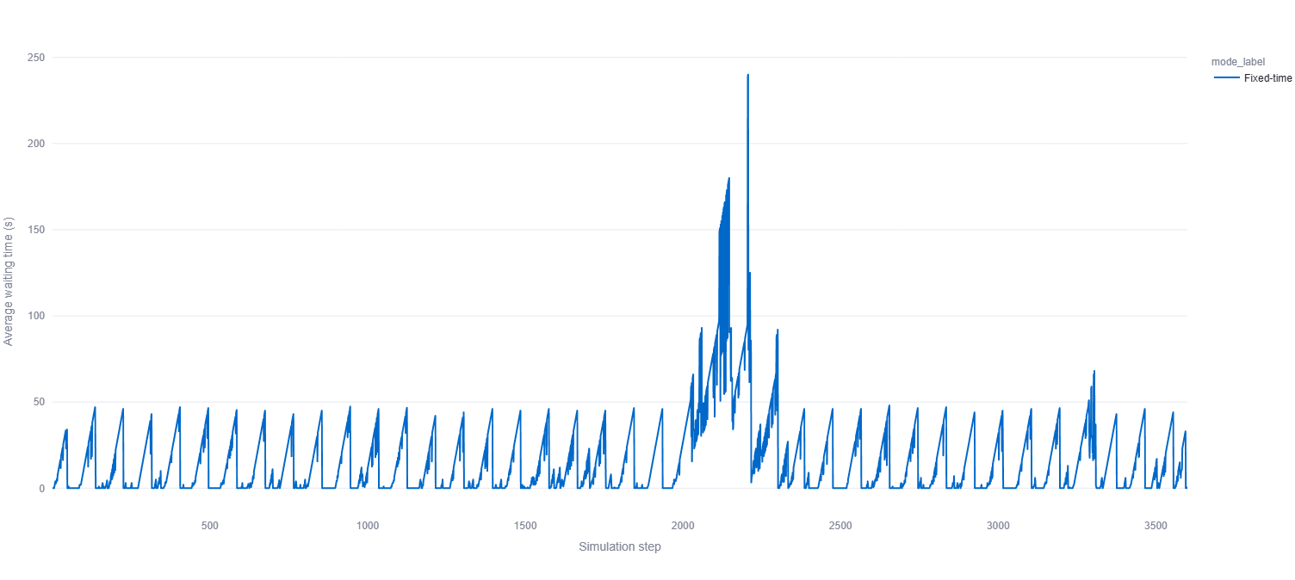

In the fixed time controller (fig 4.14), the average waiting time follows the highly regular, repeating pattern in most simulation views.Waiting time increases at each signal cycle and drops fastly, producing a consistent saw edged structure in the episode. The structure shows traffic events clearly visible between approximately simulation steps at 2000 and 2200, and the average waiting time rises unexpectedly to highest observed values up to 200 seconds before recovering. This shows that the fixed time controller cannot handle short term increases in traffic demand effectively.

**Figure 4.15:** *Average waiting time over simulation steps under GNN - A2C control.*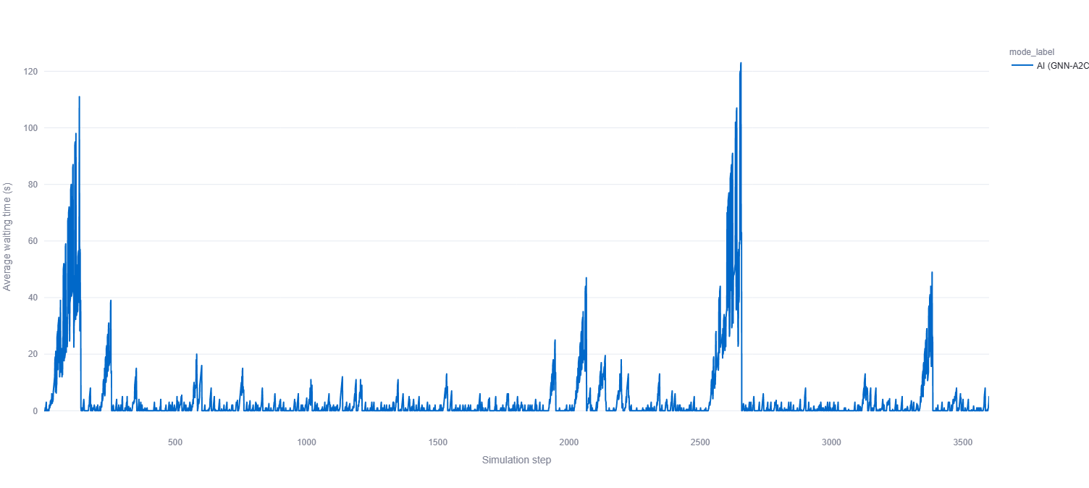

In (Figure 4.15), the GNN-A2C controller maintains very low average waiting times for most of the 3600 steps of the simulation. Outside of a limited number of intervals, the waiting time remains close to zero with only short-lived increases. Noticeable congestion is visible: the first is an early spike during the initial simulation phase, and the second is a spike around simulation step 2500. In both cases, the maximum waiting time stays lower than the fixed time controller, with peaks of around 110 and 120 seconds. These spikes are shorter in duration, and the waiting time returns rapidly to low levels after each event.

**Figure 4.16:** total accumulated waiting time (whole episode)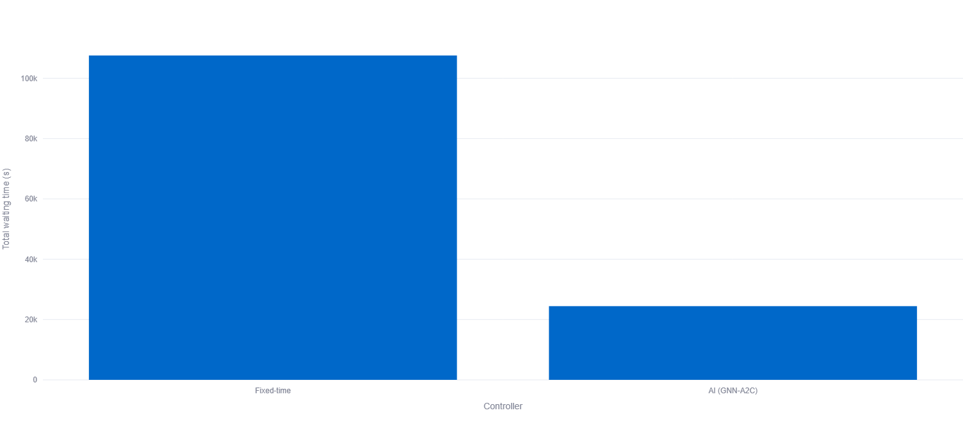

Figure 4.16 summarises overall performance by comparing total accumulated waiting time over the full 3600 steps simulation. The fixed time controller produces around **105,000 to 110,000 seconds**, while the AI (GNN - A2C) controller reduces this to approximately **24,000 to 25,000 seconds**. This is roughly a **75 to 80% reduction** in total waiting time under AI control. This shows that the improvements seen in the time series plots also lead to clear network-level benefits over the full simulation.

### 4.4.2 Queue Length Analysis

This section analyses the total queue length over the time for the fixed time controller and the AI controller using the dashboard outputs over the full simulation step which is 3600.

Figure 4.17 demonstrates that the total queue length remains within a small bounded range, with the Y axis spanning 0 to 5 vehicles. Both controllers show frequent step-to-step changes, with queue lengths usually between 0 and 3 vehicles and occasional peaks of 4 to 5 vehicles. The repetitive spikes indicate that short traffic buildups occur throughout the simulation rather than being limited to a single period.

While the queue dynamics appear broadly similar in Figure 4.17, the network efficiency differs when considering throughput.

**Figure 4.17:** Total queue length over simulation steps (vehicles in queue) for fixed time and AI (GNN - A2C) traffic signal controllers.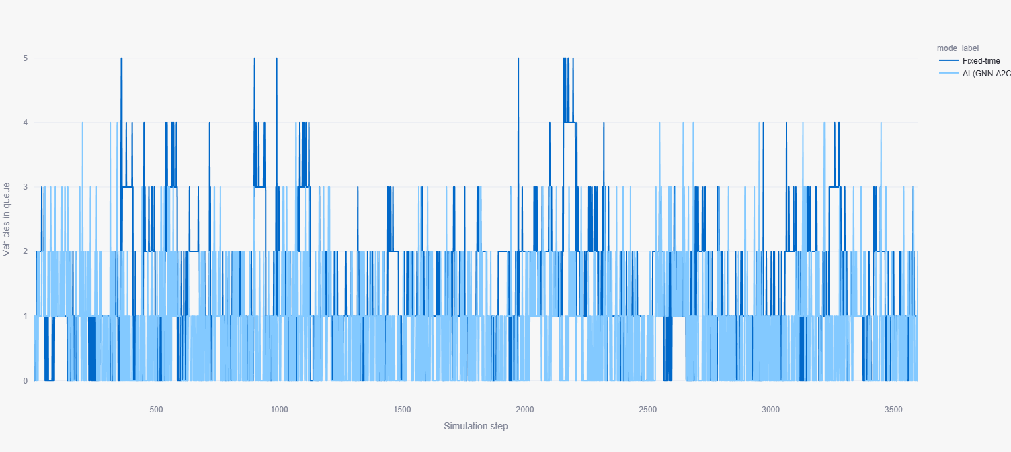

### 4.4.3 Vehicle Movement Analysis

This section compares network level vehicles for the fixed time controller and the AI controller using dashboard outputs from the full 3600 step simulation. Movement is measured as the total number of vehicles processed, which shows how efficiently traffic moves through the network.

Figure 4.18 shows the cumulative vehicles processed over time for both controllers. The GNN and A2C line stays above the fixed time line for almost the whole run, and the gap between them grows over time. This means the AI controller is processing vehicles at a higher rate than the simulation.

The fixed time controller processes a little over 5300 vehicles, while the GNN - A2C controller reaches around 6100 vehicles. This is also confirmed in Figure 4.19, which summarises the total vehicles processed using a bar chart and clearly shows the AI controller with the higher movement under the same network and traffic demand.

These results show that the AI controller improves movement in a clear way. This also matches the earlier queue length results, that the AI controller increases traffic flow without increasing congestion.

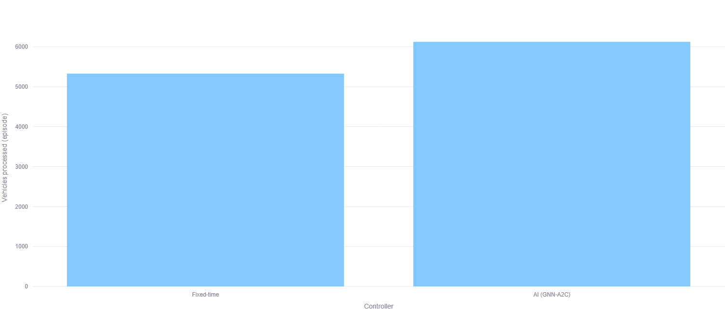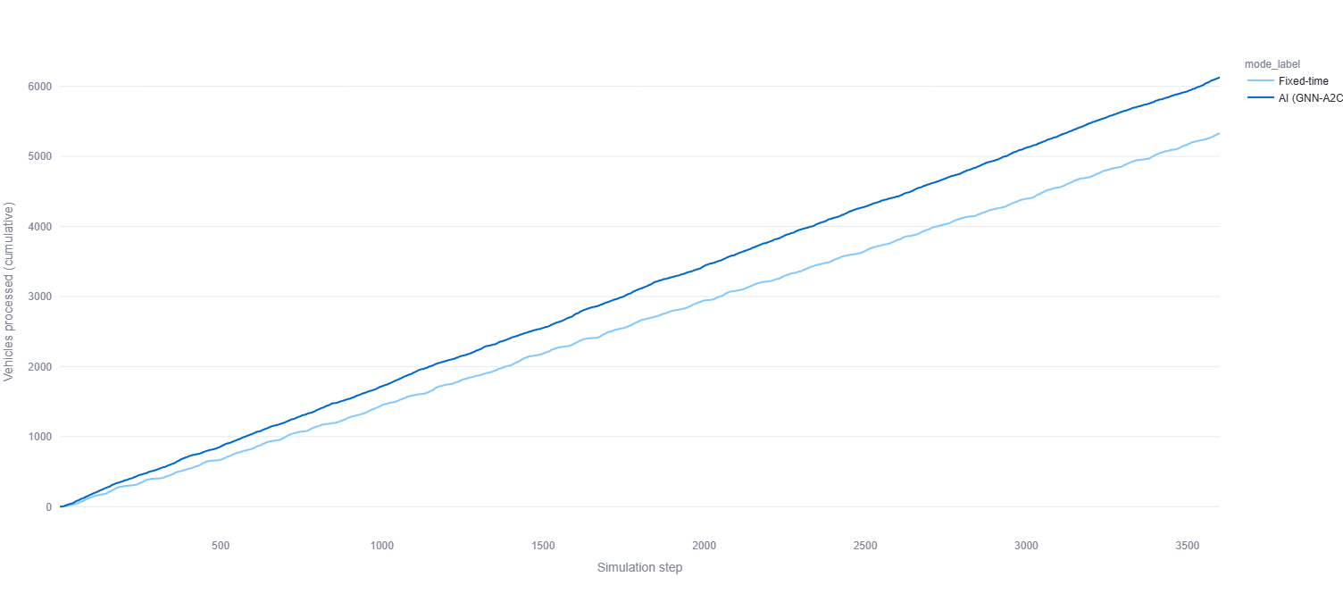**Figure 4.18:** *Cumulative vehicles processed over simulation steps for fixed-time and AI (GNN - A2C) traffic signal controllers.*

***Figure 4.19:*** *Total number of vehicles processed over the full 3600-step simulation episode under fixed-time and AI (GNN - A2C) control (higher is better).*

### 4.4.4 Reward Trend During Evaluation

This section compares the reward signal during evaluation for the fixed time controller and the AI (GNN - A2C) controller over the full 3600 steps simulation. The reward is based on total waiting time, so it is always negative, and values closer to zero mean better performance.

Figure 4.20 shows that both controllers usually stay close to zero, but there are regular negative drops when short congestion events happen. Under the fixed-time controller, these drops are deeper and more frequent. A clear example appears around steps 2100 to 2300, where the reward falls to about -0.4, showing a period of high accumulated waiting time. Also, Figure 4.21 shows the fixed-time reward trend, and Figure 4.22 shows the AI based Graph Neural Network and Actor - Critic reward trend.

In comparison, the GNN - A2C controller shows a more stable reward pattern, with most values staying above roughly -0.15, and the reward returns back near 0 more quickly.

The AI controller reduces both the size and frequency of negative reward spikes, which supports improved network performance during evaluation without causing unstable behaviour.

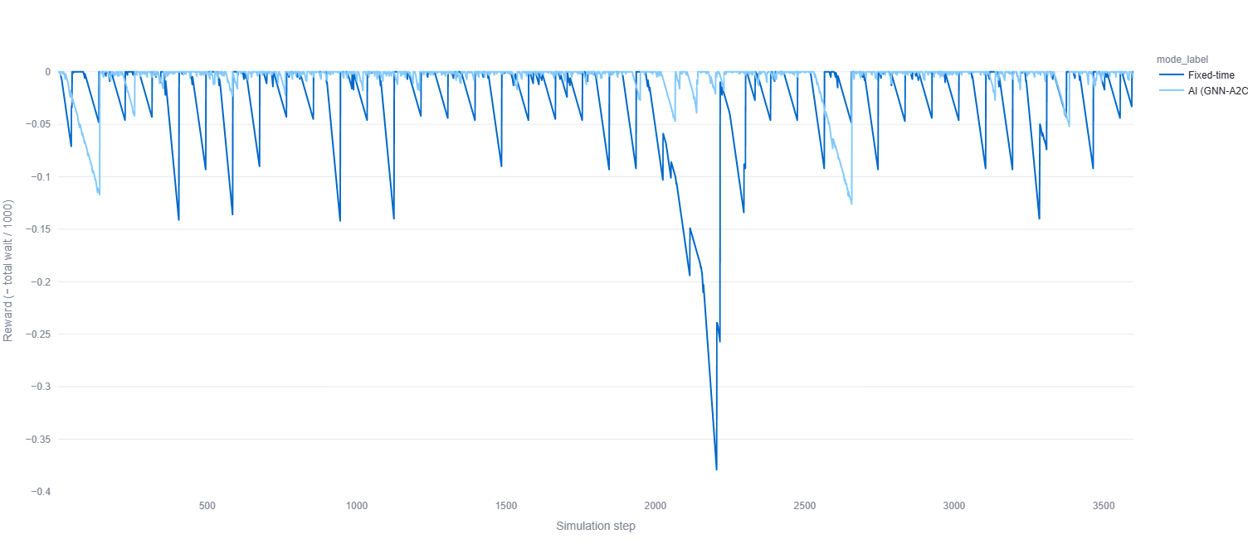

**Figure 4.20:** *Reward signal over simulation steps for fixed time and AI (GNN - A2C) controllers during the 3600 steps evaluation episode.*

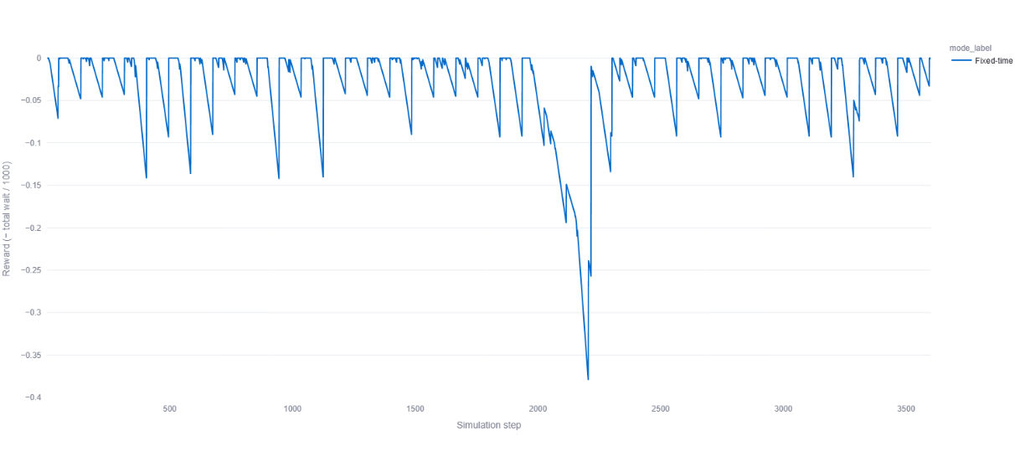***Figure 4.21:*** *Reward trend over simulation steps for the fixed time traffic signal controller during the 3600 steps evaluation episode.*

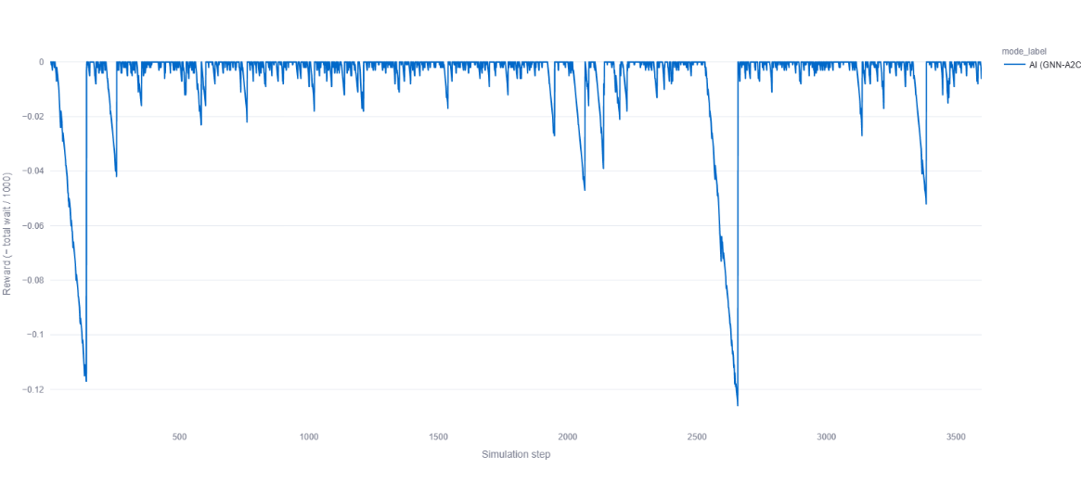

***Figure 4.22:*** *Reward trend over simulation steps for the AI(GNN - A2C) traffic signal controller during the 3600 steps evaluation episode.*

## 4.5 Intersection Level (TLS) Performance Analysis

Network level results show the overall performance, but traffic conditions can be different at each signalised intersection. For this reason, intersection level analysis is included to check how queue length and waiting time change at individual traffic lights under fixed time and AI control. To keep this section clear and short, the analysis focuses on simple trend comparisons for selected traffic light systems (TLS).

### 4.5.1 Overview of Analysed Traffic Light Systems

The simulated Sheffield network includes seven signalised intersections; each treated as a traffic light system (TLS). Each TLS was evaluated separately using the same traffic demand and simulation settings, with the only change being the control strategy fixed-time vs AI (GNN - A2C). The following TLS IDs are analysed in this section:

* **TLS 1:** 1234828897
* **TLS 2:** 1757353212
* **TLS 3:** 1757353214
* **TLS 4:** 1783045940
* **TLS 5:** 1783045985
* **TLS 6:** 1843356909
* **TLS 7:** 7671039164

The analysis is comparative and qualitative, focusing on queue length stability and waiting-time behaviour.

### 4.5.2 Individual TLS Performance Analysis

4.5.2.1 TLS 1234828897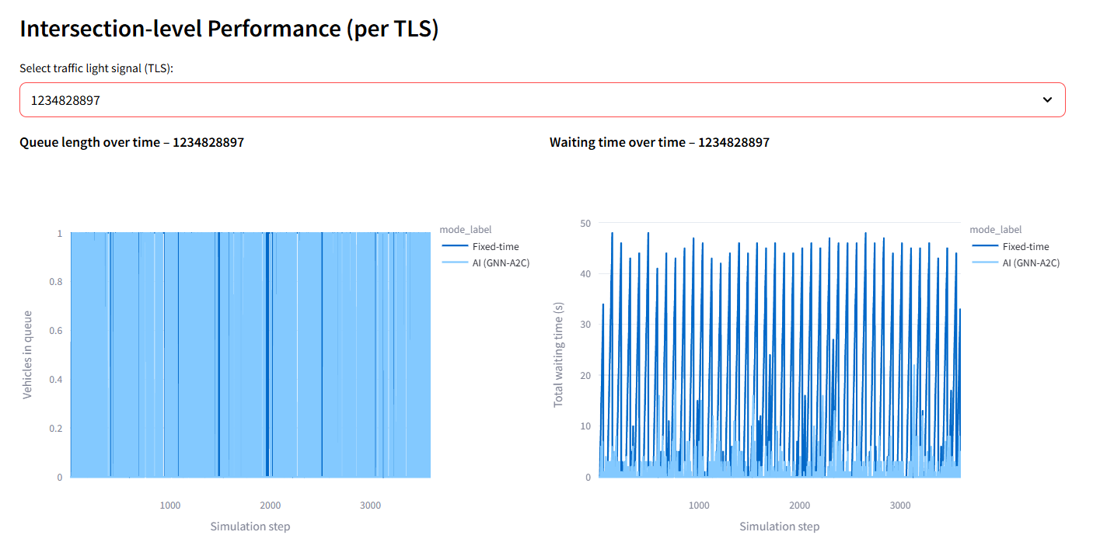

**Figure 4.23:** Intersection level queue length and waiting time over simulation steps for TLS 1234828897 under fixed time and AI (GNN - A2C) control.

**Queue length behaviour:**

At TLS 1234828897, queue length stays very low for both controllers, almost always between 0 and 1 vehicle. The AI (GNN - A2C) controller looks slightly smoother, but overall, the queue levels are similar.

**Waiting time behaviour:**

Waiting time shows clearer differences. With fixed time control, there are frequent spikes up to around 45 to 50 seconds, mainly due to rigid signal timing. With AI (GNN - A2C) control, waiting time is much lower for most of the simulation, staying below 10 seconds, with few bigger spikes.

### 4.5.2.2 TLS 1757353212

**Figure 4.24:** Intersection level queue length and waiting time over simulation steps for TLS 1757353212 under fixed time and AI(GNN - A2C) control.

**Queue length behaviour:**Queue lengths again remain low, primarily within the 0 to 1 vehicle range. Both controllers prevent queues, and the fixed time controller shows short queue switching on  compared to the AI controller.

**Waiting time behaviour:**

The fixed time controller sometimes shows large waiting time spikes close to 50 seconds. The AI (GNN - A2C) controller keeps waiting time mostly low, with only a few smaller and shorter peaks. The AI controller responds better to short term changes in traffic demand.

### 4.5.2.3 TLS 1757353214

**Figure 4.25:** Intersection level queue length and waiting time over simulation steps for TLS 1757353214 under fixed time and AI (GNN - A2C) control.

**Queue length behaviour:**This intersection shows a bit more variation. The fixed time control, the queue sometimes reaches 2 vehicles. The AI (GNN - A2C) controller limits both the frequency and duration of these increases.

**Waiting time behaviour:**The fixed time control, waiting time has repeated peaks of about 10 to12 seconds. With the AI controller, waiting time stays much lower and does not go above 2 to 3 seconds.

### 4.5.2.4 TLS 1783045940

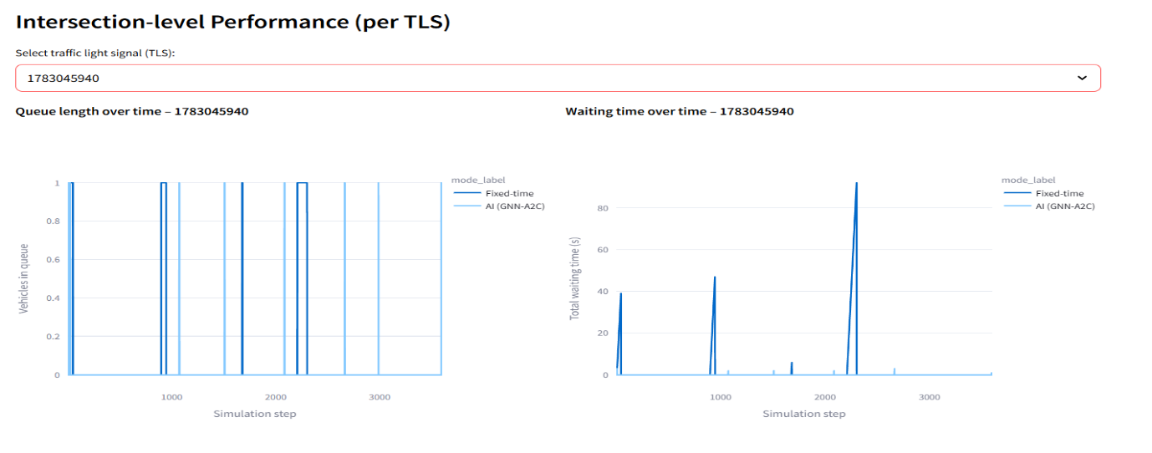

**Figure 4.26:** Intersection level queue length and waiting time over simulation steps for TLS 1783045940 under fixed time and AI(GNN - A2C) control**.**

**Queue length behaviour:**The most simulation steps exhibiting zero queued vehicles. Both controllers perform similarly in terms of queue prevention.

**Waiting time behaviour:**The fixed time control produces several large waiting time spikes, an extreme peak   reaching 90 seconds. The AI(GNN - A2C) controller reduces both the magnitude and frequency of delays.

### 4.5.2.5 TLS 1783045985

**figure 4.27:** Intersection level queue length and waiting time over simulation steps for TLS 1783045985 under fixed time and AI(GNN - A2C) control.

**Queue length behaviour:**Queue lengths remain low but show frequent short lived activations. The AI (GNN - A2C) controller shows greater stability, with fewer queue transitions.

**Waiting time behaviour:**The fixed time control again produces high waiting time spikes, often exceeding 45 seconds, while AI control maintains mostly low waiting times.

### 4.5.2.6 TLS 1843356909

**Figure 4.28:** Intersection level queue length and waiting time over simulation steps for TLS 1843356909 under fixed time and AI(GNN - A2C) control.

**Queue length behaviour:**This TLS operates under minimal congestion, with queues rarely exceeding 1 vehicle.

**Waiting time behaviour:**Waiting times are generally low for both controllers. The fixed time control shows random spikes up to 5 seconds, on the other side the AI (GNN - A2C) controller maintains near zero waiting times for most of the simulation.

### 4.5.2.7 TLS 7671039164

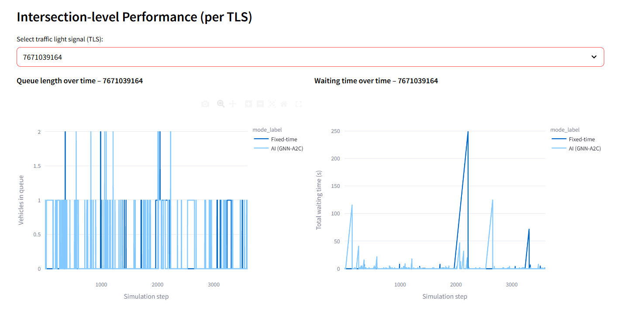

**Figure 4.29:** Intersection level queue length and waiting time over simulation steps for TLS 7671039164 under fixed time and AI (GNN - A2C) control.

**Queue length behaviour:**

Queue lengths fluctuate between 0 and 2 vehicles, with slightly higher variability than at other intersections.

**Waiting time behaviour:**This junction shows the most extreme waiting time events under fixed time control, with peaks reaching approximately 250 seconds. The AI controller significantly reduces these extremes.

### 4.5.3 Network Wide Comparison of TLS Behaviour

At all seven intersections, queue lengths remain less under both controllers, and the traffic is primarily reflected in waiting time rather than queues. The AI controller consistently reduces waiting time, particularly at delay intersections. These results show that adaptive and graph based control improves local intersection performance.

## 4.6 Overall Performance Improvement Summary

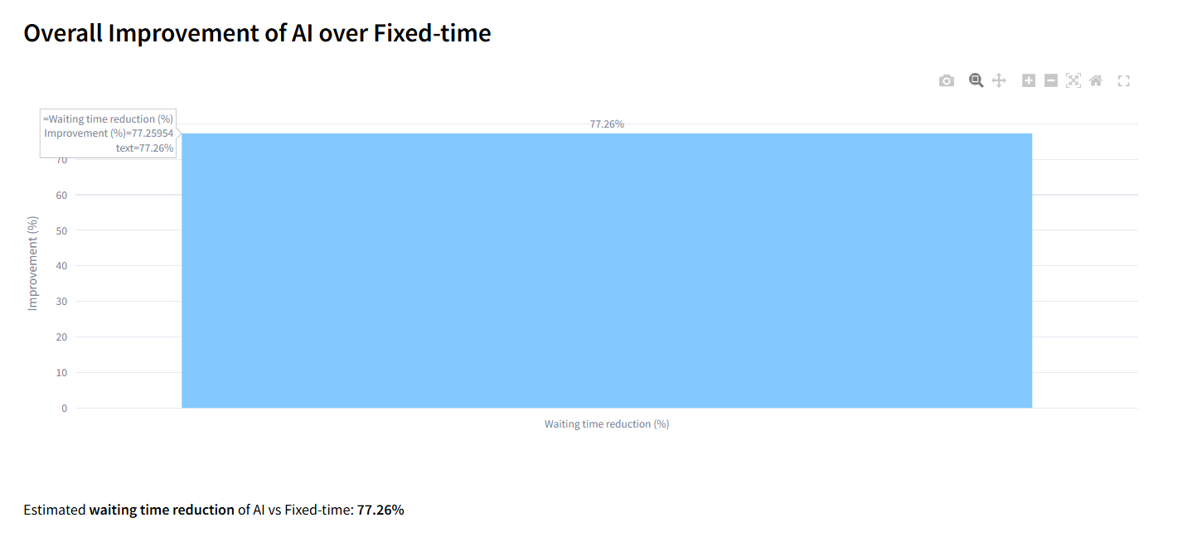**Figure 4.30:** reduction in average waiting time achieved by the AI controller relative to fixed time control.

The performance difference between the fixed time controller and the AI controller, shown in Figure 4.24. The percentage reduction in waiting time reached by the AI controller. This improvement value is calculated using the total accumulated waiting time from both controllers.

In Figure 4.24, the AI controller reduces waiting time by about 77.26% compared to fixed time control. This matches the patterns already shown in the earlier network level graphs and the intersection level comparisons in this chapter.

# CHAPTER 5: Discussion and User Evaluation

This chapter provides discussion and user evaluation for this dissertation. First, it discusses the main findings from chapter four by explaining what the results mean and why they happened, under the same sumo simulation network and same traffic demand conditions for both fixed time and AI controllers. The focus is on interpreting the behaviour seen in the evaluation outputs Like changing in waiting time queue length and vehicle processed as well as reward trends.

Secondly, this chapter presents the user evaluation of the dashboard and the system presentation. This includes a short methodology summary of how participants were shown the SUMO simulation and dashboard, followed by a structured analysis of the questionnaire results using descriptive quantitative summaries and qualitative thematic feedback from the open ended questions.

## 5.1 Discussion of Network Level Results

This section discusses the network level behaviour of the fixed time controller and the AI controller under the same Sheffield City Centre SUMO network and the same traffic demand conditions. The finding from Chapter 4 is that the AI controller reduces overall delay and processes more vehicles compared to the fixed time controller, which shows more inflexible and repetitive traffic behaviour across the whole 3600 step episode.

### 5.1.1 Average waiting time:

At the network level, the fixed time controller shows a repeating rise and drop pattern in the waiting time. This happens because fixed time signals run on a preset cycle, so vehicles build up during the red phase and then move out during the green phase.

The AI controller keeps the waiting time lower for most of the simulation, with only a few short spikes that recover quickly compared to the fixed time controller. This matches the goal of reinforcement learning in traffic signal control (Sutton & Barto, 2018; Wei et al., 2019).

### 5.1.2 Queue length:

The queue length results show that fixed time and AI controllers keep network queues in a low range for most of the simulation. In this specific network and demand setting, traffic is expressed more through delay specifically waiting time rather than through long queues. This type of outcome is common in urban networks where short stop and go behaviour increases delay without producing long queues at the same time (Wei et al., 2019). This indicates that the strongest improvement signal is found in waiting time rather than queue length.

### **5.1.3 Vehicles processed:**

The AI controller processes more vehicles compared to the fixed time controller over the full evaluation episode, meaning that traffic flows through the network more efficiently in Adaptive Control Mode. This result is consistent with the waiting time trends; the controller reduces unnecessary stops, allowing the network to handle more vehicles in the same simulated time. In Reinforcement Learning based traffic signal studies, reduced delay, improved flow, and increased vehicle processes occur together because better phase decisions increase how effectively junction capacity is used (Wei et al., 2019).

### 5.1.4 Reward trends:

The reward trends in this project are defined from the total network waiting time, and it becomes more negative when the delay increases. That means the model is learning very badly; when it comes to zero, traffic is flowing smoothly, meaning the model is learning well. This supports that the AI policy is not only better on average but is also better for responsiveness during short traffic jams, which is important because real traffic demand is rarely stable (Sutton & Barto, 2018).

5.1.5 Why the AI controller improved performance overall:  
  
The improvement can be explained by how an AI controller is built and it follows an actor critic algorithm (A2C). The actor decides what signal action to take and a critic decides how good that decision is and that helps the learning stay more and more stable in changing traffic state and environment (Mnih et al., 2016; Sutton & Barto, 2018). The model is trained using Network Level Reward And it is pushed to reduce total waiting time in the whole network as well as it is not only improving one junction on its own (Bouktif et al., 2023).

## 5.2 Discussion of Junction Level Performance

The Network Level Results in Chapter 4 show the overall improvement using the AI controller, but traffic jams are different at every signalised junction. This section discusses the junction level traffic light system patterns to explain where the AI controller helps out the most and why the fixed time controller shows delay spikes at every specific location.

### 5.2.1 Overall junction level pattern:

In the project, the queue length at the seven traffic light system intersections remains low for both controllers; it is around 0 to 1 vehicle, only sometimes rising to two vehicles at some junctions. This shows that in this Sheffield City Centre network and traffic demand, congestion is mainly as a waiting time delay rather than long physical queues. For this reason, the clearest difference between the AI controller and the fixed time controller is seen in the waiting time.

### 5.2.2 TLS where AI keeps performance consistently near zero:

At TLS 1757353214, the fix time shows repeated waiting time peaks and it is around 10 to 12 seconds as well as sometimes queue increases up to 2 vehicles. The AI controller waiting time is very low and it is up to 2 to 3 seconds in the same simulation episode. This shows the area is not only reducing major traffic jams peaks but it is reducing repeated small delays.

### 5.2.3 TLS where fixed time produces extreme delay events:

* At **TLS 1783045940**, fixed time produces an extreme waiting time peak reaching about 90 seconds, and the AI controller reduces both the size and frequency of these peaks.
* At **TLS 7671039164**, fixed time produces the most waiting times, with peaks reaching approximately **250 seconds**, and the AI controller reduces these waiting times peaks.

### 5.2.4 Why improvements vary across junctions

This difference over the TLS is expected because each junction gets a different traffic flow and it is affected by nearby roads. Fixed time control follows the same preset signal in road traffic changes, and the AI controller uses the current traffic state, so it reduces both small repeated delays and very large waiting times (Sutton & Barto, 2018; Wei et al., 2019).

In the end of this discussion, the junction level discussion supports the same conclusion as the network level analysis: the AI controller consistently reduces waiting time, and the strongest benefit is at junctions where fixed time generates the highest delay.

## 5.3 User Evaluation

### 5.3.1 Purpose and scope:

This user evaluation was conducted to understand how clearly the traffic control dashboard presents the system outputs. It also examined how easy the dashboard is for users to understand and use when comparing the fixed time controller with the AI based controller. It focused on whether users found the dashboard layout and graphs easy to interpret. It is also evaluated whether users could understand which controller performed better based on the results shown in the dashboard. This evaluation focuses only on the usability and clarity of the dashboard and how the results are presented.

### 5.3.2 Participants and recruitment:

In my dissertation user evaluation, 10 participants were recruited through email. Out of these, 9 participants attended the user evaluation meeting, and I received 8 completed responses from the participants, so the analysis is based on 8 responses. All participants were from an AI background, including one working professional, and overall, the group had a similar technical background that matches the topic of my project.

### 5.3.3 Ethics, consent, and anonymity:

Before starting the user evaluation, I clearly explained the ethics of my dissertation work to all participants. Participation was completely voluntary, and everyone had the right to withdraw at any time. I also informed participants that their personal information such as name and email address would not be shared with anyone, and the feedback would be used only for my dissertation user evaluation analysis. All responses were treated as anonymous in the reporting, and only the collected feedback was considered for writing.

### 5.3.4 Evaluation setup:

In my user evaluation, I conducted the session online using a Google Meet link. Because my whole system runs locally on my laptop and it requires high CPU usage, I did not create any public link for the dashboard. Instead, I shared my screen during the session so the participants could see the SUMO simulation and the dashboard outputs in real time.

### 5.3.5 Evaluation procedure:

In this user evaluation, I started by giving a short introduction about myself and my dissertation project. Once they understood the simulation environment, I moved to the dashboard part and explained how the dashboard is running using the Command Prompt (CMD) on my laptop.

After that, I executed the dashboard, and I showed the toggle button where the user can adjust the simulation step up to 360,0 and then I ran the dashboard. I showed the main output and graph, including the fixed time traffic controller AI controller comparison results, the intersection level performance and the improvement which is made by the AI controller. I answered their questions as well. At the end of the demonstration, I asked the users for their permissions and concerns. I shared the Google feedback form link and asked them to complete the user evaluation question. The responses were collected anonymously for the analysis.

### 5.3.7 Data analysis method

This is evaluation of the output and feedback analyse using both quantitative and qualitative methods. For the quantitative analysis Google Forms response summary charts and the statistical charts  are used and according to the feedbacks which I got from the users it also reported the descriptive values such as the mean median and mode for the rating scale questions and counts and percentage for the open ended or categorical questions this makes it easier to understand the overall trend in the feedback without using the separate tables.

For the qualitative analysis open ended responses revived and summarised them by grouping similar comments into the common points. So, this helps me to highlight what participants like about the dashboard and AI based control approach as well as the main improvement suggestion mentioned by the users.

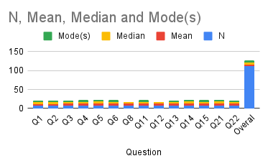

**Figure 5.1:** Summary of descriptive statistics for Likert scale questions (Q1 to Q6, Q8, Q11 to Q15, Q21 to Q22) showing N, mean, median, and mode, including overall average.

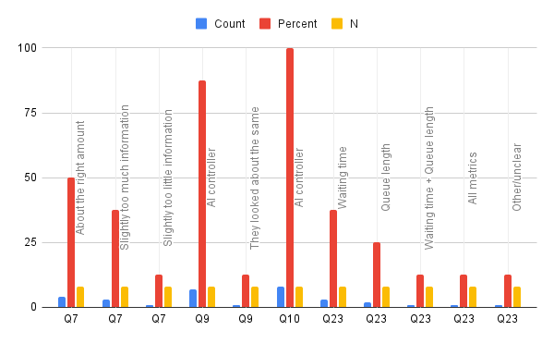

**Figure 5.2:** Categorical results summary showing counts and percentages for Q7 (information amount), Q9 and Q10 (controller preference), and Q23 (metric improved most).

**Table 5.1: Descriptive Statistics of User Evaluation Responses**

| **Evaluation Metric** | **Mean (μ)** | **Std. Dev (σ)** | **Positive Agreement (%)** |
| --- | --- | --- | --- |
| **Dashboard Usability** |  |  |  |
| Q5. Clarity of Main Graphs | 4.75 | 0.46 | **100.0%** |
| Q6. Visibility of Performance Difference | 4.62 | 0.74 | 87.5% |
| Q8. Intersection Level Clarity | 4.50 | 0.53 | 100.0% |
| Q4. Clarity of Comparison (AI vs Fixed) | 4.50 | 0.76 | 87.5% |
| Q3. Layout Ease of Understanding | 4.25 | 0.71 | 87.5% |
| **System & Concept Perception** |  |  |  |
| Q14. Support for Edge Computing | 4.88 | 0.35 | **100.0%** |
| Q21. Usefulness of SUMO Simulation | 4.88 | 0.35 | 100.0% |
| Q11. Belief in RL Adaptability | 4.62 | 0.52 | 100.0% |
| Q12. Clarity of RL Concept | 4.50 | 0.53 | 100.0% |
| Q15. Feasibility of Edge Deployment | 4.38 | 0.74 | 87.5% |
| Q22. Realism of Simulation | 4.38 | 0.52 | 100.0% |

### 4.3.8 Qualitative Feedback

This thematic analysis of the open ended responses show three main points about the system.

**Operational efficiency:** Users supported the idea of this system and they described *adaptivity* as the biggest advantage. Many responses suggest that the actor - critic based controller looks more efficient compared to the fixed time controller, because it can react to traffic changes and reduce waiting time.

**Deployment trust and safety:** Participants said the SUMO simulation is realistic enough to understand the concept, but they also raised concerns about real world stability. The most common concern was the sim to real gap. This means the AI could act differently in a real city. These were mentioned as the main risk areas if the system is deployed outside simulation.

**Dashboard refinements:**  The dashboard feedback mostly positive but some users suggest the screen should be more simplified and a few participants felt the amount of technical information. So, there might be too many non technical users and the key suggestion is to smooth queue length graphs to reduce visual noise and also add the status summary that explains what the AI is doing and why in simple words.

At the end the conclusion is the user evaluation suggests the age AI traffic control system is understandable as well as the dashboard is also usable for comparing the fixed Traffic Light System and AI Traffic light system. The quantitative rating supports the user could follow the graphs and the simulation is useful and the qualitative feedback gives a clear direction for the AI improvement, the high quantitative scores for simulation usefulness (4.88) and graph clarity (4.75) validate the design choices and that makes the system stronger for the age cases and simplify the dashboard so it can be understood by a large range of users.

# Chapter 6: summary of this dissertation report

## 6.1 Conclusion summary

This dissertation investigated whether a traffic signal controller based on reinforcement learning, supported by a results dashboard, could improve signal performance and make the comparison with a fixed-time controller easier to understand. A simulation environment using SUMO was developed for the Sheffield City Centre subnetwork, and a GNN based A2C agent was trained to learn signal control decisions using network state information. The trained controller was evaluated against a fixed time baseline using standard traffic efficiency indicators.  The results were shown through a dashboard that summarized performance.

The AI controller demonstrated an ability to respond dynamically For changing demand conditions in the Sumo Simulation Traffic System and the dashboard pads and accessible way to see the controller we have and outcomes from the AI controller. Additionally, a small user evaluation was carried out to assess how clearly users understood the interface and the results. This indicated that the dashboard structure and visual approach were generally understandable and helpful for comparing controller outputs. While the work is limited by the simulation setting and the focus on a single network, the study provides a practical process from scenario creation and training to evaluation and user presentation that can be expanded toward more realistic sensing and operational constraints.

## 6.2 Key contributions

This work makes the following contributions:

* **End to end simulation pipeline:** A complete workflow was developed in SUMO for scenario setup, controller training, evaluation, and reporting for the Sheffield City Centre subnetwork.
* **AI based signal control:** A GNN and A2C traffic signal controller was implemented and trained to use network state information to make adaptive phase decisions in the simulation.
* **Baseline comparison:** A structured comparison was produced against a fixed time controller using consistent evaluation metrics at both the network and junction level.
* **Results dashboard:** A dashboard was designed to present controller.
* **Initial usability evidence:** A small user evaluation was conducted to check the perceived clarity.

## 6.3 Limitations

This study had some several limitations and that should consider when explaining the results. Firstly, the AI Traffic signal Controller was trained and evaluated only on one road network which is the Sheffield City Centre Subcentre Network. The Learn Policy may be network specific and to other cities are any junction layouts may require for retraining or transferring the learning. Secondly The sumo simulation configuration in this project uses model car traffic only which is simplify the real world conditions where the signal timing must account for buses and two wheelers as well as for the delivery vehicles. In this evaluation everything is simulation based and SUMO supports control experimentation It cannot fully reproduce the real world such as the sensor noise unexpected driver behaviour and road networks as well as undefined incidents and weather impacts. Finally, the system was not implemented with the physical sensing or edge deployment the controller did not receive a live data from any roadside sensors like cameras loop detectors and radar and this interface was not deployed on junction level its computing hardware so the results reflect the offline simulated performance rather than the real time field operation.

## 6.4 Future work

Future work can improve both the controller and the deployment readiness of the overall system:

* **Generalisation across networks:** Train and evaluate on multiple maps (additional Sheffield areas and other cities) and explore **transfer learning** to reduce retraining effort.
* **Multi modal traffic modelling:** Extend the environment and state features including two wheelers, buses and cyclist to reflect the traffic behaviour.
* **Sensors + real time perception:** Add more sensors like loop detectors CCTV and the computer feature as well as the radar for realistic and better estimate queue length and road occupancy, Vehicle speed accurately.
* **Edge computing architecture:** The system junction label edge set up so that can make decision faster and keep working safely even if the cloud or network goes down.
* **Emergency vehicle priority:** Add a detection and priority logic so the system can temporarily adjust the timing to help ambulances and emergency vehicle passed safely without any delay.
* **Fail-safe and manual override:** If the system fails and the situation manual handing the implemented control fall back where an authorised operator can switch to manual fix time control during the faults and safely return to AI control. In addition, system failure the pop-up window will be open saying that the system is not working. So, authorised person can handle manually the traffic light system to decrease the traffic and delays.
* **Incident awareness:** Add indicator or accident awareness to support operational decisions like suggesting the timing changes or diversions. In real deployments alert should be operator due to governance and Privacy as well as safety requirements.

## 6.5 Closing statement

In summary this dissertation demonstrates a working SUMO simulation based framework for learning and evaluating an adaptive traffic light signal controller and presenting results through actionable dashboard. In addition, work on generalisation the multi model Traffic, sensing and edge deployment is the approach could be extended towards more realistic and strongly intelligent traffic management system.

# References:

1. A SUMO Based Simulation Framework for Intelligent Traffic Management System. (n.d.). SSRN Electronic Journal. <https://doi.org/10.2139/ssrn.5066810>
2. Kumar, R., Sharma, N. V. K., & Chaurasiya, V. K. (2024). Adaptive traffic light control using deep reinforcement learning technique. Multimedia Tools and Applications, 83, 13851–13872. <https://doi.org/10.1007/s11042-023-16112-3>
3. Shen, W., Zou, L., Deng, R., Wu, H., & Wu, J. (2023). A bus signal priority control method based on deep reinforcement learning. Applied Sciences, 13, 6772. <https://doi.org/10.3390/app13116772>
4. Sreejith, K., Mathi, S., & Pradeep, P. (2024). Beyond sensors: IntelliSignal’s map-integrated intelligence in traffic flow optimization. IEEE Access, 12, 39028–39040. <https://doi.org/10.1109/ACCESS.2024.3375335>
5. Agrawal, A., & Paulus, R. (2020). Intelligent traffic light design and control in smart cities: A survey. International Journal of Vehicle Information and Communication Systems, 5(4), 436–481. <https://doi.org/10.1504/IJVICS.2020.10033552>
6. German Aerospace Center (DLR), Institute of Transportation Systems. (n.d.). SUMO documentation (Simulation of Urban MObility). <https://sumo.dlr.de/docs/index.html>
7. German Aerospace Center (DLR), Institute of Transportation Systems. (n.d.). TraCI (Traffic Control Interface) — SUMO documentation. <https://sumo.dlr.de/docs/TraCI.html>
8. German Aerospace Center (DLR), Institute of Transportation Systems. (n.d.). netconvert — SUMO documentation. <https://sumo.dlr.de/docs/netconvert.html>
9. OpenStreetMap contributors. (n.d.). OpenStreetMap [Data set]. OpenStreetMap. <https://www.openstreetmap.org>
10. Open Data Commons. (n.d.). Open Database License (ODbL) v1.0. <https://opendatacommons.org/licenses/odbl/1-0/>
11. Department for Transport. (n.d.). GB road traffic counts [Data set]. GOV.UK (data.gov.uk). <https://www.data.gov.uk/dataset/208c0e7b-353f-4e2d-8b7a-1a7118467acc/gb-road-traffic-counts>
12. Python Software Foundation. (n.d.). Python documentation. <https://docs.python.org/3/>
13. TensorFlow. (n.d.). TensorFlow documentation. <https://www.tensorflow.org/>
14. Abadi, M., Agarwal, A., Barham, P., Brevdo, E., Chen, Z., Citro, C., Corrado, G. S., Davis, A., Dean, J., Devin, M., Ghemawat, S., Goodfellow, I., Harp, A., Irving, G., Isard, M., Jia, Y., Jozefowicz, R., Kaiser, L., Kudlur, M., … Zheng, X. (2016). TensorFlow: Large-scale machine learning on heterogeneous distributed systems. arXiv. <https://arxiv.org/abs/1603.04467>
15. Keras team. (n.d.). Keras documentation. <https://keras.io/api/>
16. Streamlit. (n.d.). Streamlit documentation. <https://docs.streamlit.io/>
17. Plotly. (n.d.). Plotly Python graphing library documentation. <https://plotly.com/python/>
18. Plotly. (n.d.). Dash documentation. <https://dash.plotly.com/>
19. The pandas development team. (n.d.). pandas documentation. <https://pandas.pydata.org/docs/>
20. German Aerospace Center (DLR), Institute of Transportation Systems. (n.d.). Trip generation tools (randomTrips.py) — SUMO documentation. <https://sumo.dlr.de/docs/Tools/Trip.html>
21. German Aerospace Center (DLR), Institute of Transportation Systems. (n.d.). *Installing SUMO* (SUMO documentation).<https://sumo.dlr.de/docs/Installing/index.html>
22. Baeva, S., Hinov, N., & Nakov, P. (2025). Comparative analysis of some methods and algorithms for traffic optimization in urban environments based on maximum flow and deep reinforcement learning. Mathematics, 13, 2296. <https://doi.org/10.3390/math13142296>
23. Chen, S., Dong, J., Ha, P., Li, Y., & Labi, S. (2021). Graph neural network and reinforcement learning for multi-agent cooperative control of connected autonomous vehicles. Computer-Aided Civil and Infrastructure Engineering, 36(7), 838–857. <https://doi.org/10.1111/mice.12702>
24. Kővári, B., Tettamanti, T., & Bécsi, T. (2022). Deep reinforcement learning based approach for traffic signal control. Transportation Research Procedia, 62, 278–285. <https://doi.org/10.1016/j.trpro.2022.02.035>
25. Zhang, G., Chang, F., Huang, H., & Zhou, Z. (2024). Dual-objective reinforcement learning-based adaptive traffic signal control for decarbonization and efficiency optimization. Mathematics, 12, 2056. <https://doi.org/10.3390/math12132056>
26. Hazarika, A., Choudhury, N., Nasralla, M. M., Khattak, S. B. A., & Rehman, I. U. (2024). Edge ML technique for smart traffic management in intelligent transportation systems. IEEE Access, 12, 25443–25458. <https://doi.org/10.1109/ACCESS.2024.3365930>
27. Mamond, A. W., Kundroo, M., Yoo, S.-e., Kim, S., & Kim, T. (2025). FLDQN: Cooperative multi-agent federated reinforcement learning for solving travel time minimization problems in dynamic environments using SUMO simulation. Sensors, 25, 911. <https://doi.org/10.3390/s25030911>
28. Sun, S., & Liu, M. (2025). Optimisation of lane-level dynamic traffic control strategy based on bidirectional adaptive gated graph convolutional network and deep reinforcement learning. IET Intelligent Transport Systems, 19(1). <https://doi.org/10.1049/itr2.70055>
29. García-Cerrud, G.-C. C., Hernández-Rojas, M., & de la Mora, I. F. (2024). Introducing fine grained energy consumption variables into a public passenger transport simulation in SUMO. Procedia Computer Science, 232, 1890–1899. <https://doi.org/10.1016/j.procs.2024.02.011>
30. Xu, C. (2025). Leveraging edge computing for real-time traffic management and simulation with SUMO in smart cities [Master’s thesis, Lund University]. Lund University Publications. <https://lup.lub.lu.se/student-papers/search/publication/9188899>
31. Alshardan, A., Maashi, M., Alanazi, S. M., Darem, A. A., Mahgoub, H., Alliheedi, M. A., & Alshammeri, M. (2024). Mathematical modeling and simulation of traffic flow control in urban environments using fuzzy deep neural network with optimization algorithm. IEEE Access, 12, 158322–158332. <https://doi.org/10.1109/ACCESS.2024.3483846>
32. Zhang, G., Chang, F., Jin, J., Yang, F., & Huang, H. (2024). Multi-objective deep reinforcement learning approach for adaptive traffic signal control system with concurrent optimization of safety, efficiency, and decarbonization at intersections. Accident Analysis & Prevention, 199, 107451. <https://doi.org/10.1016/j.aap.2023.107451>
33. Li, Z., Yu, H., Zhang, G., Dong, S., & Xu, C.-Z. (2021). Network-wide traffic signal control optimization using a multi-agent deep reinforcement learning. Transportation Research Part C: Emerging Technologies, 125, 103059. <https://doi.org/10.1016/j.trc.2021.103059>
34. Cao, K., Wang, L., Zhang, S., Duan, L., Jiang, G., Sfarra, S., Zhang, H., & Jung, H. (2024). Optimization control of adaptive traffic signal with deep reinforcement learning. Electronics, 13, 198. <https://doi.org/10.3390/electronics13010198>
35. Singh, A. R., Ashraf, M. W. A., Rathore, R. S., Li, B., & Sujatha, M. S. (2025). Real-time traffic flow optimization using large language models and reinforcement learning for smart urban mobility. Applied Soft Computing, 185(Part A), 113917. <https://doi.org/10.1016/j.asoc.2025.113917>
36. Garg, T., Kaur, G., & Rana, P. S. (2023). Real-time traffic light optimization using simulation of urban mobility. SN Computer Science, 4, 526. <https://doi.org/10.1007/s42979-023-01916-9>
37. Wang, X., Mu, H., Fan, Y., et al. (2025). Road and speed restriction strategies for alleviating tunnel congestion based on SUMO traffic simulation. International Journal of ITS Research, 23, 1026–1043. <https://doi.org/10.1007/s13177-025-00499-4>
38. Flötteröd, Y.-P., & Wagner, P. (2025). SUMO simulation of DLR’s research intersection. SUMO Conference Proceedings, 6, 25–32. <https://doi.org/10.52825/scp.v6i.2633>
39. Skoropad, V. N., Deđanski, S., Pantović, V., et al. (2025). Dynamic traffic flow optimization using reinforcement learning and predictive analytics: A sustainable approach to improving urban mobility in the City of Belgrade. Sustainability, 17(8), 3383. <https://doi.org/10.3390/su17083383>
40. Tao, Q. (2024). Predictive analytics for traffic flow optimization in urban logistics: A transformer-based time series approach. Science Progress, 107(3). <https://doi.org/10.1177/00368504241265196>
41. Dikshit, S., Atiq, A., Shahid, M., Dwivedi, V., & Thusu, A. (2023). The use of artificial intelligence to optimize the routing of vehicles and reduce traffic congestion in urban areas. EAI Endorsed Transactions on Energy Web, 10. <https://doi.org/10.4108/ew.4613>
42. Meng, Z., Du, X., Sottovia, P., Foroni, D., Axenie, C., Wieder, A., & Sommer, C. (2022). Topology-preserving simplification of OpenStreetMap network data for large-scale simulation in SUMO. SUMO Conference Proceedings, 3, 181–197. <https://doi.org/10.52825/scp.v3i.111>
43. Hassan, M. M., Karungaru, S., & Terada, K. (2025). Traffic light optimization (TLO) using reinforcement learning for automated transport systems. International Journal of Advances in Intelligent Informatics, 11(1), 102–119. <https://doi.org/10.26555/ijain.v11i1.1655>
44. Tang, D., & Duan, Y. (2024). Traffic signal control optimization based on neural network in the framework of model predictive control. Actuators, 13(7), 251. <https://doi.org/10.3390/act13070251>
45. Paul, A., & Mitra, S. (2022). Deep reinforcement learning based cooperative control of traffic signal for multi-intersection network in intelligent transportation system using edge computing. Transactions on Emerging Telecommunications Technologies, 33(11). <https://doi.org/10.1002/ett.4588>
46. Jamil, Q. U., Kallu, K. D., Khan, M. J., Safdar, M., Zafar, A., & Ali, M. U. (2025). Urban traffic signal control optimization through Deep Q Learning and double Deep Q Learning: A novel approach for efficient traffic management. Multimedia Tools and Applications, 84(22), 24933–24956. <https://doi.org/10.1007/s11042-024-20060-x>
47. Russell, S. J., Norvig, P., & Davis, E. (2016). Artificial intelligence: A modern approach (3rd global ed.). Pearson.
48. Saunders, M., Lewis, P., & Thornhill, A. (2016). Research methods for business students (7th ed.). Pearson.
49. Melnikovas, A. (2018). Towards an explicit research methodology: Adapting research onion model for futures studies. Journal of Futures Studies, 23(2), 29–44. <https://doi.org/10.6531/JFS.201812_23(2).0003>
50. Behrisch, M., & Weber, M. (Eds.). (2019). Simulating urban traffic scenarios: 3rd SUMO Conference 2015 Berlin, Germany. Springer. <https://doi.org/10.1007/978-3-319-33616-9>
51. Bouktif, S., Cheniki, A., Ouni, A., & El-Sayed, H. (2023). Deep reinforcement learning for traffic signal control with consistent state and reward design approach. Knowledge-Based Systems, 267, 110440. <https://doi.org/10.1016/j.knosys.2023.110440>
52. Mnih, V., Badia, A. P., Mirza, M., Graves, A., Lillicrap, T. P., Harley, T., Silver, D., & Kavukcuoglu, K. (2016). Asynchronous methods for deep reinforcement learning. In M. F. Balcan & K. Q. Weinberger (Eds.), Proceedings of the 33rd International Conference on Machine Learning (Vol. 48, pp. 1928–1937). PMLR. <https://proceedings.mlr.press/v48/mniha16.html>
53. Sutton, R. S., & Barto, A. G. (2018). Reinforcement learning: An introduction (2nd ed.). MIT Press. <http://incompleteideas.net/book/the-book-2nd.html>
54. Wei, H., Chen, C., Zheng, G., Wu, K., Gayah, V., Xu, K., & Li, Z. (2019). PressLight: Learning max pressure control to coordinate traffic signals in arterial network. In Proceedings of the 25th ACM SIGKDD International Conference on Knowledge Discovery and Data Mining (pp. 1290–1298). ACM. <https://doi.org/10.1145/3292500.3330949>
55. Wei, H., Xu, N., Zhang, H., Zheng, G., Zang, X., Chen, C., Zhang, W., Zhu, Y., Xu, K., & Li, Z. (2019). CoLight: Learning network-level cooperation for traffic signal control. In Proceedings of the 28th ACM International Conference on Information and Knowledge Management (pp. 1913–1922). ACM. <https://doi.org/10.1145/3357384.3357902>
56. Behrisch, M., Bieker, L., Erdmann, J., & Krajzewicz, D. (2011). SUMO – Simulation of Urban MObility: An overview. In Proceedings of SIMUL 2011, The Third International Conference on Advances in System Simulation. <https://elib.dlr.de/71460/>
57. Xiao, F., Lu, J., Li, L., Tu, W., & Li, C. (2025). Advances in reinforcement learning for traffic signal control: A review of recent progress. Intelligent Transportation Infrastructure, 4, liaf009. <https://doi.org/10.1093/iti/liaf009>
58. Williams, R. J. (1992). Simple statistical gradient-following algorithms for connectionist reinforcement learning. Machine Learning, 8, 229–256. <https://doi.org/10.1007/BF00992696>
59. Pascanu, R., Mikolov, T., & Bengio, Y. (2013). On the difficulty of training recurrent neural networks. In S. Dasgupta & D. McAllester (Eds.), Proceedings of the 30th International Conference on Machine Learning (Vol. 28, pp. 1310–1318). PMLR. <https://proceedings.mlr.press/v28/pascanu13.html>
60. Kingma, D. P., & Ba, J. (2015). Adam: A method for stochastic optimization. arXiv. <https://arxiv.org/abs/1412.6980>
61. Sutton, R. S. (1988). Learning to predict by the methods of temporal differences. Machine Learning, 3, 9–44. <https://doi.org/10.1007/BF00115009>
62. Chen, H., & Wu, Y. (2025). Intelligent traffic signal optimization algorithm based on multi-source data fusion. International Journal of Distributed Sensor Networks, 21(2). <https://doi.org/10.1177/18724981251369386>
63. Department for Transport. (2023). Transport and environment statistics: 2023. GOV.UK. <https://www.gov.uk/government/statistics/transport-and-environment-statistics-2023>
64. INRIX. (2023). 2022 Global Traffic Scorecard. <https://inrix.com/scorecard/>
65. Yang, F., Liu, X. C., Lu, L., Wang, B., & Liu, C. (2025). A self-supervised multi-agent large language model framework for customized traffic mobility analysis using machine learning models. Transportation Research Record, 2679(7), 1–16. <https://doi.org/10.1177/03611981251322468>
66. The National Archives. (2014). Open Government Licence (OGL) v3.0. <https://www.nationalarchives.gov.uk/doc/open-government-licence/version/3/>
67. OpenStreetMap contributors. (n.d.). OpenStreetMap. <https://www.openstreetmap.org>
68. Open Data Commons. (n.d.). Open Data Commons Open Database License (ODbL) v1.0. <https://opendatacommons.org/licenses/odbl/1-0/>
69. Abadi, M., Agarwal, A., Barham, P., et al. (2016). Large-scale machine learning on heterogeneous distributed systems. arXiv. <https://doi.org/10.48550/arXiv.1603.04467>
70. Department for Transport. (n.d.). GB road traffic counts: Average annual daily flow (AADF) and related statistics [Data set]. data.gov.uk. <https://www.data.gov.uk/dataset/208c0e7b-353f-4e2d-8b7a-1a7118467acc/gb-road-traffic-counts>
71. Eclipse SUMO Project. (n.d.). Eclipse SUMO (Simulation of Urban MObility) [Computer software]. <https://eclipse.dev/sumo/>
72. Eclipse SUMO Project. (n.d.). TraCI (Traffic Control Interface) [Documentation]. SUMO Documentation. <https://sumo.dlr.de/docs/TraCI.html>
73. Eclipse SUMO Project. (n.d.). netconvert [Documentation]. SUMO Documentation. <https://sumo.dlr.de/docs/netconvert.html>
74. Google. (n.d.). Google Forms [Web-based software]. Google Workspace. <https://docs.google.com/forms/d/1BjsokFYkZccnK6YVNFutIhnQrivwzxo_0cbAe6_Lxi0/edit#responses>
75. Keras Team. (n.d.). Keras: Deep learning for humans [Computer software]. <https://keras.io/>
76. Krajzewicz, D., Erdmann, J., Behrisch, M., & Bieker, L. (2012). Recent development and applications of SUMO—Simulation of Urban MObility. In A. S. Sumi (Ed.), Simulation of Urban Mobility (pp. 1–18). Springer. <https://doi.org/10.1007/978-1-4419-6142-6_7>
77. Plotly. (n.d.). Dash documentation & user guide [Software documentation]. <https://dash.plotly.com/>
78. Python Software Foundation. (n.d.). Python [Computer software]. <https://www.python.org/>
79. TensorFlow Developers. (2025). TensorFlow [Computer software]. Zenodo. <https://doi.org/10.5281/zenodo.4724125>
80. Streamlit Team. (n.d.). Streamlit [Computer software]. Streamlit Documentation. https://docs.streamlit.io/
81. Angelina, G.-C. C., Manuel, H. R., & Idalia, F. de la M. (2024). Introducing fine grained energy consumption variables into a public passenger transport simulation in SUMO. *Procedia Computer Science*, *232*, 1890–1899.<https://doi.org/10.1016/j.procs.2024.02.011>
82. Agrawal, A., & Paulus, R. (2020). *Intelligent traffic light design and control in smart cities: A survey on techniques and methodologies*. *International Journal of Vehicle Information and Communication Systems, 5*(4), 436–481. <https://doi.org/10.1504/IJVICS.2020.111456>

# Appendices

# Appendices A: Ethics approval







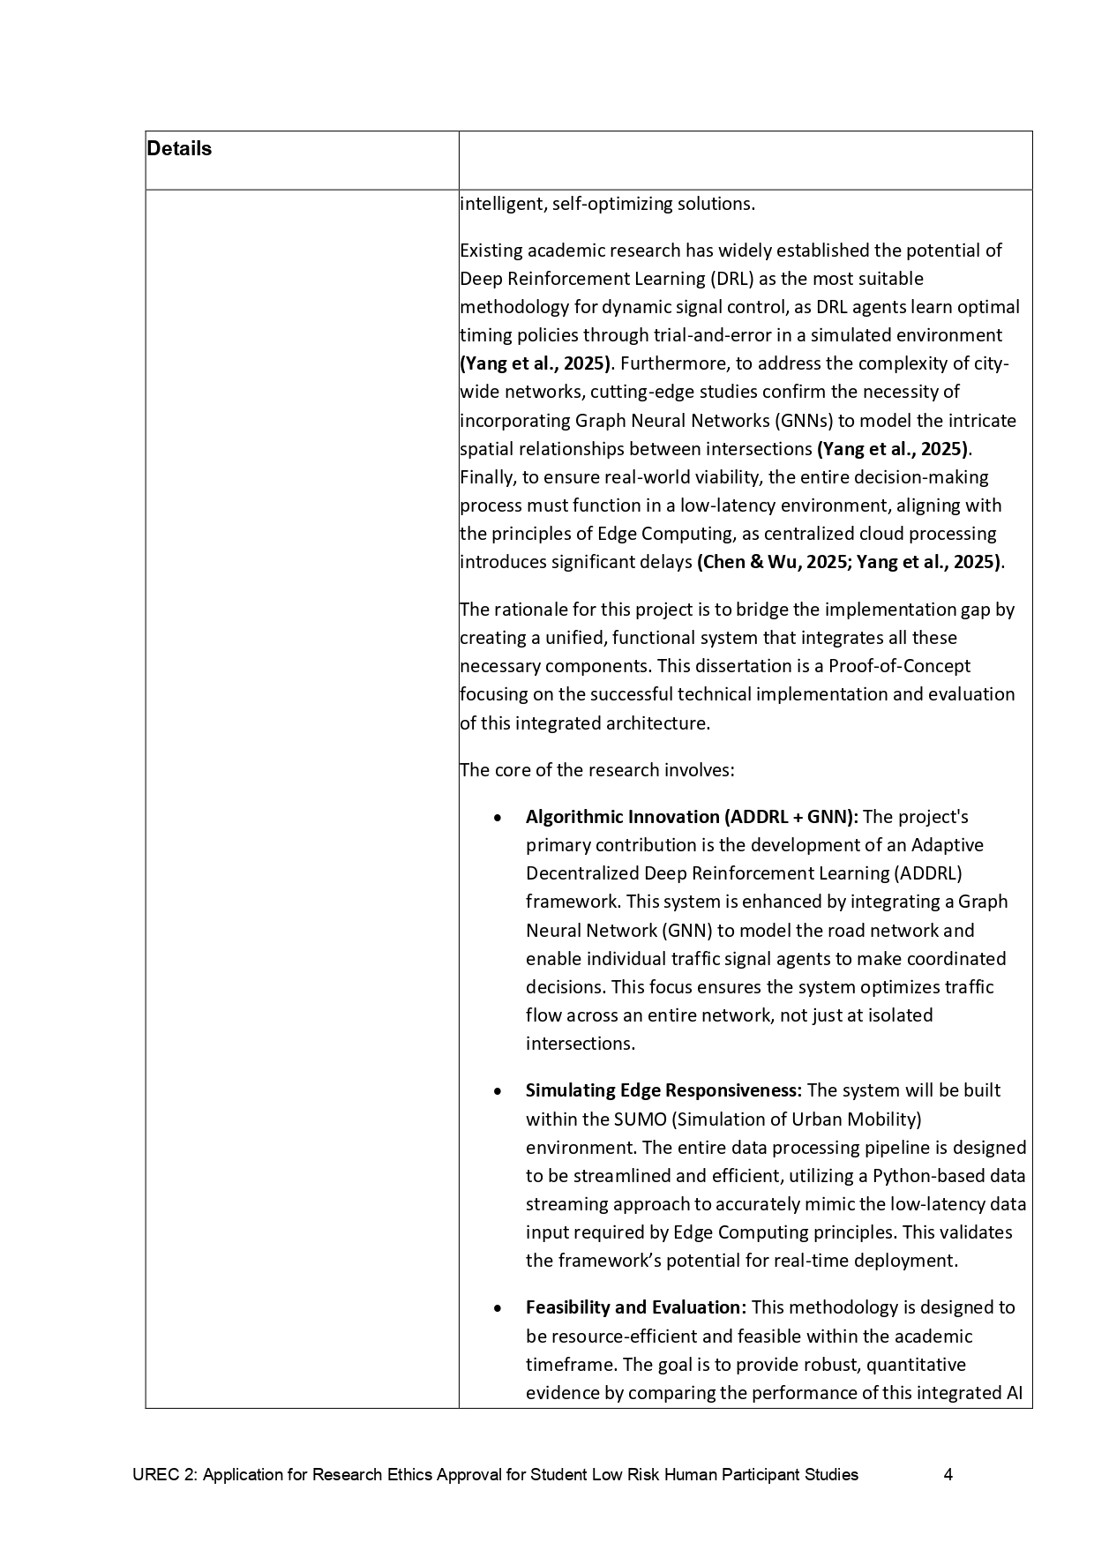

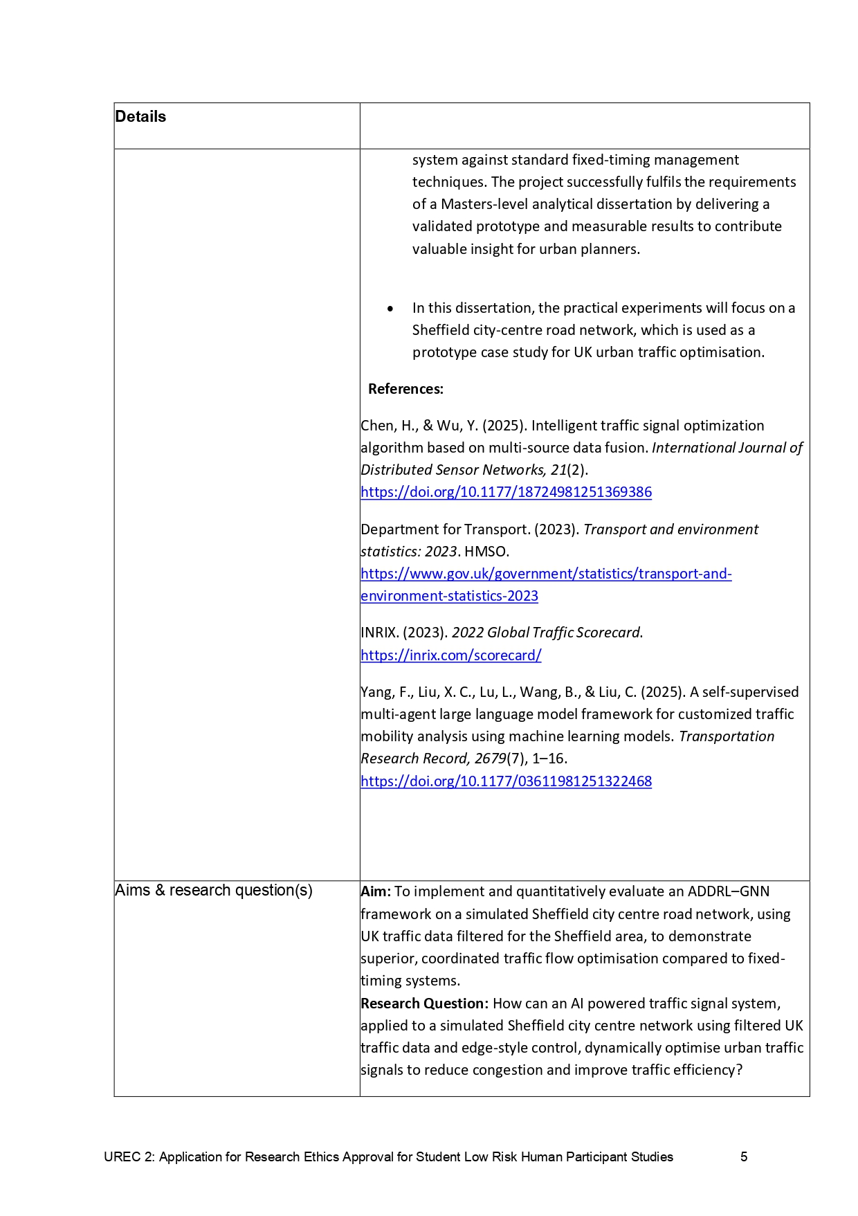

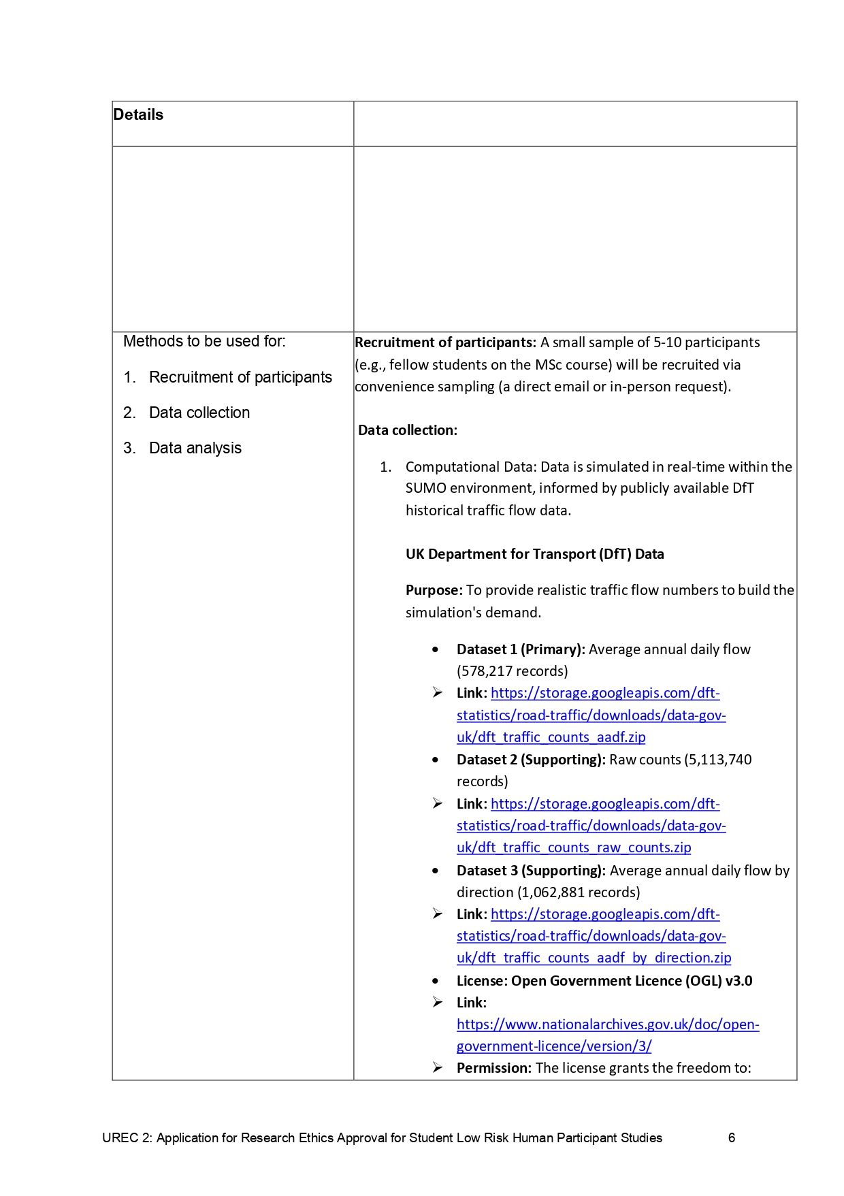









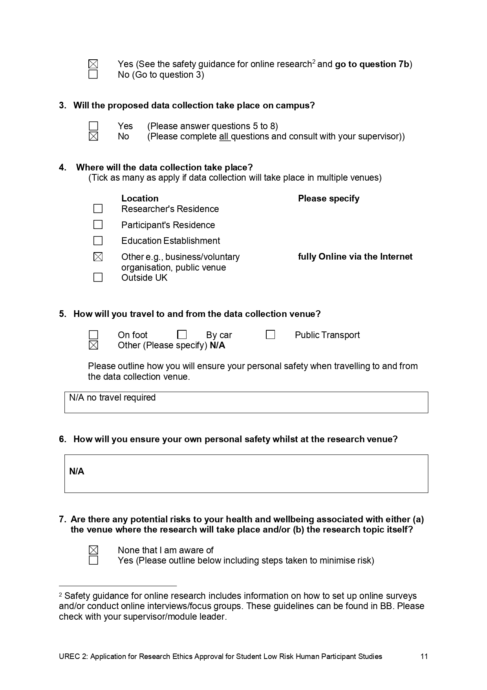







# Appendices B: Participant documents

* 1. **Participant Information Sheet**



**Participant Information Sheet**

**Title of Project:** AI-Powered Urban Traffic Optimization in the UK using Reinforcement Learning and Edge Computing.

**Student Researcher:** Mandar Dnyaneshwar Satpute (MSc Big Data Analytics)

**Supervisor:** Domdouzis Konstantinos

**Legal basis for research for studies:** The University undertakes research as part of its function for the community under its legal status. Data protection allows us to use personal data for research with appropriate safeguards in place under the legal basis of public tasks that are in the public interest. A full statement of your rights can be found at: <http://www.shu.ac.uk/about-this-website/privacy-policy/privacy-notices/privacy-notice-for-research.>

However, all University research is reviewed to ensure that participants are treated appropriately and their rights respected. This study was approved by the University’s Research Ethics Committee. Further information at: <http://www.shu.ac.uk/research/excellence/ethics-and-integrity>

**1. Invitation and purpose of research** You are being invited to take part in a small research study for my MSc Big Data Analytics dissertation. The purpose of this study is to evaluate the usability and clarity of a data visualisation dashboard I have created. This dashboard shows the performance of an AI traffic control system compared to a standard fixed-timing system.

**2. Why have you asked me to take part?** You have been invited because you are a fellow student at Sheffield Hallam University. Your feedback on how complex data is presented is highly valuable for validating the final deliverable of this project.

**3. Do I have to take part?** No, your participation is completely voluntary. You are free to withdraw at any time without giving a reason. Because the questionnaire is fully anonymous, it will not be possible to withdraw your data after you have submitted it, as I will not be able to identify which response is yours.

**4. What will I be required to do?** You will be asked to look at a single-page visualisation dashboard (sent as an image or file) which contains several charts. You will then be asked to complete a short, anonymous online questionnaire (e.g., on Google Forms) to give your opinion on its clarity and usefulness.

**5. Where will this take place?** The study is conducted **fully online**. You can complete the questionnaire on your own computer at a time that is convenient for you.

**6. How long will it take?** The entire process of reviewing the dashboard and completing the questionnaire should take **no more than 10 minutes** of your time.

**7. Are there any possible risks in taking part?** There are no identified risks in participating in this study.

**8. What are the possible benefits of taking part?** There are no direct benefits to you. However, your feedback will be a great help in validating this dissertation project and will contribute to a better understanding of how to effectively present complex AI simulation results to non-expert stakeholders.

**9. Will anyone be able to connect me with what is recorded and reported?** **No. The study is 100% anonymous.** The online questionnaire will **not** ask for your name, student ID, email address, or any other personal identifiable information.

**10. What will happen to the information when this study is over?** The anonymous responses will be aggregated (grouped together) and stored securely on a university-managed, networked F drive. The raw anonymous data will be deleted after the dissertation has been successfully graded, as per university policy.

**11. How will you use what you find out?** The aggregated, anonymous feedback will be summarised and discussed in Chapter 5 (Results & Evaluation) of my final dissertation report. No individual responses will ever be published.

**12. How can I find out about the results of the study?** The final dissertation will be available through the Sheffield Hallam University library after it has been graded and published.

**13. Who can I contact if I have concerns?**

* **Researcher:** Mandar Dnyaneshwar Satpute   
  <mailto:MandarDyaneshwar.D.Satpute@student.shu.ac.uk>
* **Supervisor:** Domdouzis Konstantinos   
  <mailto:K.Domdouzis@shu.ac.uk>

You should contact the **Data Protection Officer** [**mailto:DPO@shu.ac.uk**](mailto:DPO@shu.ac.uk)if:

* you have a query about how your data is used by the University.
* you would like to report a data security breach.
* you would like to complain about how the University has used your personal data.

You should contact the **Head of Research Ethics** [**mailto:ethicssupport@shu.ac.uk**](mailto:ethicssupport@shu.ac.uk)if:

* you have concerns with how the research was undertaken or how you were treated.

**Postal address:** Sheffield Hallam University, Howard Street, Sheffield S1 1WBT **Telephone:** 0114 225 5555

* 1. **Participant Consent Form**



**Participant Consent Form**

**TITLE OF RESEARCH STUDY:** AI-Powered Urban Traffic Optimization in the UK using Reinforcement Learning and Edge Computing. **Note:** This study is conducted **fully online and is anonymous**. This form will be presented as the first page of the online questionnaire. Clicking "Yes, I agree" will serve as your consent and allow you to proceed to the questionnaire.

Please answer the following questions.

**1. I have read the Participant Information Sheet for this study and have had details of the study explained to me.**

* YES
* NO

**2. My questions about the study have been answered to my satisfaction and I understand that I may ask further questions at any point.**

* YES
* NO

**3. I understand that my participation is voluntary and that I am free to withdraw at any time simply by closing this browser window.**

* YES
* NO

**4. I understand that my responses are fully anonymous and that no personal identifiable information (such as my name or email) will be collected.**

* YES
* NO

**5. I agree to provide information to the researchers under the conditions of confidentiality set out in the Information Sheet.**

* YES
* NO

**6. I wish to participate in the study under the conditions set out in the Information Sheet.**

* YES
* NO

**7. I consent to the information I provide, once anonymised, to be used for any other research purposes (such as future publications).**

* YES
* NO

*(The fields for participant signature/name are not required as this is an anonymous online survey)*

**Researcher's Name (Printed):** Mandar Dnyaneshwar Satpute **Researcher's contact details:** <mailto:MandarDyaneshwar.D.Satpute@student.shu.ac.uk>

* 1. **Google Forms consent confirmation showing 8/8 participants agreed to take part (anonymous online consent).**

# Appendices C: User evaluation instrument

* 1. **User Evaluation feedback Questions.**

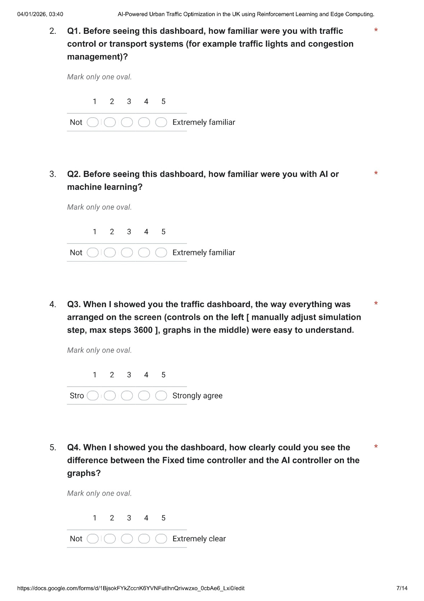<https://docs.google.com/forms/d/e/1FAIpQLSeiksDqh44fzp2ZZm8a98YUUREscimYiWebQugHB4DzfhgIMw/viewform?usp=dialog>





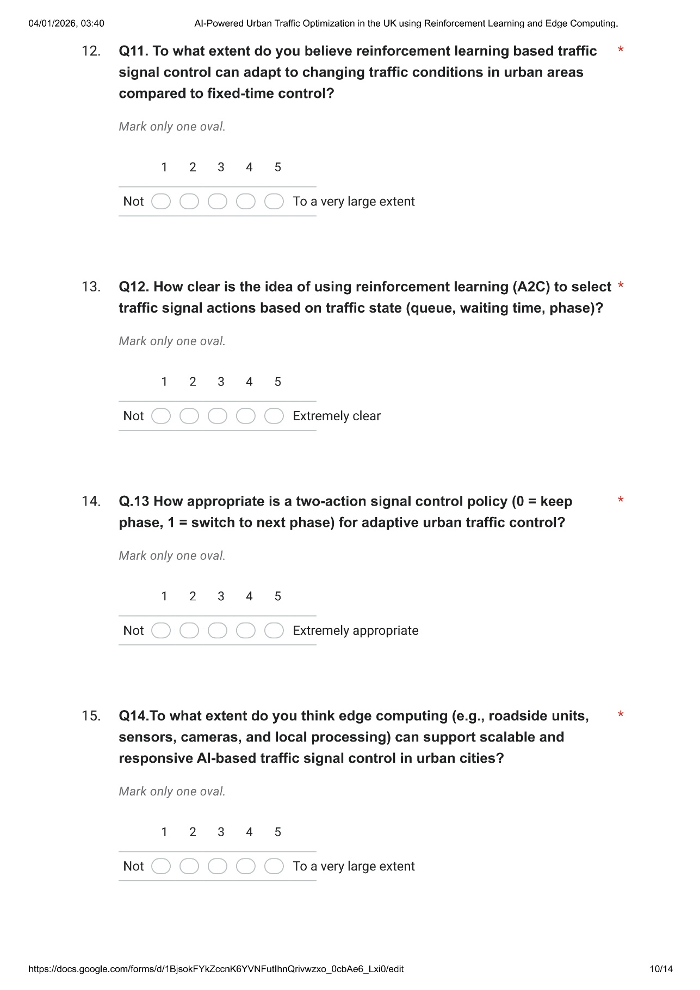







# Appendices D: User evaluation responses

* 1. **Evaluation responses**

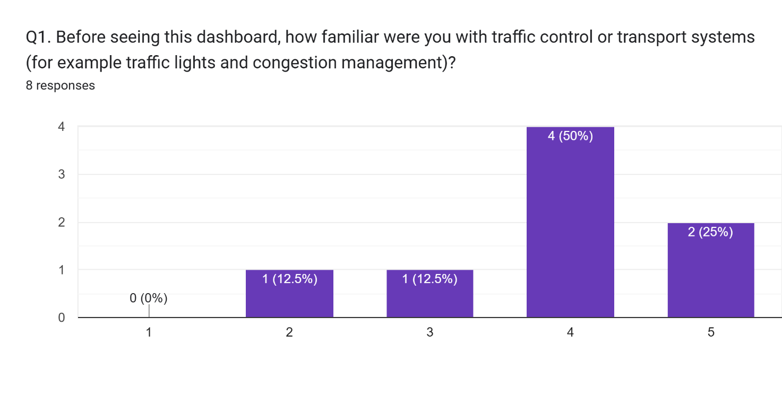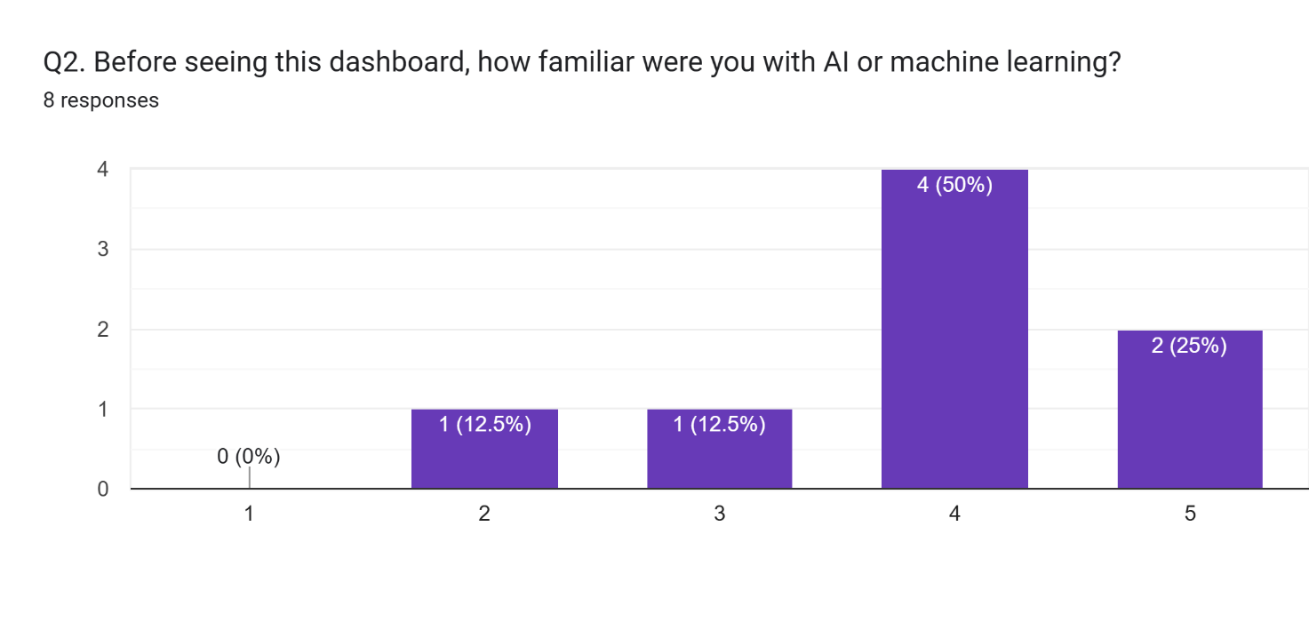

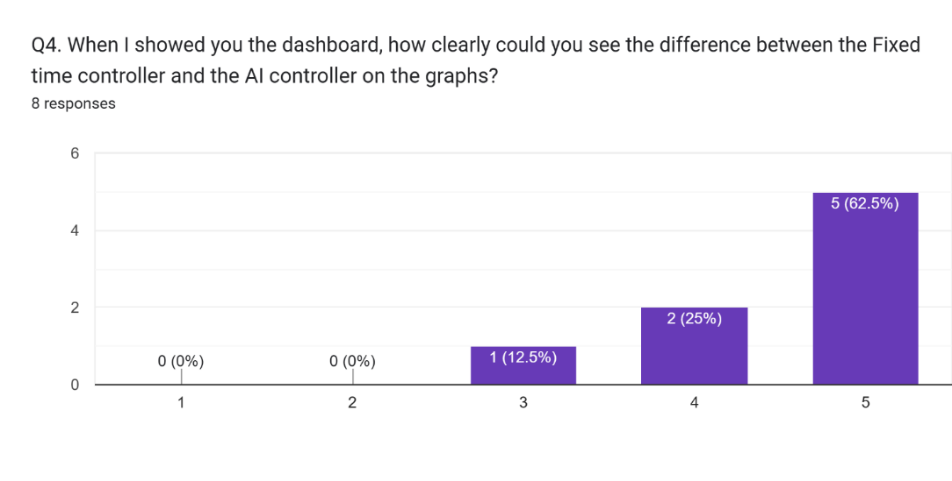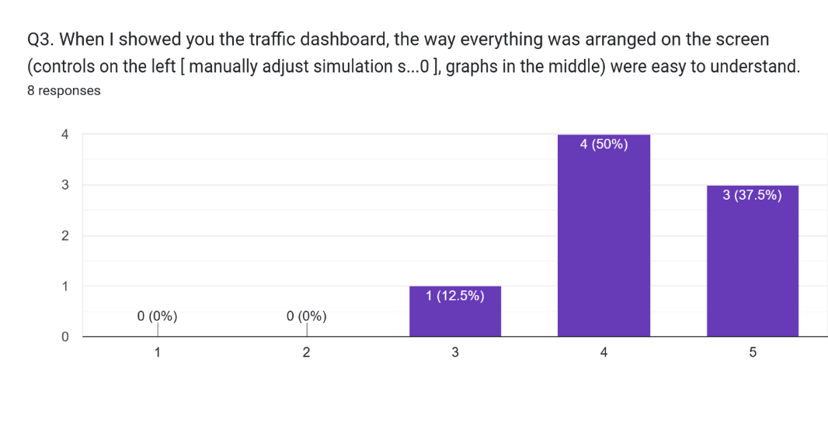

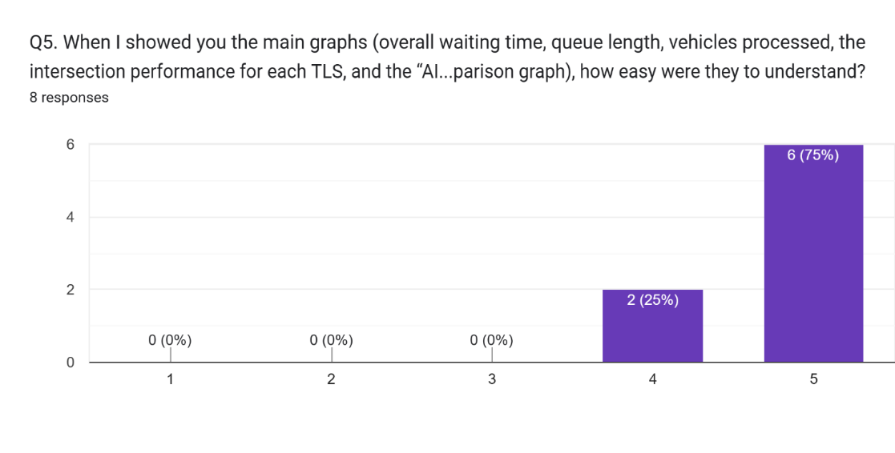

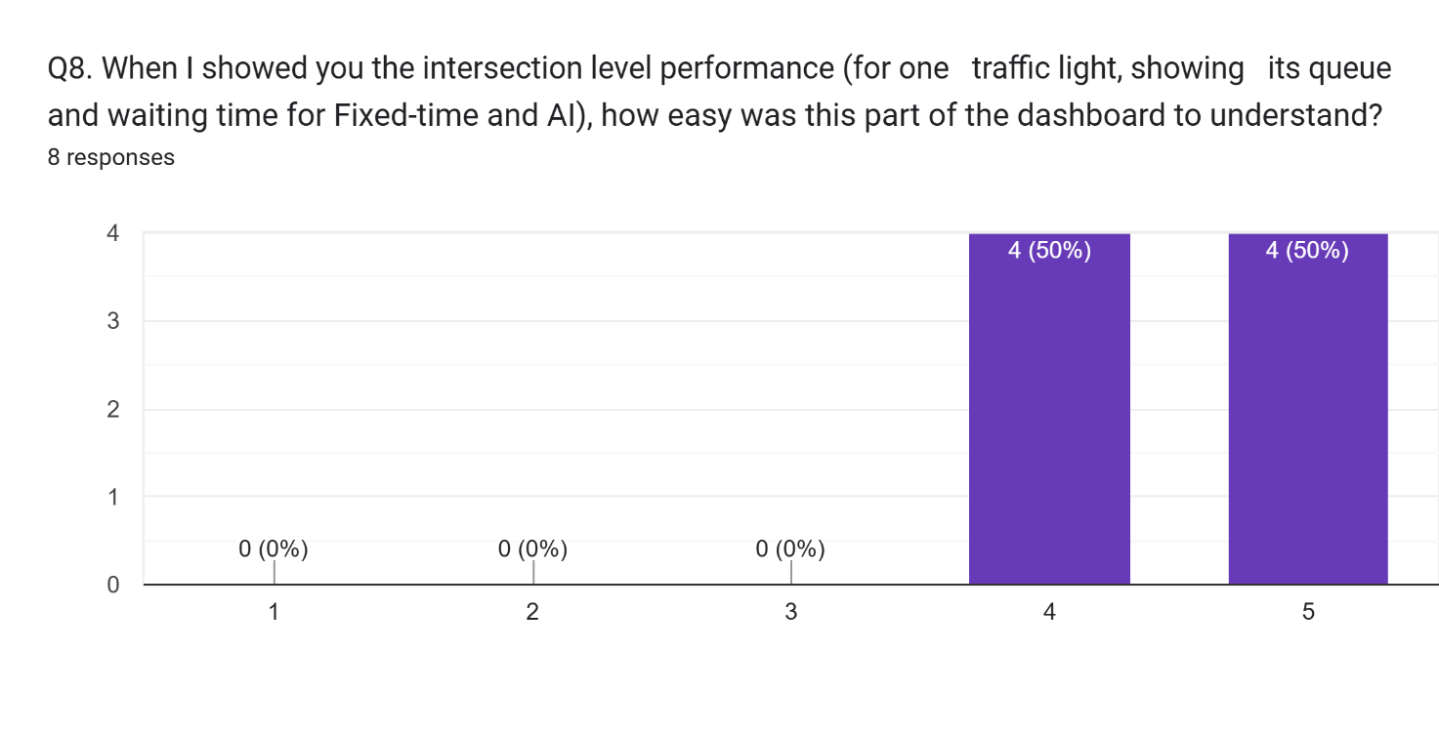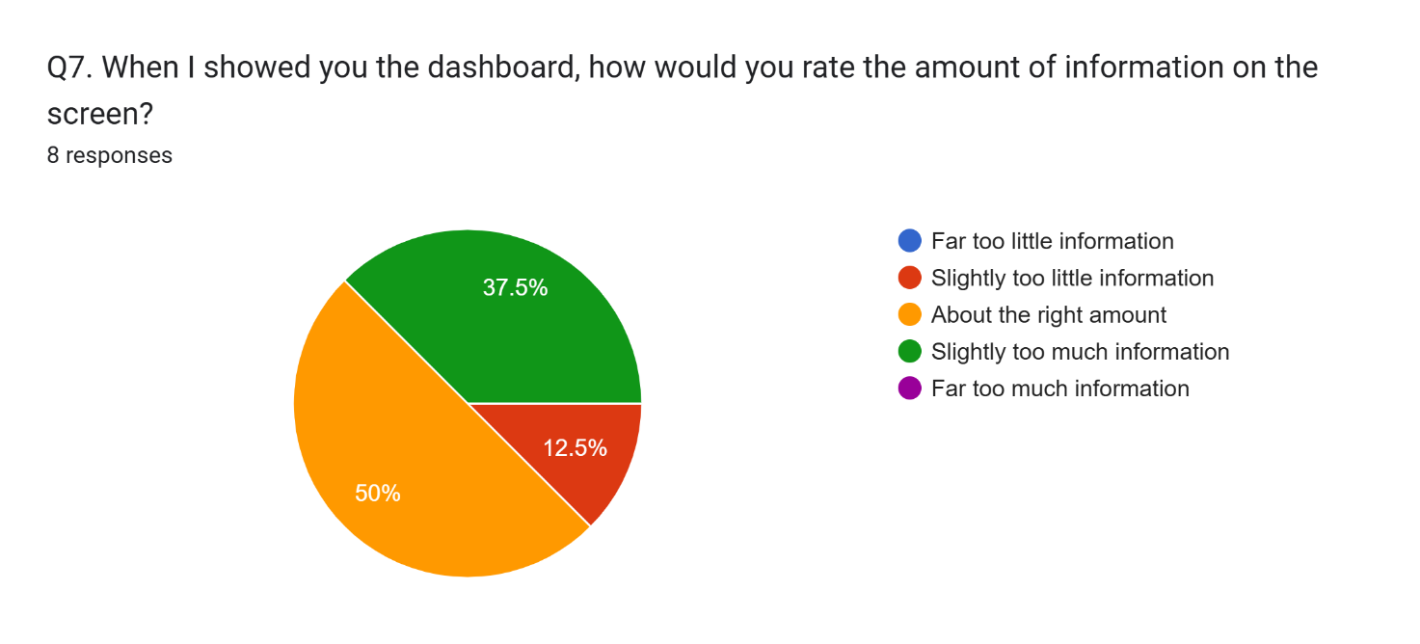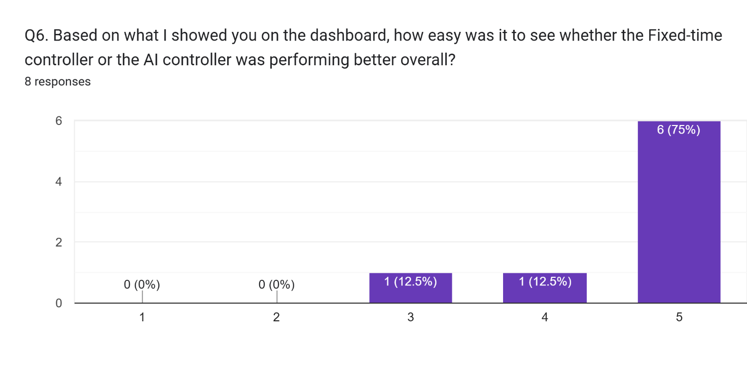

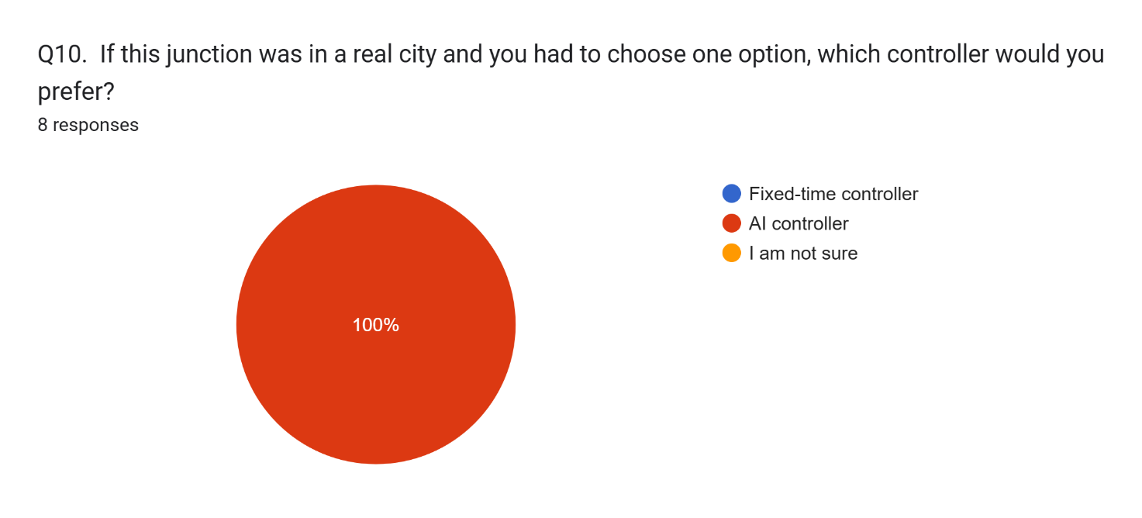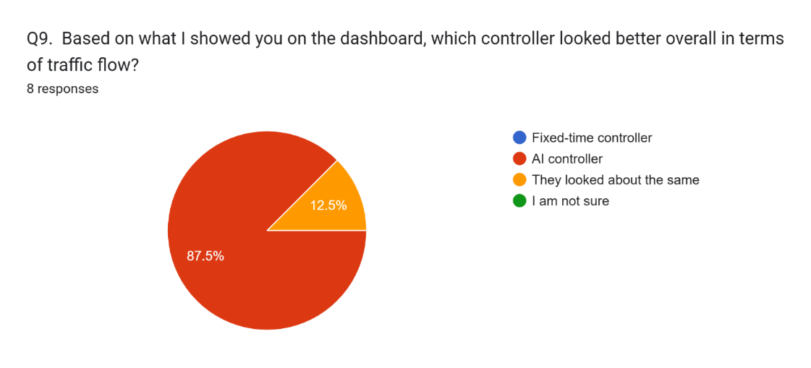

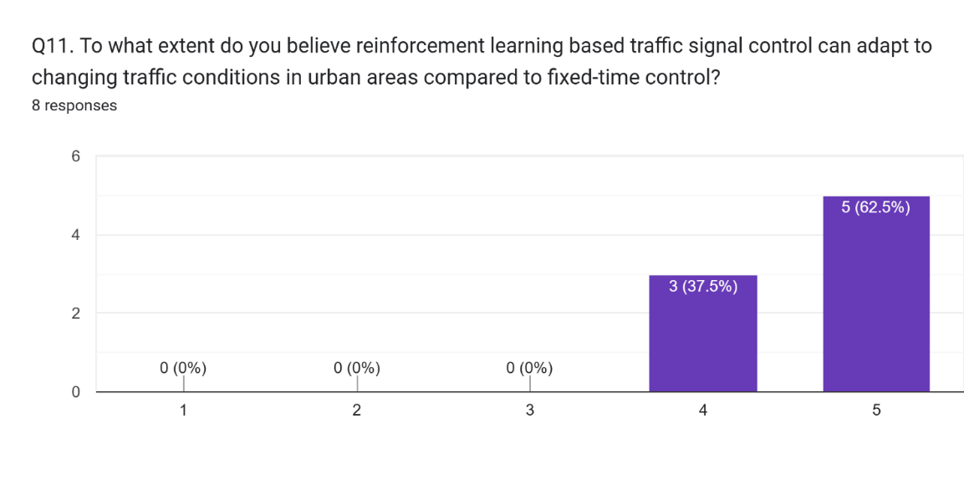

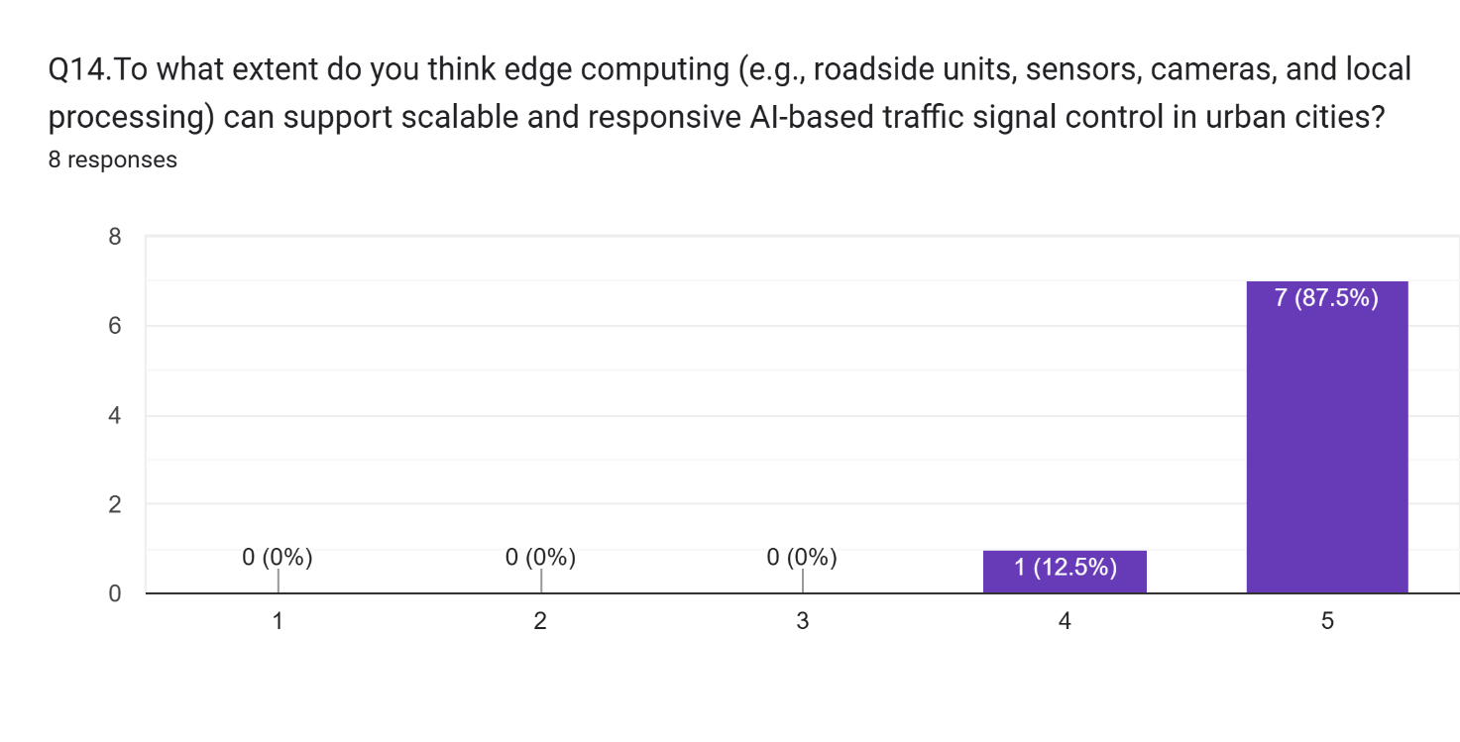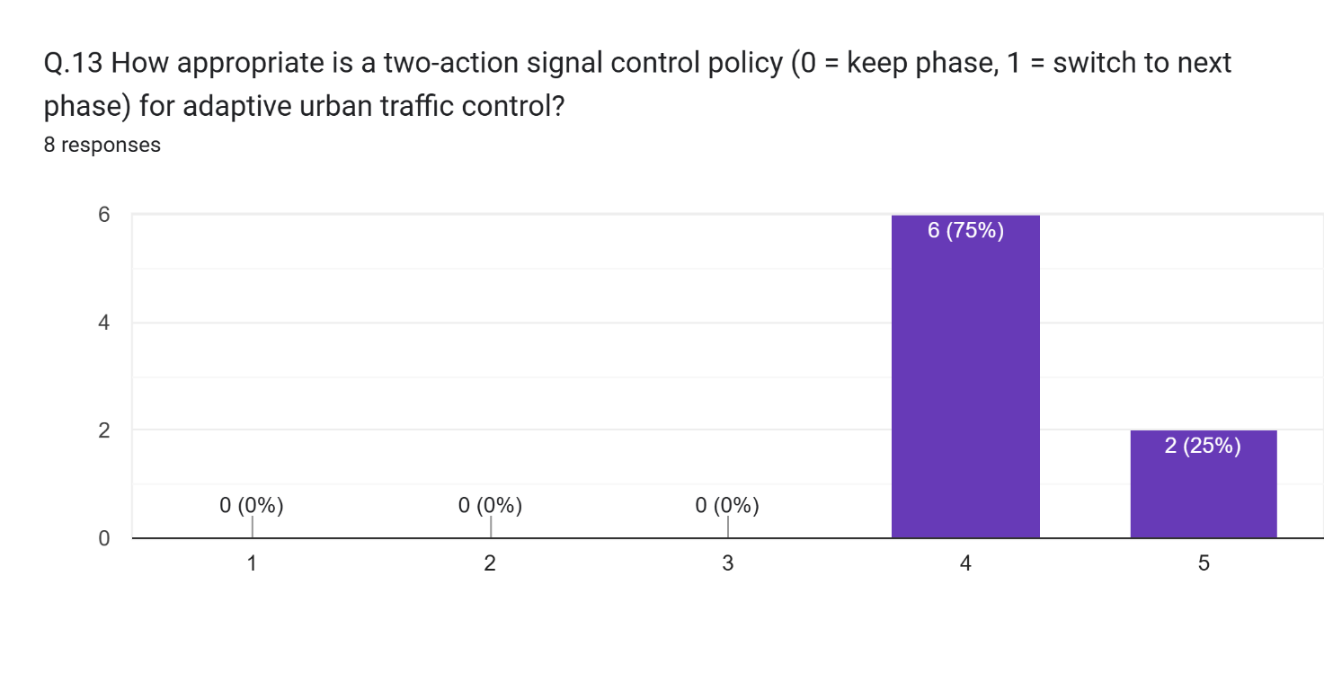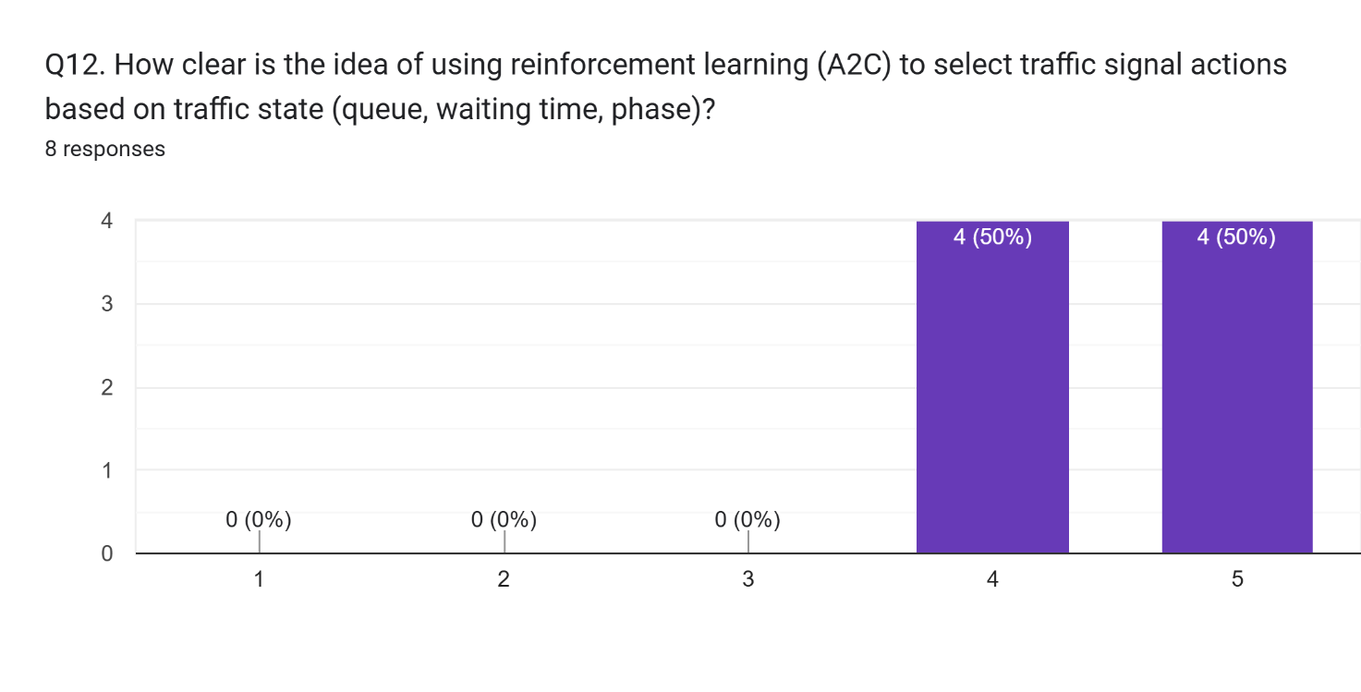

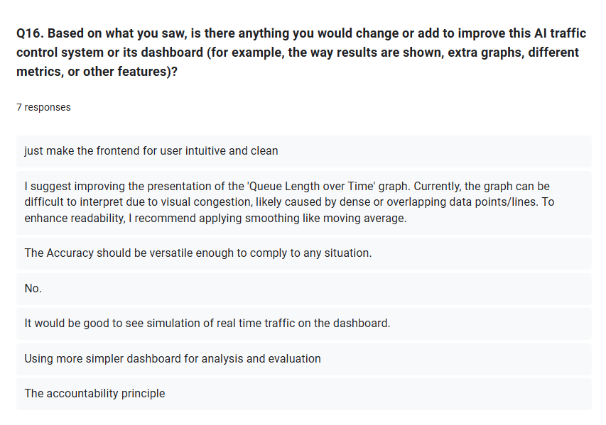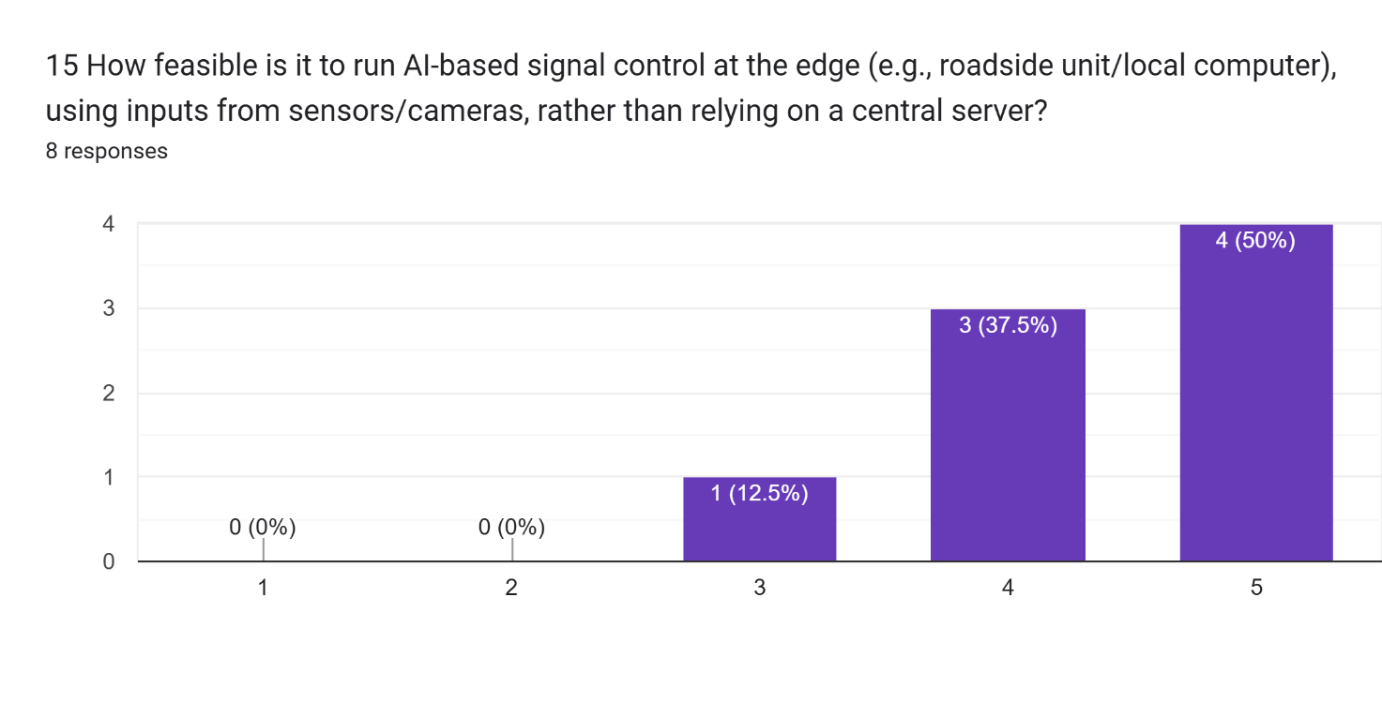

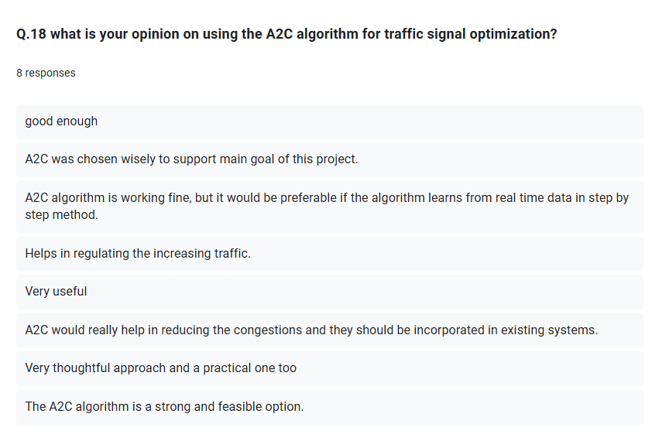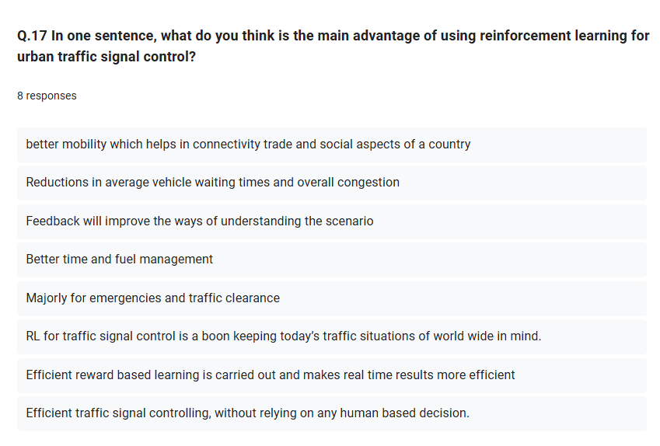

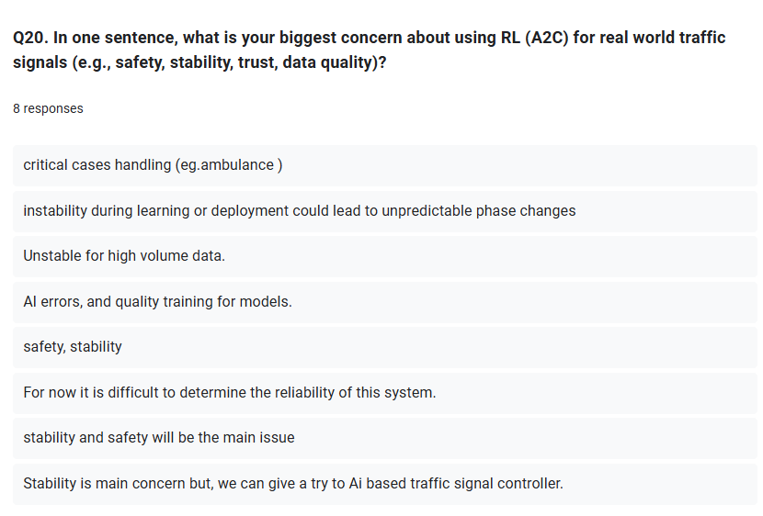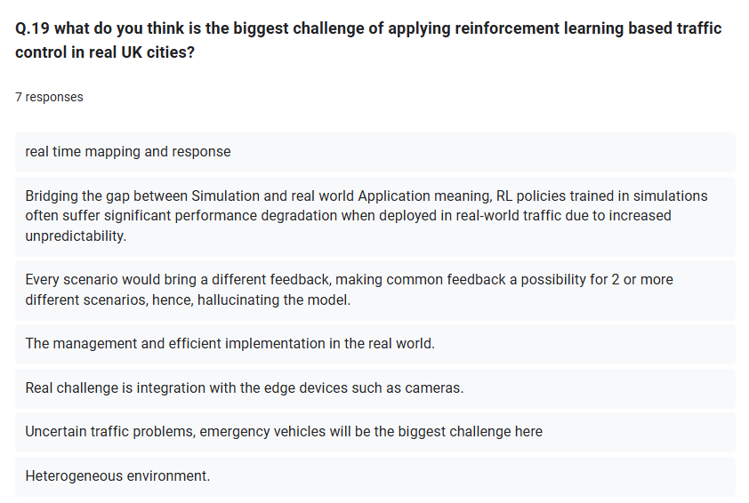

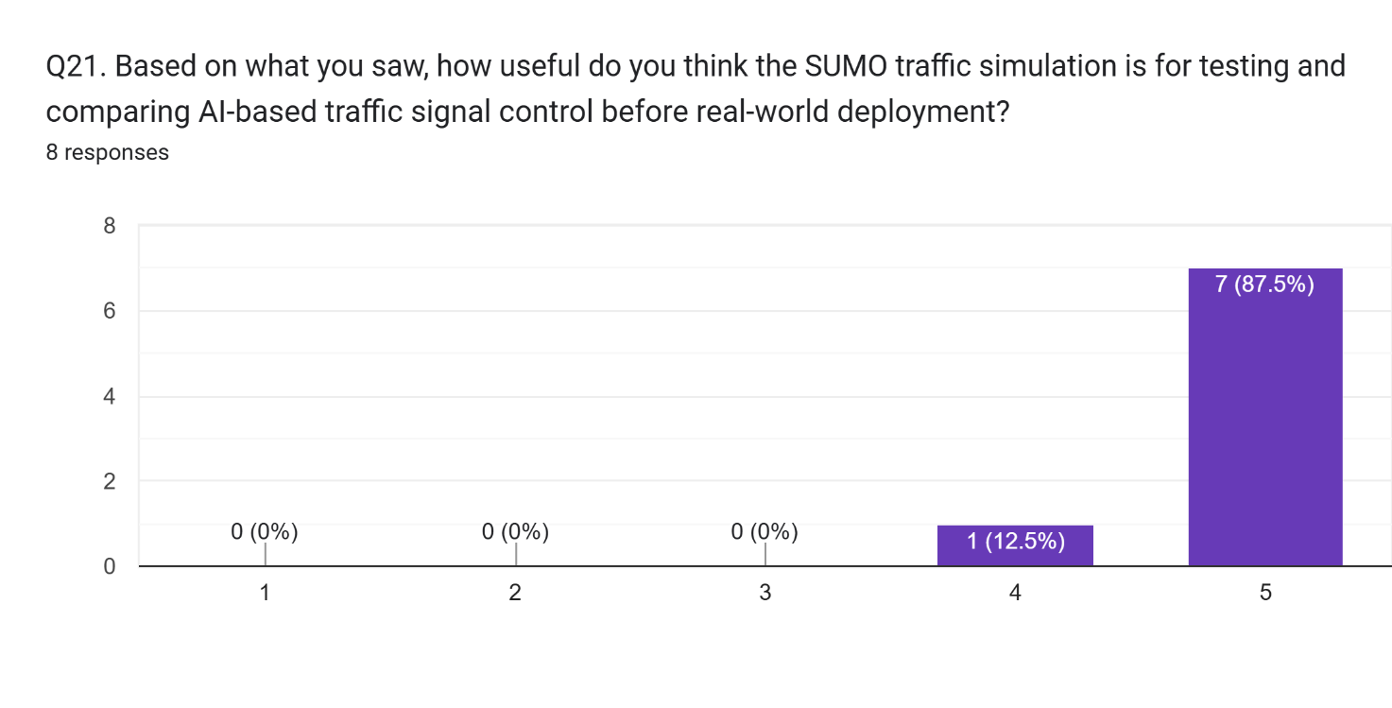

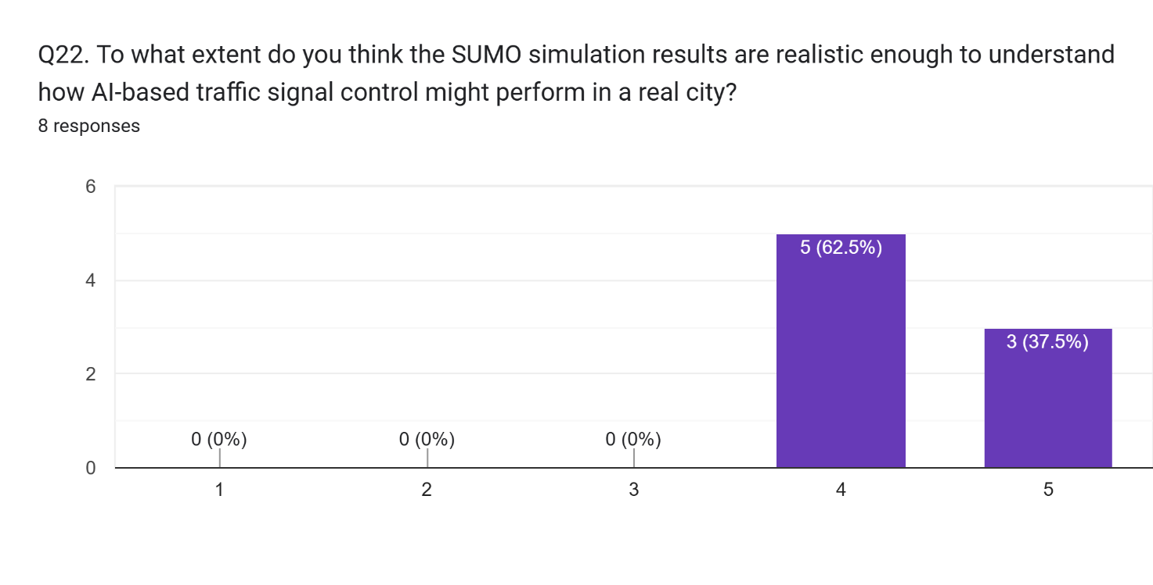

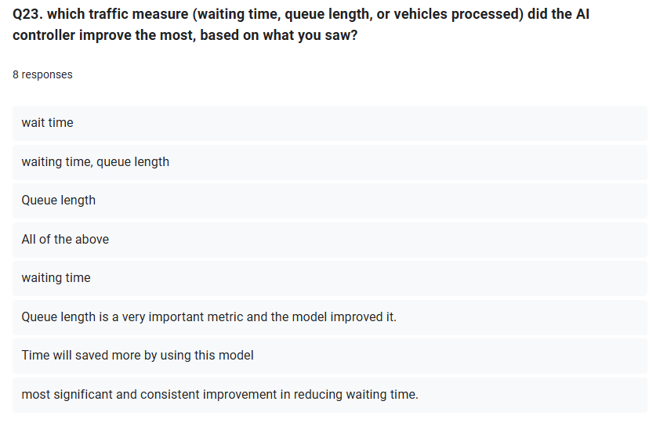

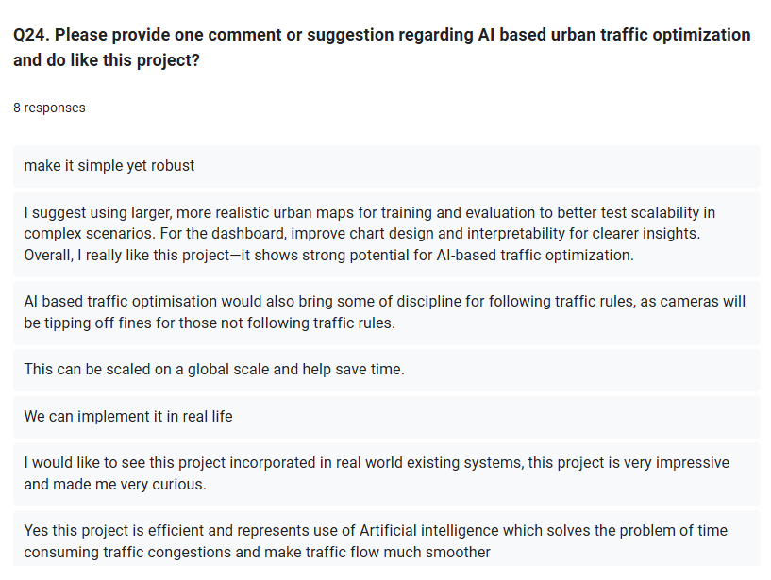

# Appendices E: Project code

* 1. 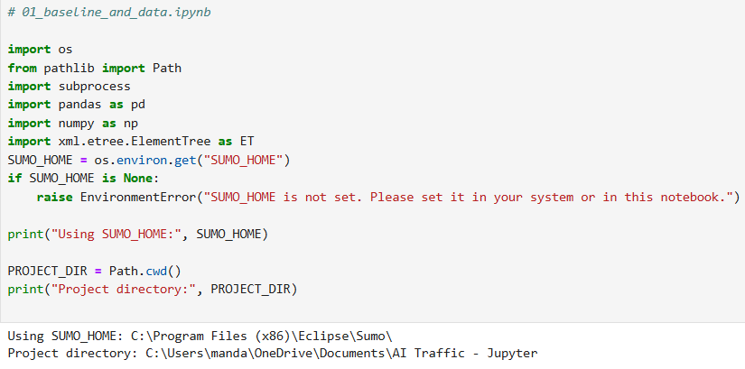**Initial project setup and environment configuration for the SUMO-based traffic simulation pipeline.**
  2. **Sheffield AADF data loading, cleaning, and peak hour demand calibration code used for SUMO route generation**

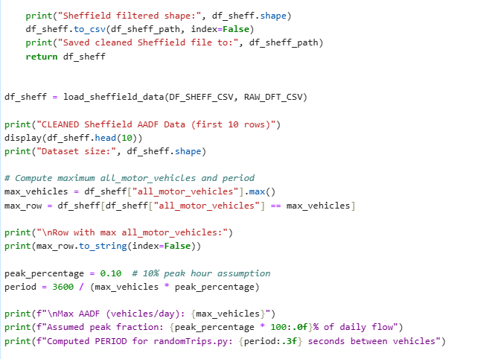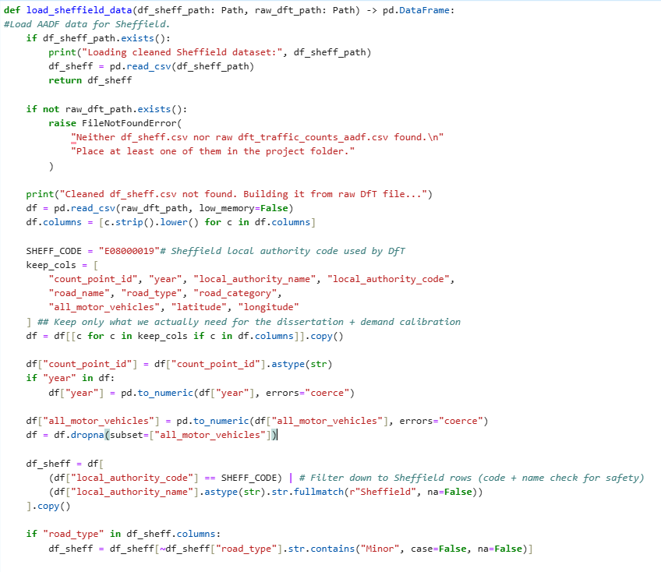

* 1. 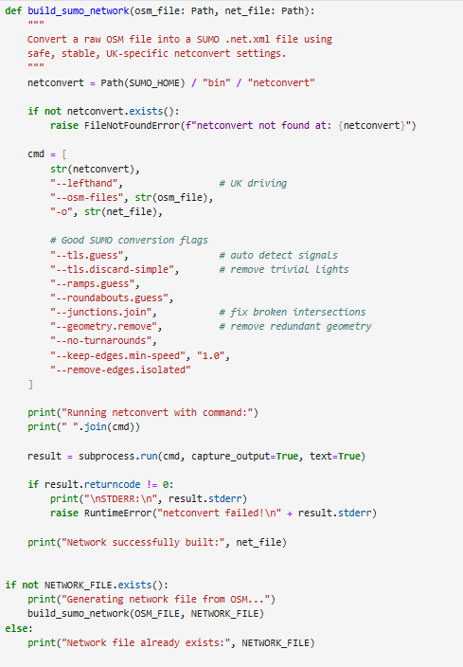**SUMO network generation from OpenStreetMap data using netconvert (OSM to my_network.net.xml)**
  2. **Synthetic traffic route generation using SUMO’s randomTrips.py with AADF calibrated vehicle generation period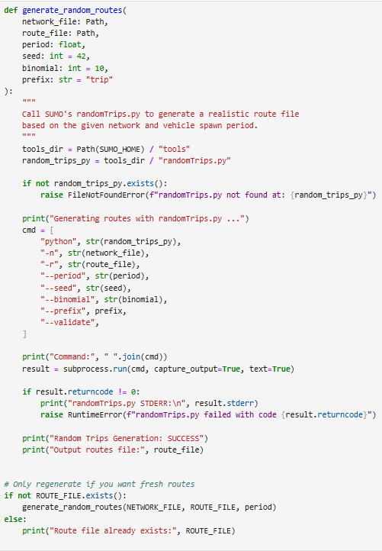.**
  3. 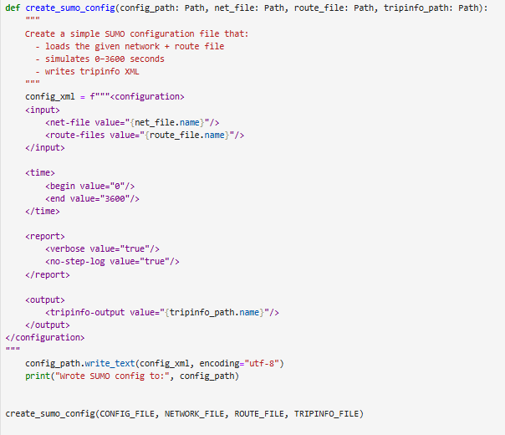**Automatic generation of SUMO configuration file linking network, routes, and trip information output**
  4. 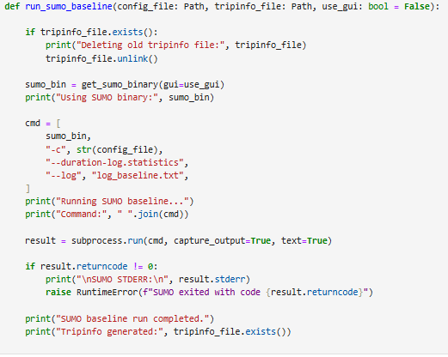**Execution of fixed-time SUMO baseline simulation and generation of trip level performance metrics**
  5. **SUMO fixed-time baseline simulation log and performance statistics (log_baseline.txt)**

Loading net-file from 'C:\Users\manda\OneDrive\Documents\AI Traffic - Jupyter\my_network.net.xml' ... done (19ms).

Loading route-files incrementally from 'C:\Users\manda\OneDrive\Documents\AI Traffic - Jupyter\my_routes.rou.xml'

Loading done.

Simulation version 1.25.0 started with time: 0.00.

Warning: Teleporting vehicle 'trip28'; waited too long (wrong lane), lane='164073716#2_1', time=309.00.

Warning: Teleporting vehicle 'trip5'; waited too long (jam), lane=':7671039164_0_1', time=319.00.

Warning: Teleporting vehicle 'trip35'; waited too long (yield), lane='15833384#1_0', time=321.00.

Warning: Vehicle 'trip5' ends teleporting on edge '324489280#0', time=324.00.

Warning: Vehicle 'trip35' teleports beyond arrival edge '107445428#1', time=328.00.

Warning: Teleporting vehicle 'trip51'; waited too long (jam), lane=':7671039164_0_0', time=330.00.

Warning: Vehicle 'trip51' ends teleporting on edge '821520605', time=332.00.

Warning: Vehicle 'trip28' teleports beyond arrival edge '-974103232#0', time=338.00.

Warning: Teleporting vehicle 'trip76'; waited too long (jam), lane=':7671039164_0_0', time=635.00.

Warning: Vehicle 'trip76' ends teleporting on edge '821520605', time=637.00.

Warning: Teleporting vehicle 'trip125'; waited too long (jam), lane=':7671039164_0_1', time=663.00.

Warning: Vehicle 'trip125' ends teleporting on edge '822595543', time=680.00.

Warning: Teleporting vehicle 'trip167'; waited too long (yield), lane='15833384#1_0', time=846.00.

Warning: Vehicle 'trip167' ends teleporting on edge '107445428#1', time=864.00.

Warning: Teleporting vehicle 'trip114'; waited too long (jam), lane=':7671039164_0_0', time=940.00.

Warning: Vehicle 'trip114' ends teleporting on edge '821520605', time=946.00.

Warning: Teleporting vehicle 'trip191'; waited too long (yield), lane='15833384#1_0', time=1151.00.

Warning: Vehicle 'trip191' ends teleporting on edge '107445428#0', time=1156.00.

Warning: Teleporting vehicle 'trip224'; waited too long (wrong lane), lane='164073716#2_1', time=1299.00.

Warning: Teleporting vehicle 'trip154'; waited too long (jam), lane=':7671039164_0_0', time=1301.00.

Warning: Vehicle 'trip224' teleports beyond arrival edge '107445426#0', time=1302.00.

Warning: Vehicle 'trip154' teleports beyond arrival edge '-974103232#1', time=1311.00.

Warning: Teleporting vehicle 'trip171'; waited too long (jam), lane=':7671039164_0_0', time=1705.00.

Warning: Teleporting vehicle 'trip1022'; waited too long (yield), lane='15833384#1_0', time=1710.00.

Warning: Teleporting vehicle 'trip366'; waited too long (wrong lane), lane='164073716#2_1', time=1711.00.

Warning: Teleporting vehicle 'trip647'; waited too long (jam), lane=':7671039164_0_1', time=1713.00.

Warning: Vehicle 'trip171' teleports beyond arrival edge '107445426#0', time=1715.00.

Warning: Vehicle 'trip366' teleports beyond arrival edge '107445426#1', time=1715.00.

Warning: Vehicle 'trip647' teleports beyond arrival edge '324489280#0', time=1721.00.

Warning: Vehicle 'trip1022' ends teleporting on edge '107445428#2', time=1729.00.

Warning: Teleporting vehicle 'trip1671'; waited too long (jam), lane='974103233_0', time=1745.00.

Warning: Vehicle 'trip1671' ends teleporting on edge '40349438#0', time=1769.00.

Warning: Teleporting vehicle 'trip1092'; waited too long (yield), lane='15833384#1_0', time=2016.00.

Warning: Vehicle 'trip1092' ends teleporting on edge '107445428#2', time=2035.00.

Warning: Teleporting vehicle 'trip1016'; waited too long (jam), lane='164073716#0_0', time=2043.00.

Warning: Vehicle 'trip1016' ends teleporting on edge '324489280#0', time=2047.00.

Warning: Teleporting vehicle 'trip1191'; waited too long (jam), lane='822595542_0', time=2065.00.

Warning: Vehicle 'trip1191' ends teleporting on edge '164073716#0', time=2065.00.

Warning: Teleporting vehicle 'trip406'; waited too long (wrong lane), lane='164073716#2_1', time=2257.00.

Warning: Vehicle 'trip406' teleports beyond arrival edge '107445426#0', time=2260.00.

Warning: Teleporting vehicle 'trip1098'; waited too long (yield), lane='15833384#1_0', time=2320.00.

Warning: Vehicle 'trip1098' teleports beyond arrival edge '107445428#1', time=2338.00.

Warning: Teleporting vehicle 'trip794'; waited too long (jam), lane=':7671039164_0_1', time=2520.00.

Warning: Vehicle 'trip794' ends teleporting on edge '324489280#0', time=2522.00.

Warning: Teleporting vehicle 'trip414'; waited too long (wrong lane), lane='164073716#2_1', time=2558.00.

Warning: Vehicle 'trip414' teleports beyond arrival edge '107445426#0', time=2561.00.

Warning: Teleporting vehicle 'trip1159'; waited too long (yield), lane='15833384#1_0', time=2722.00.

Warning: Vehicle 'trip1159' ends teleporting on edge '107445428#2', time=2741.00.

Warning: Teleporting vehicle 'trip442'; waited too long (wrong lane), lane='164073716#2_1', time=2859.00.

Warning: Vehicle 'trip442' teleports beyond arrival edge '315129218#0', time=2860.00.

Warning: Teleporting vehicle 'trip1081'; waited too long (jam), lane=':7671039164_0_0', time=2861.00.

Warning: Teleporting vehicle 'trip963'; waited too long (jam), lane='164073716#0_1', time=2863.00.

Warning: Vehicle 'trip963' ends teleporting on edge '324489280#0', time=2866.00.

Warning: Vehicle 'trip1081' ends teleporting on edge '821520605', time=2866.00.

Warning: Teleporting vehicle 'trip844'; waited too long (jam), lane=':7671039164_0_1', time=2888.00.

Warning: Vehicle 'trip844' ends teleporting on edge '324489280#0', time=2893.00.

Warning: Teleporting vehicle 'trip1267'; waited too long (yield), lane='15833384#1_0', time=3069.00.

Warning: Vehicle 'trip1267' ends teleporting on edge '107445428#2', time=3088.00.

Warning: Teleporting vehicle 'trip1332'; waited too long (yield), lane='15833384#1_0', time=3435.00.

Warning: Vehicle 'trip1332' ends teleporting on edge '107445428#2', time=3454.00.

Simulation ended at time: 3600.00.

Reason: The final simulation step has been reached.

Performance:

Duration: 5.29s

Real time factor: 681.173

UPS: 87749.101230

Vehicles:

Inserted: 5456 (Loaded: 13628)

Running: 129

Waiting: 8172

Teleports: 30 (Jam: 15, Yield: 9, Wrong Lane: 6)

Statistics (avg of 5327):

RouteLength: 103.58

Speed: 5.33

Duration: 66.43

WaitingTime: 49.38

TimeLoss: 59.03

DepartDelay: 293.38

* 1. **Discovery of traffic light signal (TLS) IDs from the SUMO network using TraCI.**

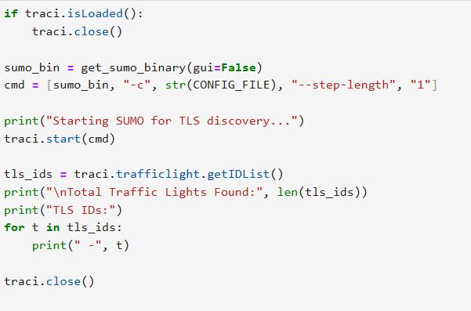

* 1. **Mapping of traffic light signals (TLS) to their controlled lanes using TraCI.**

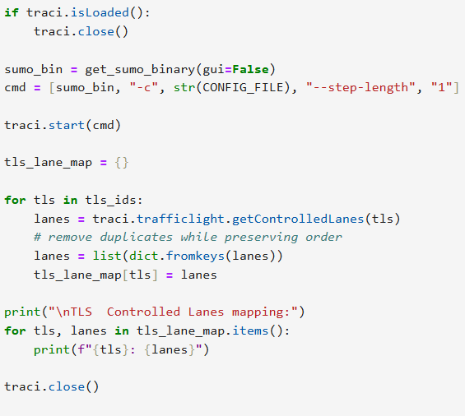

* 1. 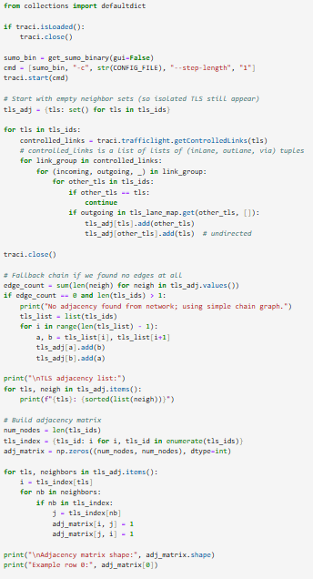**Construction of the traffic light adjacency graph for GNN input using controlled link connectivity**
  2. ***Definition and validation of the global reward function based on total lane waiting time.***

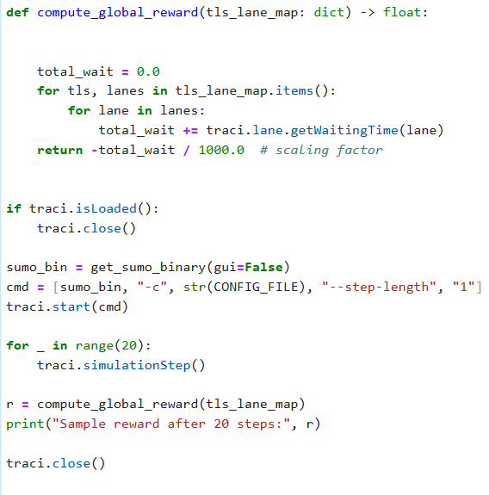

* 1. **Identification of traffic light signals (TLS) and construction of the TLS lane control mapping.**

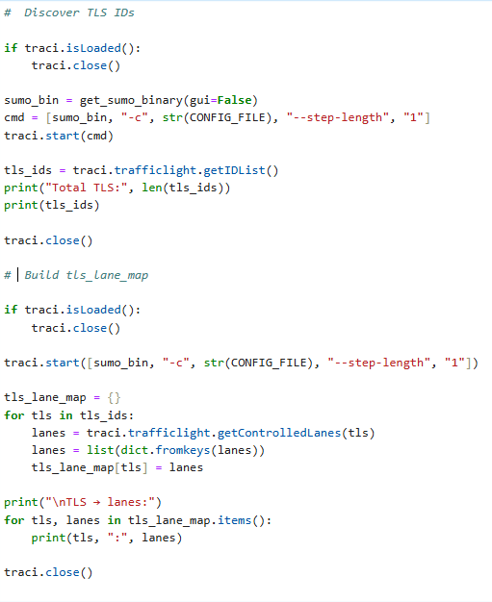

* 1. **Simplified global reward function definition based on aggregated lane waiting time.**

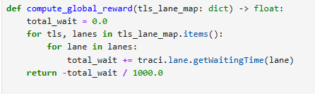

* 1. 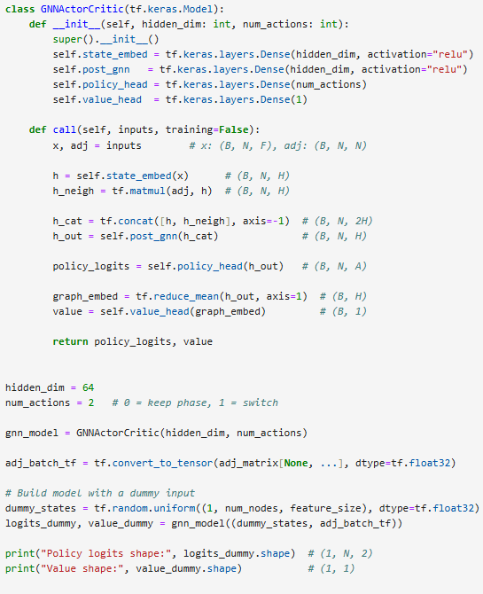**Graph Neural Network based Actor Critic (A2C) model architecture for decentralised traffic signal control**
  2. 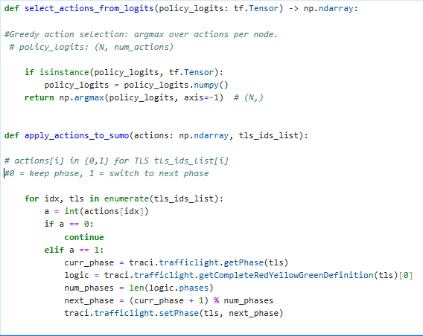**Greedy action selection and application of GNN A2C traffic signal actions within the SUMO environment.**
  3. **One step inference and action execution using the trained GNN A2C traffic signal controller.**

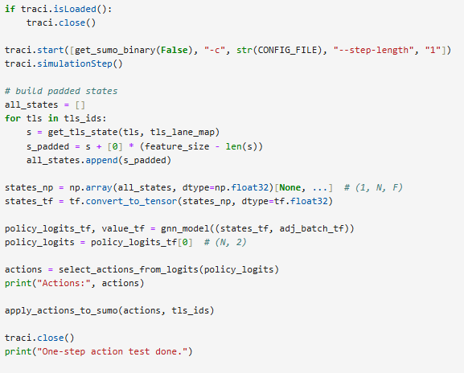

* 1. **A2C hyperparameter configuration for stable training of the GNN-based traffic signal controller**

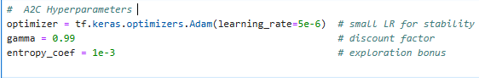

* 1. 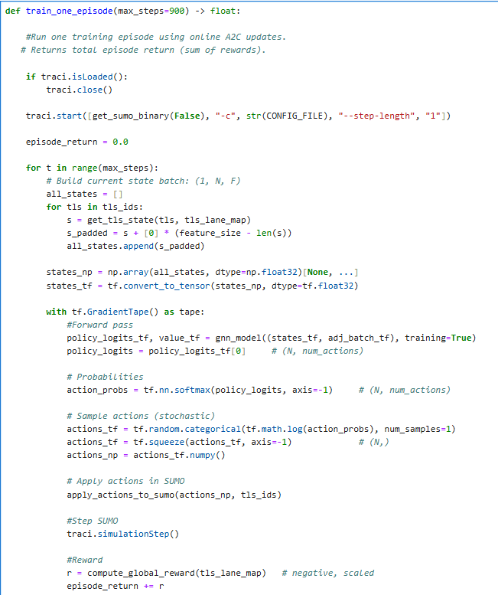**training loop for the GNN A2C traffic signal controller using SUMO and TraCI.**

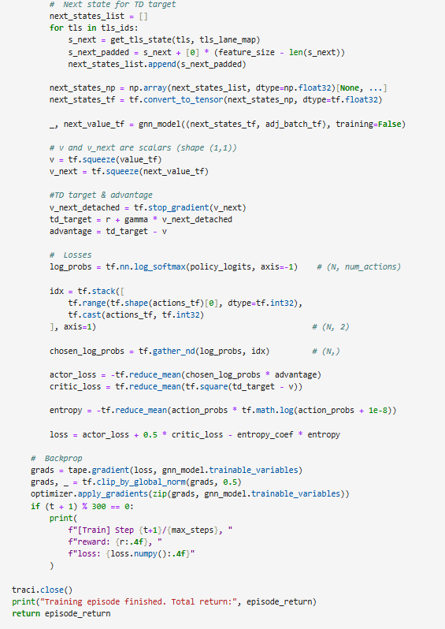

* 1. **Execution of multiple training episodes and logging of cumulative returns for the GNN A2C controller.**

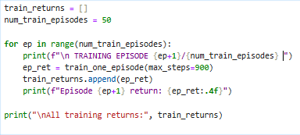

* 1. **Saving the best performing GNN A2C model weights (gnn_a2c_best.weights.h5) based on highest episode return during training.**

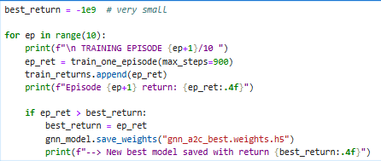

* 1. ***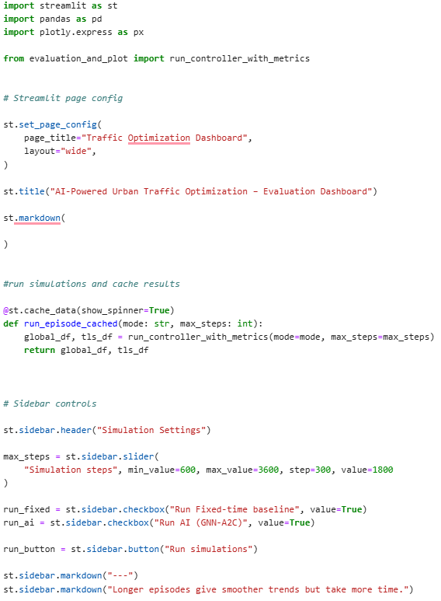*Streamlit dashboard setup and user controlled simulation configuration for fixed-time and GNN A2C traffic signal evaluation.**
  2. **This code implements the episode level comparison logic used in the dashboard to quantify and visualise performance differences between fixed-time and GNN A2C traffic signal controllers.**

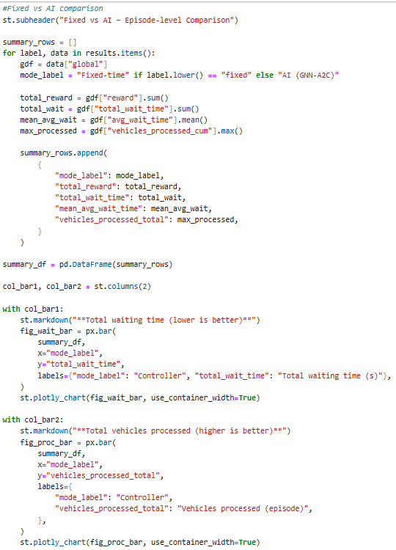

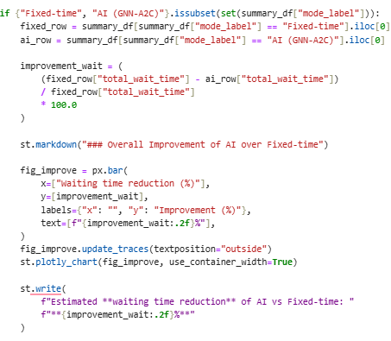

* 1. 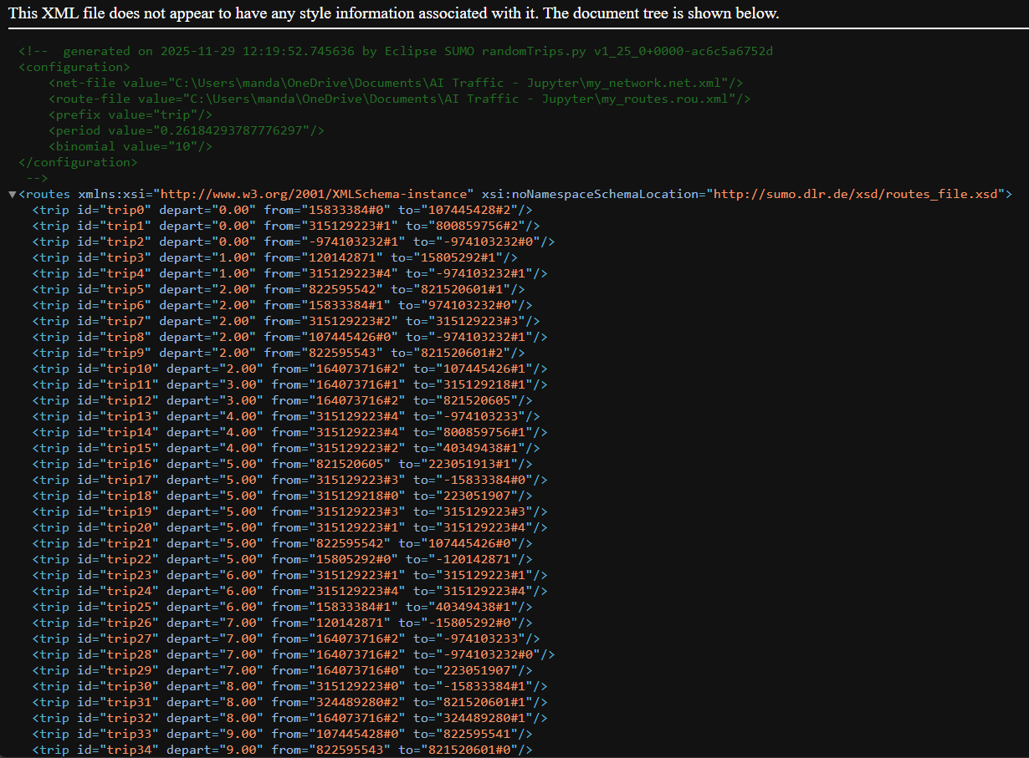**Sample of the generated trips file (XML) showing departure time and OD definitions.**

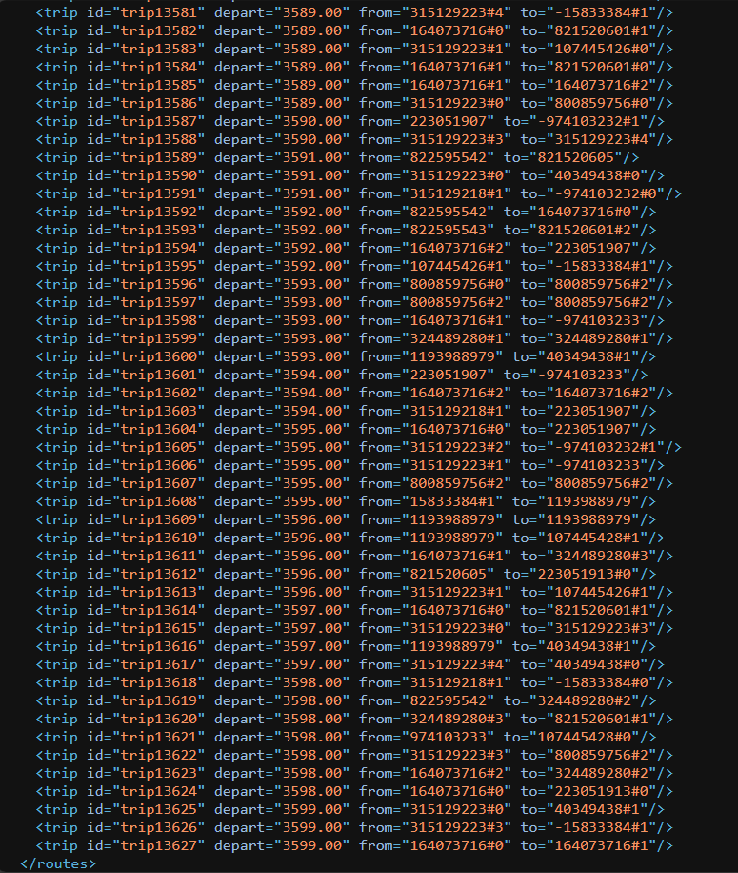

**24. Launching the Streamlit evaluation dashboard locally from the command line (directory setup and run command).**

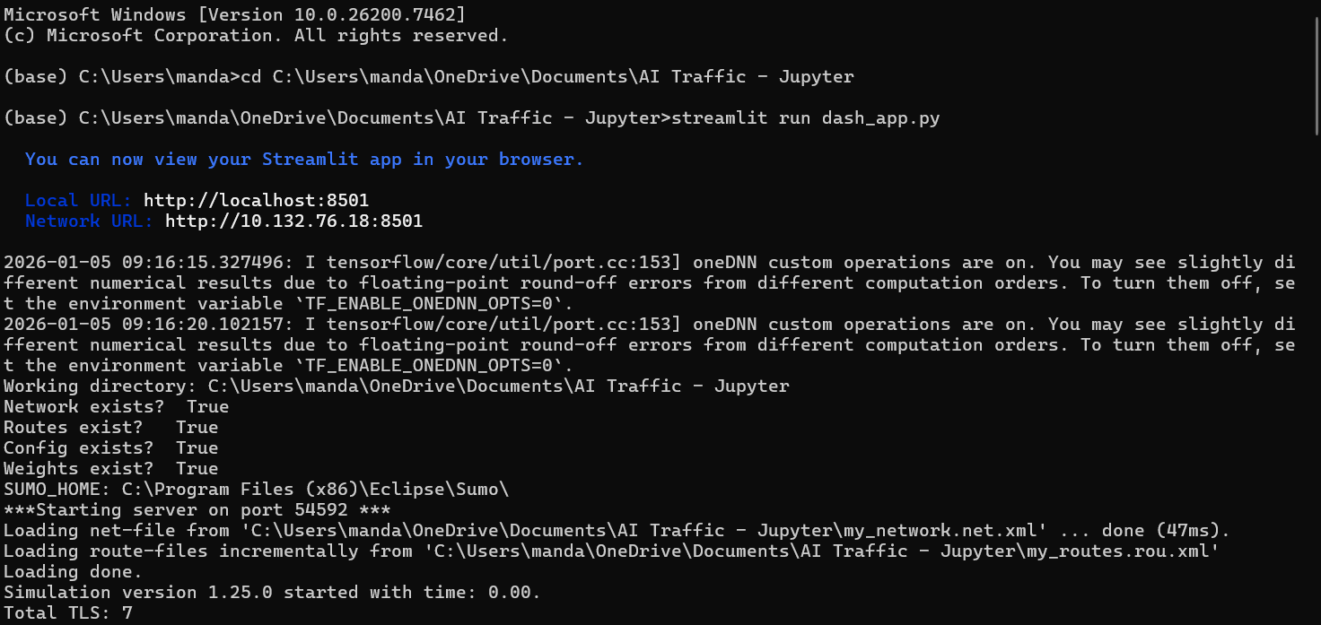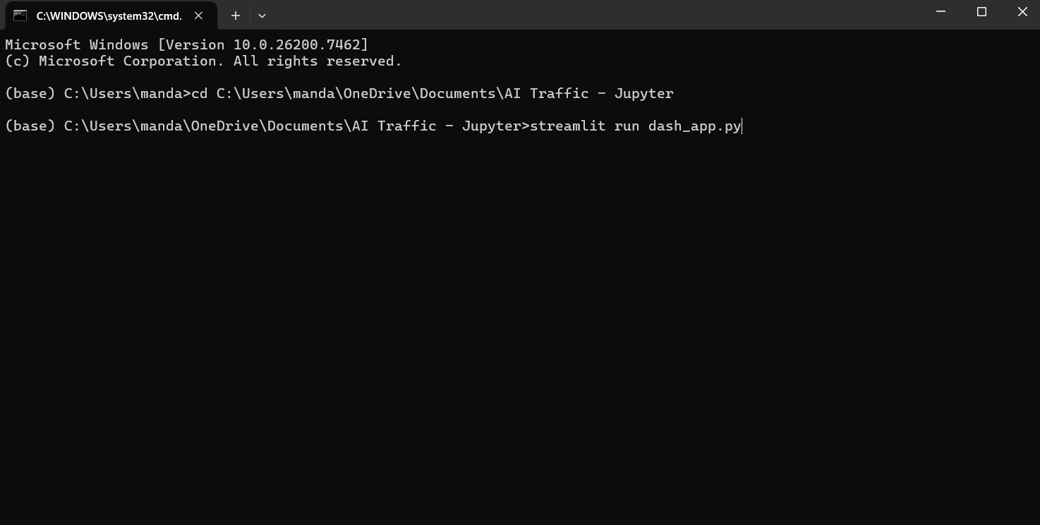

# **Appendix F: Artificial Intelligence Transparency Statement (AITS** 2)

I used AI at AITS 2 (AI for Shaping) of the Artificial Intelligence Transparency Scale (AITS). I used ChatGPT as a support tool to generate section ideas, shape chapter structure. I did not use AI to generate the final dissertation content or to produce original research contributions. All coding, simulation setup, experiments, result interpretation, and final writing decisions were completed by me.